Cognitive Callisthenics: Do FPS computer games enhance the player’s cognitive abilities?

Paul R Kearney
School of Computing and Information Technology
Unitec New Zealand
Auckland, New Zealand
+649 815 4321
pkearney@unitec.ac.nz

ABSTRACT
This document details an initial study into cognitive abilities that may be enhanced from playing computer games. Using a neuro-psychological assessment software package titled SynWin, participants were tested for their ability to function in a synthetic work environment. Scores were recorded and after playing computer games for specified lengths of time, the participants were tested again.
The computer game employed was Counter Strike. This game is categorised as a first-person shooter (FPS), and is a multiplayer networked game. Differences between this game and other first-person shooters such as Quake III include the realism that Counter Strike achieves and the immersive qualities that surround that player.
Different experiments were completed; group one, the control group, where the participants were tested three times without playing computer games between tests and group two where they were only tested twice, but played Counter Strike for two hours before the second test. This group showed a statistically significant improvement in their multitasking abilities.
In summary, this study indicates that certain types of computer games can improve cognitive functions, and suggests further research to ascertain if these abilities are retained and what other skills can be enhanced by games similar to Counter Strike.

Keywords
FPS, Cognitive abilities, Multitasking, Multiplayer

BACKGROUND
According to Mulligan and Patrovsky [11], research analysts suggest that over 100 million people in the United States alone play computer games. The China Center of Information Industry Development (CCID) estimates that there will be 48 million online gamers in China by the end of 2005 [2]. The popular gaming web site “GameSpy” maintains that the action computer game Counter-Strike is played by eight times more players than any other game [7]. It is widely accepted that educational computer games are a valuable resource for learning and action computer games are often viewed as mindless entertainment, but a study completed recently by researchers Green and Bavelier [8] showed other benefits are gained from computer games, such as the enhancement of peripheral vision. It has long been known that puzzle games, such as Tetris, enhance the player’s cognitive abilities. Okagaki and Frensch [12] used Tetris in their research; they found that spatial visualisation abilities were improved in college students after six hours of playing. Research done by De Lisi and Cammarano [4] showed that students improved their mental rotational skills playing a game called Block Out; a three dimensional version of Tetris. Earlier research completed by Dorval and Pepin [5] suggests that students with greater spatial visualisation abilities are generally high achievers and excel in subjects like maths and science.
Unfortunately, today’s generation do not play Tetris or Block out. They are more captivated by action games, known as first-person shooter games, like Counter-Strike and Quake. In a survey of 25 computer game players, it was suggested that these games “not only enhanced hand-eye co-ordination, but also increased their ability to multi-task. A typical first-person shooter involves controlling the player movement, aiming and firing the chosen weapon, evading being a target for other players, monitoring health status and ammunition supplies, and devising a seek and destroy strategy in order to complete the level. All this is done in unison, in a pressure situation.” [9]. If action computer games do enhance basic cognitive abilities, like multitasking and hand-eye co-ordination, and increased attention span, further research could identify specific games that enhance specific abilities. The results would be of value to people who possess learning or motor skill disabilities and those involved in working with them.
This research examined the potential of commercial FPS computer games to be used as a tool to enhance specific cognitive abilities. Tetris was found to improve spatial visualisation. If playing FPS computer games increases the player’s cognitive abilities, they may have a greater positive impact on society than Tetris. Finally, a positive outcome from this research would also be of interest to the game development industry to offset the continual bad press that these games attract. A positive outcome would show that what is currently labelled as “mindless entertainment”, does have a value in society.
This research tested the cognitive abilities of players of action computer games before and after playing such games, using computerised neuro-psychological assessment software, and assessed the potential application of these games to develop such competencies as multitasking.

METHODOLOGY
The chosen design for this research was quasi-experimental design (“quasi” because it does not involve the random selection of participants to be observed). The experimental design was a repeated pre-test/post-test control-group design. Zikmund [18] states that this method is “a true experimental design in which the experimental group is tested before and after exposure to the treatment, and the control group is tested at the same time without being exposed to the experimental treatment” (p.277). The design employed is shown in figure 1.
Control Group.

Test-------------------------------------Test------------------------------------Test

Experiment one.

Test-------------------------------- Treatment --------------------------------Test

Where:

- The test consists of a five-minute test using computerised neuro-psychological assessment software: SynWin version 1.2.33.

- The treatment is continuous playing of a first-person shooter computer game; Counter-Strike (Valve Software).

Figure 1 : Experimental Design

SynWin from Activity Research Services, is the Windows version of SynWork1; a DOS based program developed by Elsmore [6] to simulate a work environment. Both versions are calibrated using the same parameters, making test scores from earlier studies comparable; as long as workload parameters are not modified. The Windows version has a slightly modified interface making use of the graphical environment that Windows provides. The product does not emulate any specific work application, but it does contain elements of work-based activities. Originally developed while Elsmore was contracted as a visiting scientist to the Naval Health Research Centre in Washington DC., SynWork1 creates a synthetic work environment similar to watch-standing jobs like operating a weapons assignment console; locating targets, reacting to audible tones, calculating variables, and remembering weapons assignments.
Most of the SynWin settings are able to be altered though the command line when starting the product; duration, points, sequencing, intervals, and number of tasks to be run simultaneously. SynWin can be set to test only one or more of the tasks or all four with a composite multitasking score. Results for each test and each session are automatically written to a file, identified by the session number and user ID code.

RESULTS AND DISCUSSION
The composite scores for the control group of eight participants (group 1) over three tests were collated. The control group consisted mainly of participants who did not play games at all. This group was included to ascertain the level of increase in scores gained from repeated use of the assessment software. Both non-parametric and one-way ANOVA tests were performed and figure 2 shows the graphed output. The confidence intervals were also added to the graph for each score to show the variance in the results.
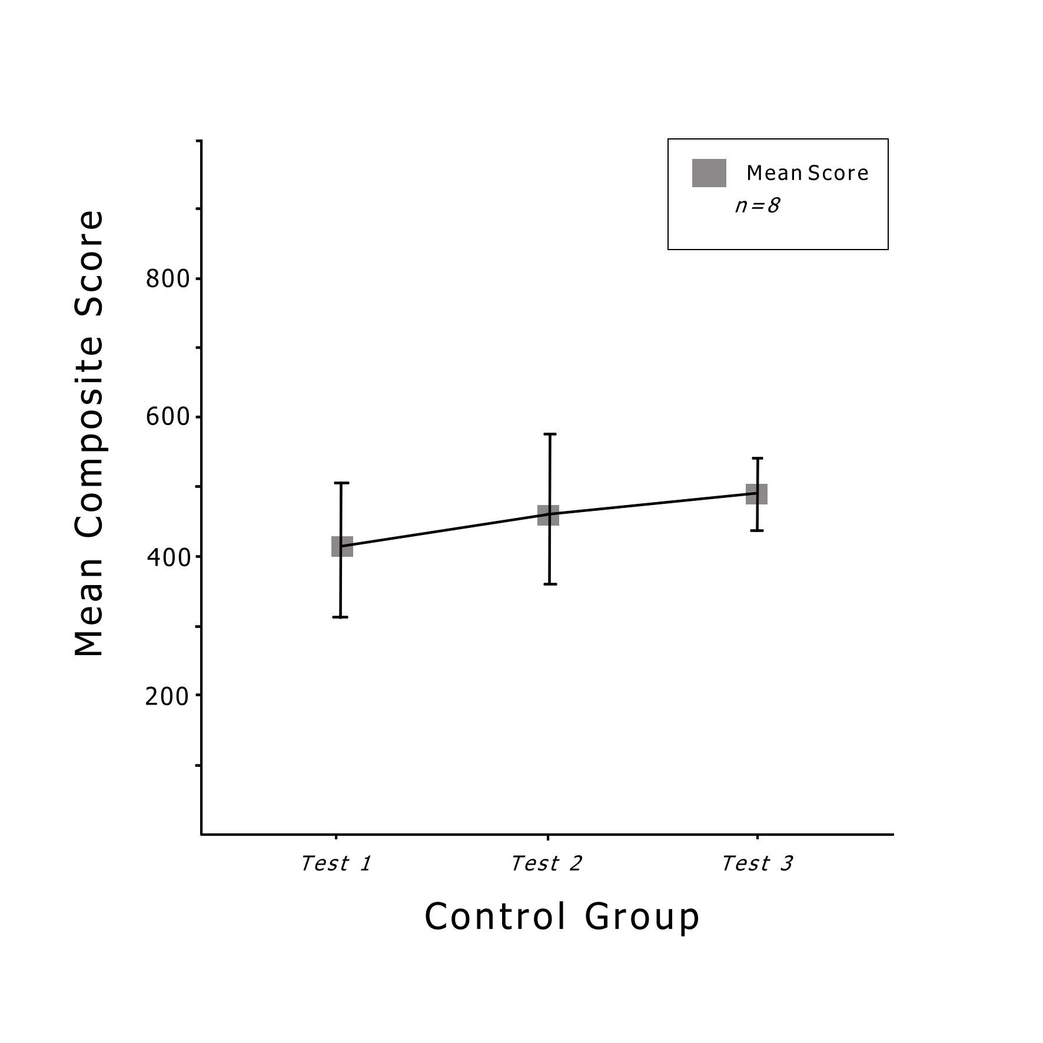
Source | DF | SS | F | P
Factor | 2 | 27144 | 1.21 | 0.318
Error | 21 | 235464
Total | 23 | 262608

Group | n = | Mean | StDev
Test 1 | 8 | 410.8 | 118.3
Test 2 | 8 | 468.5 | 127.5
Test 3 | 8 | 490.5 | 58.4

Figure 2: Control group SynWin mean composite scores and statistical test output.
The data in figure 2 shows a minimal increase of multitasking ability with a mean composite score of 410.8 for the initial test, rising to 468.5 after the second test and 490.5 after the third. Overall increases of 57.7 and 22, with a total increase in the mean score of 79.7, are observed.
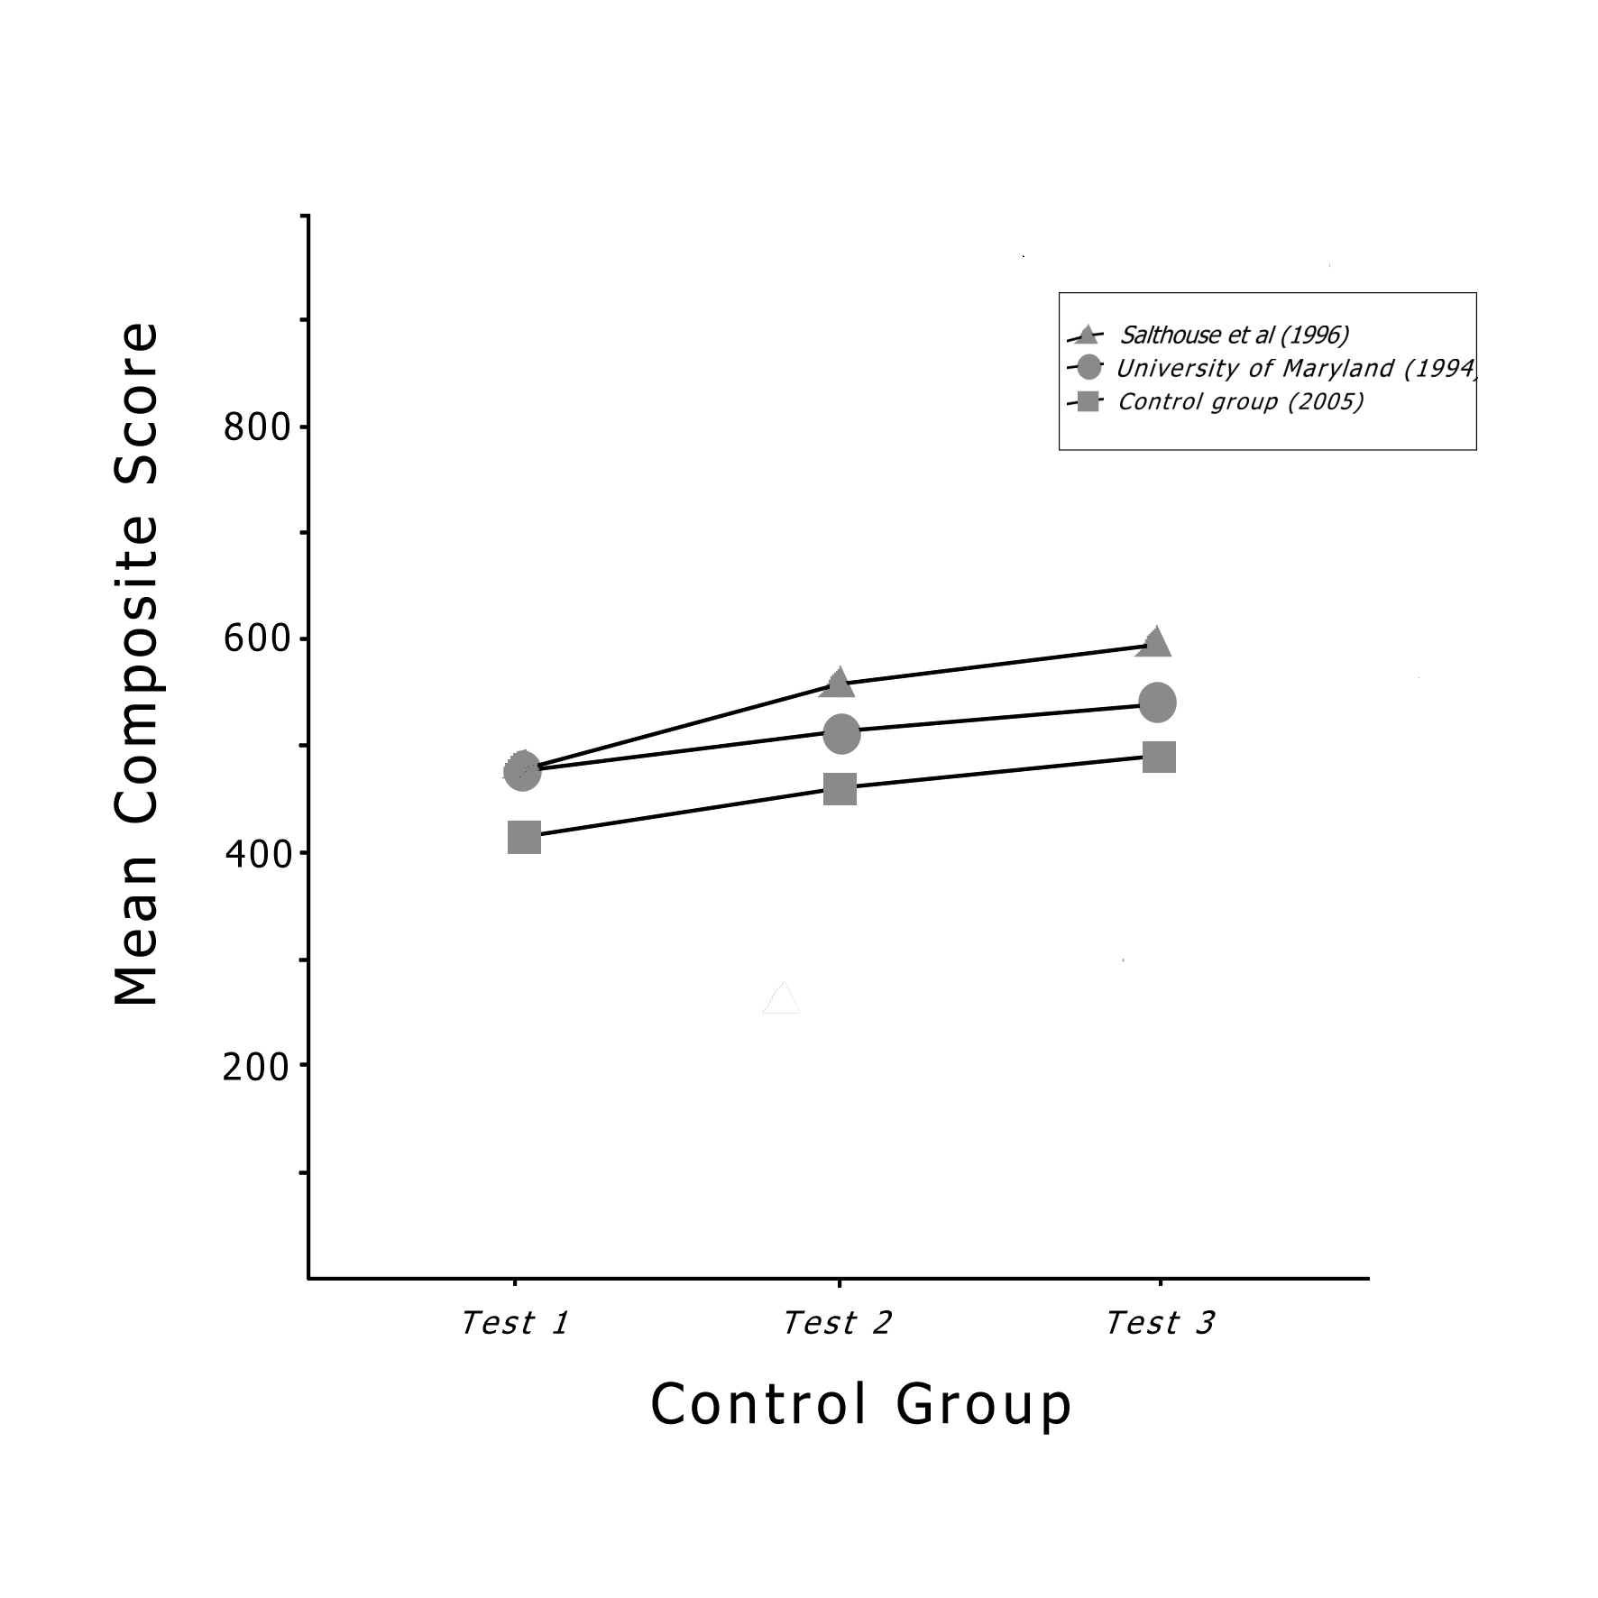
These figures agree with scores in previous studies, with University of Maryland [17] having increases of 43 and 34 respectively, and Salthouse, Hambrick, Lukas, and Dell [16] showing increases of 80 and 25 in mean composite scores. Across the three studies, the average increases in the composite scores were 60 for the second test and 27 for the third test. The graph in figure 3 compares the mean composite scores from each of the three tests completed by the control group with the results of the previous studies. In all studies, the participants were not subjected to any treatment between the first three tests. This suggests that the expected increases in composite score for the control group (60 and 27 respectively) are justified.

Figure 3: Control group composite score comparison
The data from the output files also enabled the composite scores for the control group to be broken down into memory, mathematics, visual and auditory tasks. The control group in this study improved in all but their visual monitoring task when being tested the second time. This task did improve for the third test, but the auditory task showed a minimal reduction in score. Overall, the improvement over the three tests presented a P-value of > 0.3, making the increases statistically insignificant.
Although there were no participants under the age of 20 years, the scores from the other age groups within the control group fall within the expected range. Age is a factor when testing multi-tasking abilities, however it is not considered to have a detrimental affect on the outcome of this control group. As few participants in the control group played computer games and their scores were no better than those of the others in the group, the hours of play were also not considered to be a significant factor within this group.
Group 2 played Counter-Strike for two hours before being retested with SynWin. Non-parametric and one-way ANOVA tests were performed on their scores and figure 4 shows the graphed output. Error bars show the confidence interval for 95% of the mean difference for each score and the output in table shows statistical significance with P<0.05.
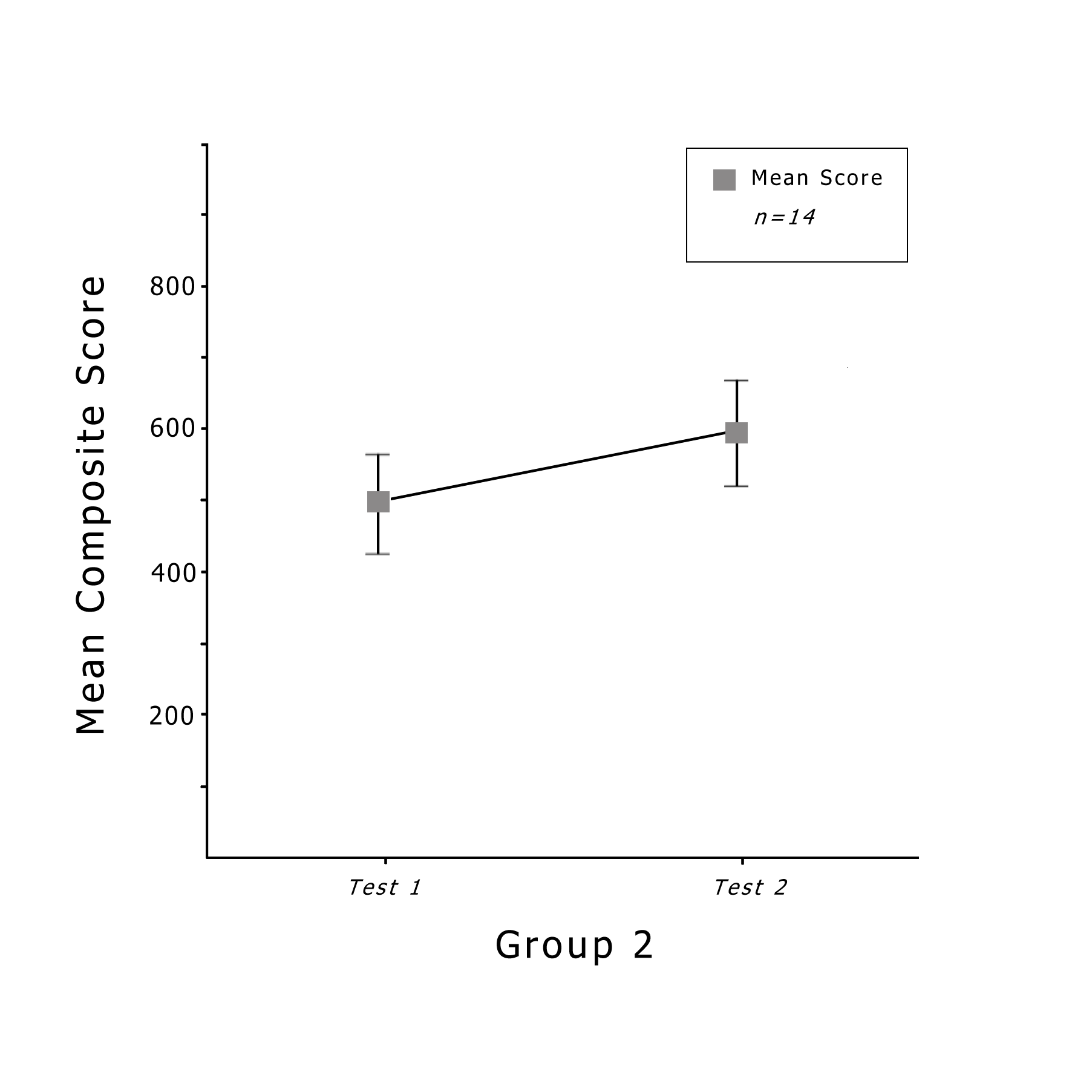
Source | DF | SS | F | P
Factor | 1 | 84920 | 4.57 | 0.042
Error | 26 | 482913
Total | 27 | 567833

Group | n = | Mean | StDev
Test 1 | 14 | 491.1 | 129.8
Test 2 | 14 | 601.3 | 142.4

Figure 1 : Group 2 SynWin mean composite scores and statistical test output.

Group 2 completed experiment two in the laboratory and under controlled conditions. After playing Counter-Strike for two hours in a multiplayer game, the participants recorded an increase in the mean composite score of 110.2; significantly higher than the increase shown by the control group. Using the ANOVA test to analyse the variance, a P-value of < 0.05 was calculated. With the scope of this study only including the control group and group 2, then based on the recorded figures the hypothesis that playing action computer games improves multitasking capabilities within the player is proven to be true.

Increases in all tasks were recorded, but the visual monitoring improved by only a mean of 4 points. There were possible limitations with this task, as suggested by Proctor, Wang, and Pick [15], and these are discussed under limitations of design. However, these limitations did not affect this study and therefore do not affect the results. This group consisted of 14 participants and they were tested in two separate groups at different times. All tests were run in a controlled environment in a computer laboratory and an increase is seen in all tasks, although the increase in visual scores is minimal.
ANOVA test were completed for group 2 and the overall mean increases in score were grouped by age and by hours of play. All groups showed significant increases with the exception of those who play 13 to 16 hours per week. A spread of increase in score was observed across all groups and therefore this is not considered a factor in the outcome of this test.

CONCLUSION
The experiments completed by group 2 clearly show a statistically significant increase in the participant’s multitasking ability. The increase appears in each of the monitoring tasks and the overall composite score. A one-way ANOVA test using the data from group 2, results in a p-value of P<0.05. This suggests that playing the first-person shooter Counter-Strike appears to increase the player’s multitasking ability. The immersive environment created by Counter-Strike captivated the attention of the players in group 2. The participants were completely focused on the game and this concentration appeared to influence the results of the subsequent multitasking test. If, in fact, games such as Counter-Strike and America’s Army do simulate the real world, the United States military are justified in using these games for recruitment and training. In a real life combat situation, a soldier’s ability to multi-task, focus on multiple applications, and to increase these abilities throughout the exercise would be imperative. The military have concluded that this does happen when playing these computer games but do not understand what characteristics within the game promote this ability; hence a proposed study by Prensky (2001).
Limitations of the test software, SynWin, were reported to lie within the visual monitoring task. Procter et al. [15] suggested that the visual monitoring task in Synwork1 (an early version of this software) was too consistent with point allocation and points could be accumulated at the same rate no matter when the gauge was clicked. They contended that there was no difference between waiting for the gauge to reach maximum points and clicking it early multiple times. This may have been the case in SynWork1, where the visual task was timed to restart at regular intervals and progress along a linear horizontal gauge. However, SynWin has made extensive use of the graphical environment of Windows and now uses a semi-circular gauge for this task. Comparison tests were completed for this study and, by configuring the software to execute the visual task only, the concerns of Procter et al. were not seen. By waiting until the gauge reached maximum points, a higher score was achieved, compared to repeatedly clicking the gauge early. However, it was noted that most participants quickly realised that ignoring this task paid a high point penalty: ten points were deducted for every second that the gauge was left on zero. With that in mind, the majority of participants scored high points on the visual task on the first test, and because this is a timed task, a significant increase was not able to be obtained in the second test.
Some participants also concluded that, to maximise their composite score, they needed to concentrate on the math task; Procter et al. [15] also noted this. Being the only task that was not restricted by time, concentrating on the math task enabled participants to add to their score as fast as they could perform addition. Unfortunately, the math task in the SynWin version of this assessment software accumulated points incorrectly. This was noticed while analysing the captured data during the data analysis phase. The math task adds twenty points to the composite score for a correct answer and deducts twenty points for an incorrect answer; and this was while using the default parameters. Previous versions of the product and the documentation of this version state that only ten points are added or deducted for this task. All data was manually, and accurately, adjusted for this study prior to the data being analysed.
The computerised assessment software used in this study was designed specifically to create a synthetic work environment and test the user’s ability to multitask. Further research could involve sourcing or creating other assessment software specifically designed to test for changes in other cognitive abilities such as hand-eye coordination and attention span. Counter-Strike could be retested to determine if other cognitive functions are also increased. Okagaki and Frensch [12] found that Tetris improved spatial visualisation; perhaps Counter-Striker or other first-person shooter computer games also have this ability.
This study suggests that the characteristics such as immersion, collaborative play, and realism are required in a computer game to promote cognitive learning. Once these traits are identified and quantified, a system such as that suggested by Pillay [13] could be devised to identify which commercial computer games promote which abilities. Games could then be categorised and labelled in a similar way to the violence rating system currently employed. Game developers would undoubtedly embrace such a system if games that promote learning, yet are traditionally labelled as mindless entertainment, show an increase in sales and reputation.
In summary, this study has indicated that a player’s cognitive ability can be enhanced by playing a commercial computer game that, on one hand is linked with studies showing violent behaviour in young people, and on the other, is used by the military to hone cognitive skills required for warfare. It could be argued that the military condone the aggressive traits shown by game players, and employ these games for that end; however literature such as the papers by Chathman [1] and McGuire, van Lent, Prensky, and Tarr [10] disagree with this. Cramer, Ramachandran, and Viera [3] go further and suggest that the future of learning revolves around three dimensional worlds that inherently promote learning; Counter-Strike appears to be one of those worlds. Further research is required to ascertain what other cognitive abilities are improved by Counter-Strike, which other games hold the same promise, how the relevant characteristics can be easily identified and quantified, and how they can be developed into commercial computer games, marketed solely for entertainment.

REFERENCES
- Chathman, R. (2003). A possible future for military training. Retrieved 20th December, 2004, from http://www.t2net.org/briefs/dakc/DARPA_TrainingVision_5D8BF.pdf
- China Daily. (2004). Why virtual entertainment means real money. Retrieved 2oth January, 2005, from http://www.chinadaily.com.cn/en/doc/2004-01/02/content_295214.htm
- Cramer, M., Ramachandran, S., & Viera, J. (2004). Using computer games to train information warfare teams. Paper presented at the Industry/Interservice, Training, Simulation & Education Conference (I/ITSEC 2004), Orlando, Florida.
- De Lisi, R., & Cammarano, D. M. (1996). Computer experience and gender differences in undergraduate mental rotation performance. Computers in Human Behavior, 12, 351-361.
- Dorval, M., & Pepin, M. (1986). Effect of playing a video game on a measure of spatial visualization. Perceptual Motor Skills, 62, 159-162.
- Elsmore, T. (1994). Synwork1: A pc-based tool for assessment of performance in a simulated work environment. Behavior Research Methods, Instruments, & Computers, 26(4), 421-426.
- GameSpy. (2004). GameSpy Stats. Retrieved 15th August, 2004, from http://archive.gamespy.com/stats
- Green, C., & Bavelier, D. (2003). Action video game modifies visual attention. Nature, 423, 534-537.
- Kearney, P (2003). The impact of Computer Games on Children's aggressive behaviour and learning abilities. Bulletin of Information Technology Research. 1(1), 1-8.
- McGuire, F., van Lent, M., Prensky, M., & Tarr, R. (2002). Defense combat sim olympics – Methodologies incorporating the cyber gaming culture. Paper presented at the Industry/Interservice, Training, Simulation & Education Conference (I/ITSEC 2002), Orlando, Florida.
- Mulligan, J., & Patrovsky, B. (2003). Developing Online Games: An Insider's Guide (1st ed.). Indianapolis: New Riders
- Okagaki, L. & Frensch, P. A. (1994). Effects of video game playing on measures of spatial performance: Gender Effects in Late adolescence. Journal of Applied Developmental Psychology. 15. 33-58.
- Pillay, H. (2003). An investigation of cognitive processes engaged in by recreational computer game players: Implications for skills of the future. Journal of Research on Technology in Education, 34(3), 336-350.
- Prensky, M. (2001). True believers: Digital game-based learning in the military. In Digital game-based learning (1st ed., pp. Chapter 10). New York, NY: McGraw-Hill.
- Proctor, R., Wang, D., & Pick, D. (1998). An empirical evaluation of the Synwork1 multiple-task work environment. Behavior Research Methods, Instruments, & Computers, 30(2), 287-305.
- Salthouse, T., Hambrick, D., Lukas, K., & Dell, T. (1996). Determinants of adult age differences on synthetic work performance. Journal of Experimental Pyschology:Applied, 2(4), 305-329.
- University of Maryland. (1994). Stress and decisionmaking in trauma patient resuscitation. Retrieved 31 December, 2004, from http://www.hfrp.umm.edu/research
- Zikmund, W. G. (2003). Business Research Methods (7th ed. Vol. 1). Ohio: South-Western.

