Socially Adaptable Games
Daniel Eriksson, Johan Peitz, Staffan Björk
Interactive Institute
Hugo Grauers gata 3
412 96 Göteborg, Sweden
+46 (0)31 183015
{daniel.eriksson|johan.peitz|staffan.bjork}@tii.se

ABSTRACT
This paper introduces the concept of Social Adaptability, a characteristic of games that are explicitly designed to function in changing social environments, and provides initial guidelines for how to design games so that they have this characteristic. The guidelines are based upon analysis of related concepts, types of social roles players can have in games, and how social environments in games can change during gameplay.

Keywords
board games, game design, social adaptability

INTRODUCTION
Mobile and pervasive computing offer a new avenue for computer games where gameplay can take place at user-chosen locations and can be affected by the real world context of those locations. The motivation for this paper is grounded in the observation that the full potential of mobile and pervasive computer games will not be possible until these games are possible to coexist with complex and changing social environments, as introduction of technology is usually disruptive in a social environment. For instance, a handheld game using players’ physical location in a city as input puts players in a dilemma between navigating the physical world (e.g. avoiding traffic) and attending events in the virtual game world. Also, activities that are normally socially unacceptable are unlikely to be regarded differently to observers when part of gameplay, especially if it is difficult to discern that the activity is actually part of a game.
All games need to be able to coexist with changing social environments. For non-computerized (and non-mechanized) games this is normally not an issue, since gameplay only progresses due to player actions and a social contract between players dictate how to handle changes in the environment. Computer actions in real-time computer games are done without knowledge of the players’ real world environment where only the ability to pause is helpful to avoid conflicts. For multiplayer games it is not possible to allow pauses without breaking game consistency, interrupting gameplay, or disadvantages to the pausing player, but this is usually solved by players trying to setup controlled gameplay environments where interruptions are minimized. However, pervasive games (c.f. [7]) are designed to take place over extended periods of time or in environments that change. Further, many pervasive games are built to take place in public settings, so consideration to how bystanders, aware or not that a game is being played, needs to considered. Therefore, the ability of a game to adapt to changing social environment, for which we use to term Social Adaptability, is an important design issue for creating pervasive games.

Social Adaptability
We define social adaptability as follows:
The ability of a game to adjust, either actively or passively, to changes in the social environment so that negative effects on gameplay or activities overlapping play sessions are minimized.
The meaning of “active” and “passive” in our definition concerns games’ abilities to observe changes in the social environment independently of players. Thus, games that make use of sensors to continuously update how the game should behave in a social environment are examples of active social adaptability. This type of social adaptability can be seen as one of the use areas of context-awareness computing (see e.g. [14]). Passive social adaptability, in contrast, is based upon the game design only demanding as much attention as the player is giving it. Traditional card and board games are examples of this; nothing happens in the game unless the players give their attention to it. However, the social adaptability of traditional games is not perfect: if a player is interrupted from playing the game, the game may adapt to that player’s changed social environment but the other players are usually forced to adapt as well, typically by taking a pause in the game. Lastly, it should be noted that the activities referred to in the definition can be those done either by players or by other people in the vicinity of the gameplay.

Related Concepts
In order to contextualize social adaptability we first identified a number of related concepts from the field of human-computer interaction and interaction design.
The concept of calm technology was introduced by Weiser [18] and is closely linked to his vision of ubiquitous computing environments. Calm technology is also ever present, but emphasize that technology should be built to function as a peripheral source of information.
Noting that ambiguity should not be used as an excuse for poor design nor incorporated into designs for its own sake as it typically adds mostly confusion, Gaver et al. [4] find several uses of ambiguity for opening up new design possibilities. They identify three categories of ambiguity while charting its use in design: ambiguity of information, ambiguity of context, and ambiguity of relationship.
Toney et al [16] introduced the concept of Social Weight, defining it as ‘the measure of the degradation of social interaction that occurs between the user and other people caused by the use of that item of technology’. The authors use social weight to analyze the impact technologies have from both input and output perspectives, but do not described how to use it for design purposes.
Several researchers [5, 8, 9, 11] have studied user focus and attention, researching methods of decreasing the negative effects of interruptions. However, little is mentioned of how to actually embrace Interruptability in designs to support adaptability to changing environments.
Chalmers & Galani [2] note that making technology "invisible" may be impossible in many situations, as this creates seams in technology-dependent activities. To resolve the problem, Chalmers & Galani advocate what they call "seamful interweaving", supporting technological systems so that they can be accommodated and appropriated to the users' social interaction. They note that designing for Seamfulness, and the appropriation this supports, may be advantageous where personalization, adaptation and exploration are required.

Reasons for Changes in Social Environments during Gameplay
Concepts such as social weight, interruptability, and seamfulness supports a higher level of granularity when discussing social adaptability but does not help categorize what types of changes in the social environment can occur during gameplay. In order to categorize these changes, we used the magic circle concept [6, 13] as a simplistic model of the social environment.
Two main sets of changes were identified and analyzed through player roles and types and the previously identified concepts. The first set, intra-ludic events, deals with changes between the participants of the game, i.e. the ones that are inside the magic circle. The second set, extra-ludic events, covers changes between the players inside the circle and non-players on the outside. These events can be affected by considering the related concepts.

Intra-ludic Events
Looking at events that involve the game’s participants we have identified four different changes in the social context. The first change occurs when a person within the circle starts to communicate with another player. This can be either mediated communication or not. The next change occurs when the technology that mediates the communication breaks down or requires input or attention from the player, creating a very distinct change. The two other changes are when a player takes a break, i.e. leaves the circle, or reenters the game after a break.
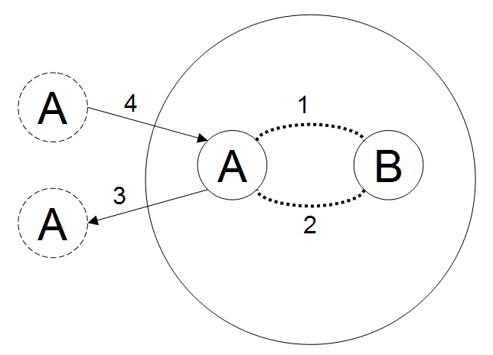
Figure 1: Changes inside the circle because of in-game events.

Extra-ludic Events
We also identified four different types of changes that depend on events occurring outside the magic circle. The first change is caused by events outside the magic circle that forces participants of the game to stop communicating with each other. If the change affects some players and not others, there is a risk that gameplay suffers.
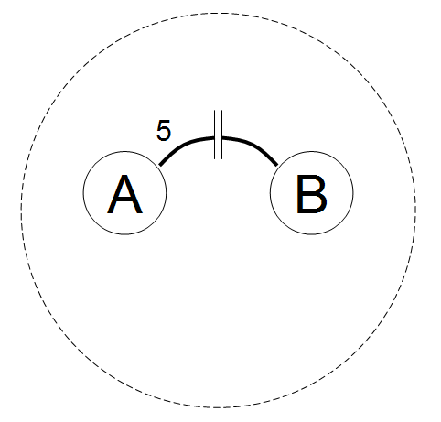
Figure 2: Technology breakdown changing the social environment.
Two other types of changes in the social context can occur when a person on the inside communicates with someone on the outside while still playing the game. This generates two cases; one where the person inside the circle initiates contact and one where someone who is not playing the game, and thus outside the circle, talks to someone inside the circle.
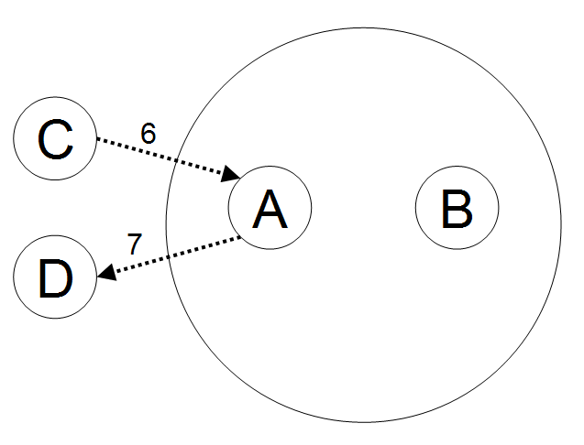
Figure 3: Changes inside the circle because of extra-game events.
The last identified event is when two non-players communicate with each other so that players observe them.

Aspects of Social Interaction in Games
To understand social adaptability we wished to have a more detailed categorization of social interaction regarding gameplay. This was done by analyzing the different roles identified by earlier research [1, 3, 17] and identifying a new categorization of roles: social and functional.

Social Roles
During the research study on inherently socially adaptable games (i.e. board games) two observations were that temporary departures of players occurred frequently and that the presence of onlookers affected gameplay. This led us to consider changes between active and passive playing as well as looking at the concepts of Lurkers and Spectators. This has been discussed [10, 15] from an online community perspective where Lurkers and Spectators are described as, although silent, an important part of any community. Another observation was that players’ social roles could change quickly during gameplay, not only because of extra-ludic events but also due to changes in mode of play or the current game state.
Banned – people not allowed to play the game.
Outcast – a player excluded from social interaction by the other players.
Recluse – a player willingly isolated from social interaction with other players.
Motivator – a player providing or advocating activities and experiences in the game without seeking any in-game benefit.
Negotiator – a player negotiating between two other players.
Mediator – a player performing action for another player, either through his or her own actions or by taking over the other player’s possibilities to influence the game.
Helper – a player actively helping another player perform actions in the game.
Violator – a player trying to affect other players’ gameplay against their will through explicit actions.
Dominator – a player trying to influence other players to perform specific actions for the player’s own in-game benefits.
Exhibitionist – a player performing actions in the game to gain the other players’ attention.
Most of the identified social roles are compatible with other social roles. For example, exhibitionists may function as motivators to draw attention to what they are doing and one way of being an exhibitionist is to act as a violator publicly.

Functional Roles
Players in a board game often have different abilities or choices based on the game rules, dividing them into different functional roles. These roles are defined by the sets of actions that are available to players due to the game rules and game state. Functional roles in games can be described by six categories based on how the abilities they give players differ from the abilities given to other players. All functional roles consist of abilities from one or more of these categories:
Observational functionality – people that can observe gameplay.
Basic functionality – actions available to all players.
Dedicated functionality – actions available to some, but not all players.
Unique functionality – actions available to only one of the players.
Supporting functionality – actions available to one player but only indirectly help that player since the actions directly help other players.
Meta functionality – actions available that affect the characteristics of game instances or meta games.
Some actions provided by functional roles are social in their nature, e.g. various actions to communicate with other players. Since social interaction in games is mediated or motivated by the actions available to the players, use of functional roles allows for the game designer to influence the social interaction that takes place. For example, a player with a unique ability will attract the attention of the other players and private communication channels in multiplayer games allows for more personal communication.

Guidelines for Socially Adaptable Games
This section presents a set of guidelines distilled from the knowledge described in the sections above. The guidelines were created with the primary intention of supporting game designers to explicitly discuss socially adaptability in the design process.

Support Interruptability
Consider making it possible for individual players to pause their gameplay since it may be impossible for the system to determine when players can or cannot play the game due to extra-ludic events. Various ways to support interruptability include making the game completely player driven, allowing for asynchronous play sessions and encourage players to take breaks through game design. It is also important to consider how to handle player reentry in the game world.

Allow Multiple Communication Channels
In order for the game to be able to continue in a changed social context, allow players to communicate, both between each other and with the game, through multiple channels. If these channels can be designed to support seamful intertwining, the game will also gain seamfulness, making it possible for players to change channel at will.

Consider Ambiguity
By considering ambiguity, especially ambiguity of information, objects and activities involved in the game can be made indiscernible from other, everyday, activities. Ambiguity can also support several of the more active social roles as these can need a certain flexibility of interpretation in order to function. One method of achieving this ambiguity of information is by using information art to provide calm technology.

Design for External Events
Games which take place inside the real world and among people not playing the game are especially vulnerable to extra-ludic events. If these context changes are not taken into consideration, the gameplay might breakdown. The game design should consider what kinds of external events, both technology and gameplay related, can change the social environment in which the game is played.

Allow Modes of Play Based on Social Roles
Analyze different activities in games, or modes of play, for how they are related to different social roles. Allowing players to seamlessly move between active players and lurkers can support interruptability above. Creating functional dependencies in the game between different social roles can be used to encourage a variety of gameplay styles as well as support multiplayer games where players can have different levels of social and gameplay engagement.

Minimize Social Weight
Pervasive games are likely to occupy the same space as non-playing people. In order to minimize the impact on these bystanders, the game should be designed for minimal social weight. If this is not possible, it is worthwhile trying to have different modes of play with different social weight to support events with interaction with persons outside the magic circle.

Analyze Intended Player Groups from Several Perspectives
Having several different views on how players relate to the game allows for a more precise design to support their needs. Besides using general categorizations according to experience and preferred game activities, applying player type models as well as social and functional roles allow the game design to consider both short-term and long-term changes in player behavior.

Conclusion
This paper has introduced the concept of social adaptability in games, which we argue is crucial for the success of pervasive games, and has presented guidelines for creating games that have this property.
Social adaptability is a very important characteristic of games that take place in social environments where players are likely to meet non players during their play. In those cases where this is frequent, games will not be feasible no matter what technology or business model they are supported by, if they are unable to adapt to the new social context.
The guidelines presented in this paper are based on concept from other areas and give developers and designers a tool to create socially adaptable games. However, the value of the guidelines needs to be validated through examples and to this end we are currently creating a set of prototypes (c.f. [12]).

Acknowledgements
The results presented in this paper was produced as part of the IPerG integrated project which is funded by the European Union through the IST programme (FP6, contract 004457) and VINNOVA. Thanks to Maria Åresund for valuable suggestions on the paper.

References
1. Bartle, R. (2003) Designing virtual worlds. Prentice Hall PTR, 2003.
2. Chalmers, M. & Galani, A. (2004) Seamful Interweaving: Heterogeneity in the Theory and Design of Interactive Systems. Proceedings of DIS 2004.
3. Farmer, R. F. (1992) Social Dimensions of Habitat's Citizenry. In Loeffler, C. E., & Andersson T. (Eds.), The Virtual Reality Casebook. New York, Van Nostrand Reinhold, 1992.
4. Gaver, B., Beaver, J., & Benford, S. (2003). Ambiguity as a resource for design. Proceedings of CHI’03.
5. Horwitz, E., & Apacible, J. (2003) Learning and Reasoning about Interruption. Proceedings of the 5th international conference on Multimodal interfaces.
6. Huizinga, J. (1950) Homo Ludens: A Study of the Play-Element in Culture. Beacon Press, 1950.
7. Integrated Project on Pervasive Gaming. Available at http://www.pervasive-gaming.org, last visited 20050415.
8. McFarlane, D. (2002) Comparison of Four Primary Methods for Coordinating the Interruption of People in Human-Computer Interaction. Human-Computer Interaction, 2002, Vol. 17, pp. 63-139.
9. Nagel, K., et al. (2004) Predictors of Availability in Home Life Context-Mediated Communication. Proceedings of CSCW 2004.
10. Nonnecke, B., & Preece, J. (2000) Lurker demographics: Counting the silent. Proceedings of CHI’2000.
11. O'Conaill, B., & Frohlich, D. (1995) Timespace in the workplace: dealing with interruptions. Proceedings of CHI'95.
12. Peitz J., Eriksson D., & Björk S. (2005) Augmented Board Games: Enhancing board games with electronics. Proceedings of DiGRA 2005 Conference: Changing Views – Worlds in Play.
13. Salen, K., Zimmerman, E. (2004) Rules of Play, The MIT Press, ISBN 0-262-24045-9
14. Selker, T. & Burleson, W. (2000) Content-aware design and interaction in computer systems. IBM Systems Journal, Vol. 39, N. 3&4, 2000.
15. Takahashi M. et al, (2003) The Active Lurker: a New Viewpoint for Evaluating the Influence of an In-house Online Community. ACM SIGGROUP Bulletin archive, Vol. 23, Issue 3, December 2002.
16. Toney, A., Mulley, B., Thomas, B.H. & Piekarski, W. (2002) Minimal Social Weight User Interactions for Wearable Computers in Business Suits, ISWC 2002.
17. Yee N. (2002) Facets: 5 Motivation Factors for Why People Play MMORPG's. Available at http://www.nickyee.com/facets/home.html, last visited 20050415.
18. Weiser, M. & Brown, J. S. (1996) The Coming Age of Calm Technology. Available at: http://www.ubiq.com/hypertext/weiser/acmfuture2endnote.htm, last visited 20050415.

