Connecting Worlds. Fantasy Role-Playing Games, Ritual Acts and the Magic Circle
Drs. Marinka Copier
Institute for Media and Re/presentation (IMR)
Research Institute for History and Culture (OGC)
Utrecht University
Kromme Nieuwegracht 29
3512 HD Utrecht, The Netherlands
0031-30-2539607
marinka.copier@let.uu.nl

ABSTRACT
From a cultural history and game theoretical perspective my work focuses on the relationship between the fantasy subculture, fantasy role-playing games and the daily life of their participants in the Netherlands. Main research themes are the construction of game/play space and identities. Within this context I elaborate in this paper on the usefulness of the term magic circle (Johan Huizinga). I will argue why in game research the current use of the term magic circle is problematic. We can understand the term differently when returning to the context in which Huizinga introduced the magic circle as ritual play-ground. According to him ritual is play and play is ritual. Referring back to his work Homo Ludens (1938) I will discuss the various relationships between role-play and ritual performance. I will argue that fantasy role-playing consists of collections of performances or ritual acts, in which players construct the game/play space, identities and meaning.

Keywords
fantasy role-playing games, fantasy subculture, space, identity, magic circle, ritual, performance
“The rain poured from the sky and the grass was turning into a swamp. […] Standing below the thatched roof of a small medieval hovel I noticed with relief that such a construction is actually waterproof, though the stench of the wet woolly cloaks of the role-players surrounding me was a bit of realism I could have done without. On the second weekend of April one of the largest fantasy shops in the Netherlands Elf organized Western Europe's largest fair at no other place than historical theme park Archeon in my old hometown Alphen aan de Rijn. The Archeon was a nice setting for the Fantasy Fair. Historical re-enactment and Live Role-playing are very close related and the normal staff of the park mixed seamlessly with the orcs, elves, vampires and trolls.” [1]

FANTASY CULTURE
Following the popularity of Tolkien’s The Hobbit (1937) and Lord of the Rings (1954-1955), a genre named fantasy came into being. The genre has avant la lettre authors like William Morris and Lord Dunsany and has a close relationship to mythology and fairy tales. From the 1960s onwards, fantasy became a transmedial phenomenon, which can be found in various media such as books, movies, television series, music and games. [2] A fantasy subculture emerged in which a convergence is taking place between popular fantasy media, clothing, re-enactment and (pagan) spirituality. Because the fantasy subculture evolved very differently within various national and cultural climates my focus is on the Dutch scene. The best taste of the Dutch fantasy subculture can be found at the annual Elf Fantasy Fair, which is organized by the Elf Fantasy Shop. [3] The citation above is from one of the visitors of the first Elf Fantasy Fair in 2001. It was announced as a “Fantasy and Celtic mythology event with Witches, Hobbits and King Arthur”. During the two-day festival the Dutch historical theme park Archeon was renamed Elfië.
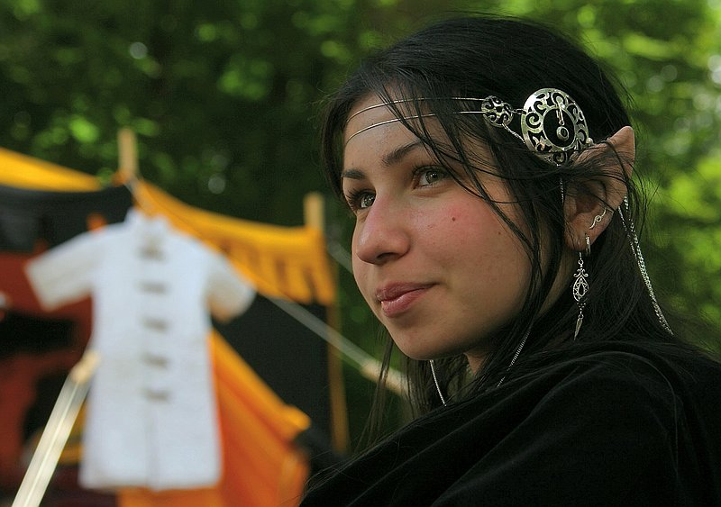
Figure 1: The Elf Fantasy Fair is the largest fantasy event in the Europe. (Elf Fantasy Fair 2004, J.J. van der Wees)

Role-Playing Games
The majority of the Elf Fantasy Fair visitors dress in fantasy style, most of the time enacting a character (Figure 1). Role-Playing Games (RPGs) take up an important part during the events, along with lectures by fantasy authors, modern witches and druids, fantasy art, re-enactment and sword fighting. Therefore I would like to argue that RPGs can no longer be seen as separate entities, they are part of a larger fantasy subculture. The Elf Fantasy Fair shows how players are at the same time involved in various digital but also analog (table-top and live action) role-playing games. Closely connected to their role-play experience is their interest in fantasy films, books, clothing, re-enactment and/or neo-pagan spirituality. What is the relationship between fantasy subculture, fantasy role-playing games and the daily life of their participants? From a cultural history and game theoretical perspective my work focuses on researching the ways in which game/play space and identities are constructed in and around digital and analog fantasy role-playing games. This paper will focus on the construction of the game/play space and elaborate on the usefulness of the term magic circle as it was introduced by the Dutch historian Johan Huizinga in his work Homo Ludens (1938). [4]

RPG history
Role-playing has a long history in Western culture from children’s games through the theater and as a training method. However, fantasy role-playing as a commercial product was developed in the 1970s as Dungeons and Dragons (D&D, 1974) by Gary Gygax and Dave Anderson. The game was based on a combination of their interests in table-top wargaming and literary fantasy [5]. In the D&D Player’s Handbook the game is described as: “[…] you create a unique fictional character that lives in your imagination and the imaginations of your friends. One person in the game, the Dungeon Master (DM), controls the monsters and people that live in the fantasy world. You and your friends face the dangers and explore the mysteries that your Dungeon Master sets before you.” [6] Table-top or pen and paper role-play does not involve any form of physical acting. Nevertheless, in the United States and England, influenced by re-enactment, players started to enact their characters, thus beginning what came to be known as Live Action Role-Play (LARP). In the 1970s many fantasy fans and D&D players had jobs as computer specialists. This influenced the spaces in which they worked: “[…] rooms in the lab were given whimsical names that fit into a Lord of the Rings theme. Printers at the lab were even programmed with an optional "Elvish" font […].” [7, Stanford University 1976] Therefore it might not be surprising that many of the computer games they developed had a fantasy theme or were based on D&D like the game Adventure. In 1978 the first Multi User Dungeon (MUD), a text based virtual reality or role-playing game, was designed by Roy Trubshaw en Richard Bartle. [8] It took almost twenty years before the first three-dimensional Massive Multiplayer Online Role-Playing Game (MMORPG), Meridian 59 (1996), was developed.

RPG in the Netherlands
During the Elf Fantasy Fairs 2003-2005, I have conducted quantitative and qualitative ethnographical research. [9] From 2001 onwards, the event has attracted an increasing number of visitors each year: 2001 (7.500), 2002 (12.000), 2003 (18.000), 2004 (20.000), 2005 (21.400). [10] Table 1 shows how many visitors express an interest in different types of role-playing. From the quantitative data I was also able to get an overview of frequently played RPGs in the Netherlands.
Table 1: Role-playing games played by visitors of the Elf Fantasy Fair 2003 (720 questionnaires, 36,4% male/ 63,6% female) and 2004 (919 questionnaires, 34,3% male/ 65,7% female) [11].

2003 2004
Digital RPG 37,7% 39,6%
Table-top RPG 30,1% 30,1%
Live action RPG 11,1% 12,7%

In 2003 and 2004, digital (online) role-playing games like Neverwinter Nights (Bioware, 2002) and Final Fantasy (Square Enix, 1987 onwards) had the most interest (40%). In 2005, many respondents added the MMORPG World of Warcraft (Blizzard, 2004). Next up in popularity are table-top role-playing games, mainly Dungeons and Dragons (30%). Only 12% of the respondents is active in live action role-play. In the early 1990s, LARP was introduced in the Netherlands by a group of Dutch players who took part in a British event called The Gathering, where thousands of live action role-players fought in fantasy battles. The first Dutch LARP group was Malatië Adventures. The Dutch LARP community currently numbers approximately forty organizations and two thousand (2,000) participants. [12] Live action role-playing groups like Vortex Adventures, Cauldron and Lands in Exile are highly visible at the Fair. While enacting their characters, they provide the entertainment, for instance by demonstrating sword fighting and playing the Bloodball tournament (figure 2).
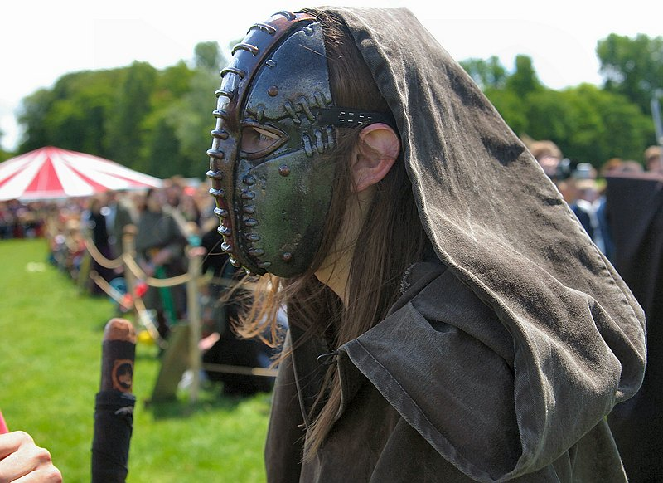
Figure 2: Live action role-player preparing for the Bloodball battle. This is the fantasy version of American football where not only physical but also magical skills are allowed. (Elf Fantasy Fair 2004, J.J. van der Wees)

Fantasy research, RPG theory and game studies
Before further elaboration on the construction of the game/play space of RPGs, I will situate my work by beginning with a brief overview of fantasy research, RPG theory and game studies. The fantasy genre is mainly studied in the margins of literary research. A broader, more transmedial perspective of fantasy can be found within the International Association for the Fantastic in the Arts. [13] In research on analog RPGs, I differentiate between research conducted by academics and research done by players. Important academic work has been done by anthropologist Gary Allen Fine (Shared Fantasy, 1983) and performance researcher Daniel Mackay (The Fantasy Role-Playing Game, 2001). Interestingly, soon after the publication of D&D, players (often with an academic background) started to theorize on RPGs in order to enhance their games (The Forge and RPGnet). [14] Within this context we can also situate the three LARP theory books, which where published for the Kuntepunkt conferences (annual LARP conferences taking place in one of the Nordic countries). [15] Some researchers take part in both the academic and the player’s discourse on RPG theory.

From a game studies perspective, mainly digital RPGs are studied. From this point of view two issues can be raised. First of all, from a game-historical perspective I would argue for the importance of studying digital RPGs in the context of analog ones. Also, a distinction can be made between role-playing games and the act of role-play. Role-playing, the activity of acting out or assuming a particular role, can be done in many forms and within many games, not only in role-playing games. RPGs just offer specific rules and settings which guide role-play. Within this context I would like to discuss whether role-playing games are a form of play or games. According to their own definitions of games, Jesper Juul, Katie Salen and Eric Zimmerman consider RPGs as “borderline” or “limit” cases of games. Consider for instance Juul’s classic game model: “A game is a rule-based formal system with a variable and quantifiable outcome, where different outcomes are assigned different values, the player exerts effort in order to influence the outcome, the player feels attached to the outcome, and the consequences of the activity are optional and negotiable.” [16] On RPGs Juul note: “[…] Pen and paper role-playing games are not normal games because with a human game master, their rules are not fixed beyond discussion.” [16] As Salen and Zimmerman argue, RPGs lack one important component of most game definitions: quantifiable outcomes. Although: “[…] if you consider the session-to-session missions that players complete, the personal goals players set for themselves, the levels of power that players attain, then yes, RPGs do have quantifiable outcomes.” [18] The fact that RPGs cannot be fitted easily into game definitions makes them interesting. Being borderline cases, they can be helpful in critically thinking about game definitions. In this discussion it is helpful to use the distinction between the role-playing game and the act of role-playing. Table-top and live-action RPGs as formal systems do not provide quantifiable outcomes, whereas MMORPGs clearly do, for example in offering players quests to solve. And when role-playing in the context of table-top, live-action or online RPGs both the DM and the players can (also) set their own goals and thereby quantifiable outcomes. From a commercial perspective, digital offline games like Baldur’s Gate (Bioware, 1998 onwards) are also considered RPGs. I would argue that these games don’t necessarily encourage role-play because players cannot add their own information or discussion over the rules as in table-top, live-action and online role-playing. Therefore I would consider offline RPGs being adventure games (always having fixed rules and quantifiable outcomes) rather than role-playing games. These games are less interesting for my research, because the main focus is the construction of game/play space and identities and therefore the role-play aspect of RPGs.
In order to understand the relationship between analog and digital forms of role-playing, fantasy subculture and the daily life of their participants, the construction of the game/play space is very important. Is there a clear-cut beginning and end to play? Does the game/play space have boundaries? Is play something that takes place in- or outside of everyday life? When researchers discuss these questions, often the term magic circle is brought up. How useful is the concept of the magic circle in discussing game/play space and the relation to the everyday life of their participants? This work will elaborate on the term magic circle while drawing from the various perspectives presented above.

MAGIC CIRCLE
The play-ground was first described as magic circle by Huizinga. His work regained interest with the re-introduction of the term ludology in game research. Espen Aarseth and Gonzalo Frasca both insisted on the importance of the game dimension in cybertexts and computergames. In his article “Ludology meets narratology” (1999) Frasca re-introduced the term ludology to describe an at that time nonexistent discipline that “[…] would focus on the study of games in general and videogames in particular.”[17] Frasca made a call for a specific set of theoretical tools to analyze games as games. In order to create game-theoretical framework researchers began to draw on the small amount of research done on analog games by, for instance, Roger Caillois, Brian Sutton-Smith and Huizinga. Huizinga’s definition of play as well as his term magic circle became frequently used in the emerging field of game studies. However, his description of play and the magic circle is sometimes misinterpreted. This might be due to the fact that Homo Ludens is written in old-fashioned Dutch and partly incorrectly translated into English (1949). It is important to note that in the Dutch language and in Huizinga’s original text, there is no difference between play and game, both are called “spel”.
Huizinga’s definition of play is: “[...] a free activity standing quite consciously outside “ordinary” life as being “not serious”, but at the same time absorbing the player intensely and utterly. It is an activity connected with no material interest, and no profit can be gained by it. It proceeds within its own proper boundaries of time and space according to fixed rules and in an orderly manner. It promotes the formation of social groupings which tend to surround themselves with secrecy and to stress their difference from the common world by disguise or other means.” [4]
Mainly by drawing on the phrases “standing outside ordinary life” and “within boundaries of time and space” game researchers discuss the term magic circle. An example of how this term is used can be found in Rules of Play (2004) by Salen and Zimmerman [18]. They introduce the magic circle as a core concept in their theoretical framework for game design. Their chapter on the magic circle opens with the picture of a chalk circle.

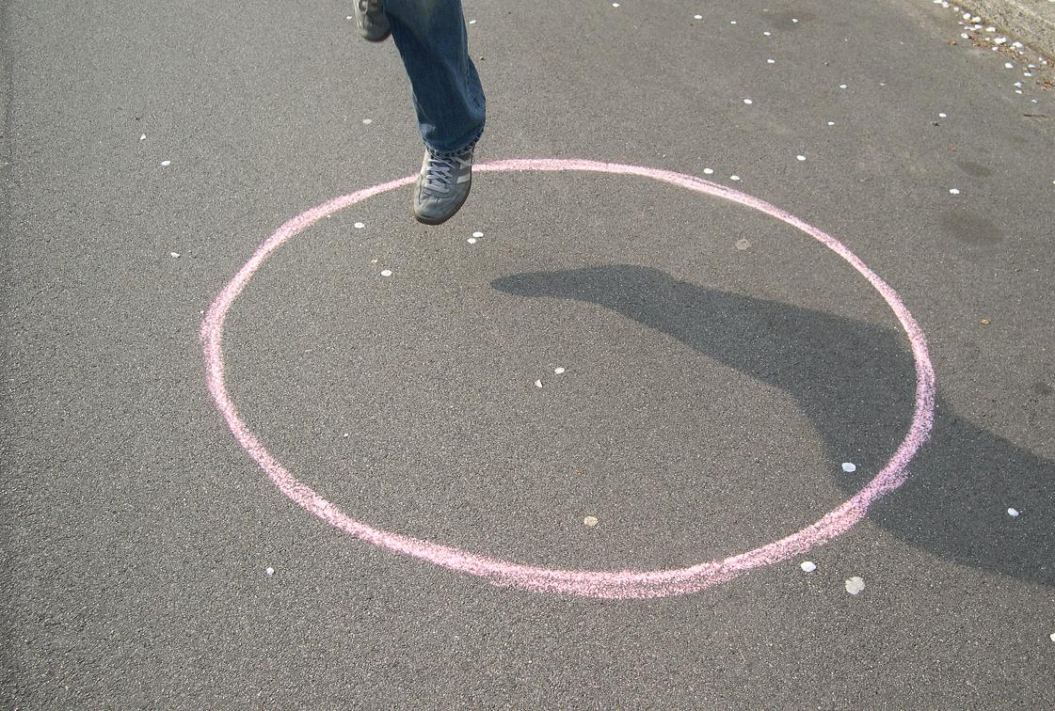
Figure 3: The magic circle, a chalked line? (2005, M. Copier)

Chalk Circle
Salen and Zimmerman ask: “What does it mean to enter the system of the game? How is it that play begins and ends? What makes up the boundary of a game?” [18] They differentiate between three main ways of understanding games: rules (formal rules of the game), play (human experience of the game) and culture (cultural aspects of the game). They cite Stephen Sniderman’s essay “Unwritten Rules”, in which the circumstances surrounding play are called the frame [19]. Salen en Zimmerman argue that “[…] the frame of a game is what communicates that those contained within it are “playing” and that the space of play is separate in some way from the rest of the world.” [20] Inspired by Huizinga, they call this frame, which defines the game in time and space, the magic circle. They have borrowed the term from the following passage in Huizinga’s book (quote Salen and Zimmerman): “The arena, the card-table, the magic circle, the temple, the stage, the screen, the tennis court, the court of justice, etc., are all in form and function play-grounds, i.e., forbidden spots, isolated, hedged round, hallowed, within special rules obtain. All are temporary worlds within the ordinary world, dedicated to the performance of an act apart.” [18]
The circle has been chalked and the next question they ask is, “how open or closed are the boundaries of the magic circle of the game and the world outside the game?” To answer this question, Salen and Zimmerman refer to their three main ways of understanding games: rules (considering games as formal systems, they are closed), play (considering the play experience games can be closed or open systems), and culture (considering games as culture they are extremely open systems). Within this framework, Salen and Zimmerman argue that in Tic-Tac-Toe (a formal game with rules) the magic circle is distinct. While in playing with a toy the boundaries are fuzzy and can be either open or closed. They represent the magic circle as a space with sometimes open and sometimes closed boundaries (depending on the point of view) wherein players can create special behavior and meanings defined by the rules of the game.

Rusty Circle
In various discussions, for instance on the games network list [20, Has the circle gone rusty?], concerns about the term magic circle have been expressed. These concerns focus on the open or closedness of the magic circle and following from this, the separation between the game and everything else. In response I would like to point to various problems concerning the ways in which the concept of the magic circle is used in game research. The work of Salen and Zimmerman on the magic circle will be used as an example.
Huizinga’s definition of games/play, as cited above, hides a paradox. In Homo Ludens he argues how culture is “sub specie ludi”, “[...] civilization arises and unfolds in and as play.” [4] He argues that play as a cultural phenomenon has boundaries of time and space: “Play is distinct from “ordinary” life both as to locality and duration. [...] It is “played out” within certain limits of time and place. It contains it’s own course and meaning.” [4] But at the same time it is an important part of daily life: “[…] play presents itself to us in the first instance: as an intermezzo, an interlude in our daily lives. As a regularly recurring relaxation, however, it becomes the accompaniment, the compliment, in fact an integral part of life in general.” [4] Games are temporary worlds within the ordinary world. In this respect I agree with Salen and Zimmerman that games are an extremely open system from the cultural point of view. But how useful is it to visualize the magic circle as a chalk line which can be either open/closed or anything in between depending on the perspective of rules, play or culture? Salen en Zimmerman note that in the work of Huizinga the magic circle is “[…] merely one of the examples in Huizinga’s list of “play-grounds”[…]” I would like to point out that we have to take a closer look at the context of this citation where he introduces the magic circle. Huizinga’s use of the magic circle was more than an example. He refers to the magic circle as a ritual space. For him it was an example of the play element of culture, to show how ritual can be regarded as play, the ritual space as playground and vice versa.
In the work of Salen and Zimmerman (among others), the magic circle became “kids drawing a chalk line”: a metaphorical way of speaking about the concept of game/play space. They argue: “As a closed circle, the space it circumscribes is enclosed and separate from the real world.” The phrase “magical” is appropriate because: “[…] there is something genuinely magical that happens when the game begins.” [18] When analyzing discussions on the magic circle I noticed that the effect of this visualization and metaphorical way of speaking is a check-mate position. The circle can be either open (culture) or closed (games), the only way out is the magical but also rather useless “something in between”, in which case we are talking about play instead of games. Salen and Zimmerman argue: “Although it is true that LARP blurs the border of the magic circle, the boundary is nowhere close to being completely eradicated.” [21] Furthermore I believe that the way in which the closed magic circle is being represented as a utopian “magical” space is problematic. It seems to have an authority of its own; creating special behavior and meaning: “The magic circle inscribes a space that is repeatable, a space both limited and limitless. In short, a finite space with infinite possibilities.” [18] In my view, this use of the term or concept of the magic circle is confusing and inappropriate. The visualization and metaphorical way of speaking of the magic circle as a chalk, or even, rusty circle is misleading. It suggests we can easily separate play and non-play, in which the play space becomes a magical wonderland. However, I argue that the space of play is not a given space but is being constructed in negotiation between player(s) and the producer(s) of the game but also among players themselves. A solution might be to look for new and improved metaphors such as the net: “If one needs a metaphor to localize and (temporarily) stabilize playing, ‘frame’ is the wrong one – it’s too stiff, too impermeable, too ‘on/off’, inside/outside.’ ‘Net’ is better: a porous, flexible gatherer; a three-dimensional, dynamic, flow-through container.” [27]
In order to understand not the boundaries but the construction of the game/play space, I propose to withdraw from these metaphorical ways of speaking and the visualization of the magic circle as a chalk circle, rusty circle or net. In my analysis of RPGs as formal structures, which encourage role-play, I will return to Huizinga’s original approach. The following section explores the various relationships between role-play and ritual performance.

PLAY AND RITUAL
Huizinga describes the relationship between play and ritual. By doing this he is not arguing for a metaphorical way of speaking or for an analogy. Instead, according to him play is not like ritual, ritual is play and play is ritual. According to him there is no formal distinction between the magic circle and the play-ground: “Formally speaking there is no difference whatever between marking out a space for a sacred purpose and marking it out for the purposes of sheer play.” [4] Huizinga’s main focus, however, is on the play-elements of ritual. Logical, when keeping in mind he was arguing for play as the foundation of human culture. Here I will put emphasis on the ritual elements of role-play. I will argue how analog and digital fantasy role-playing can be seen as collections of performances or ritual acts, in which players are connecting worlds while constructing the game/play space, identities, and meaning. In doing this I differentiate between the cultural-historical and game theoretical relationships between role-play and ritual performance, although these are in practice deeply intertwined.
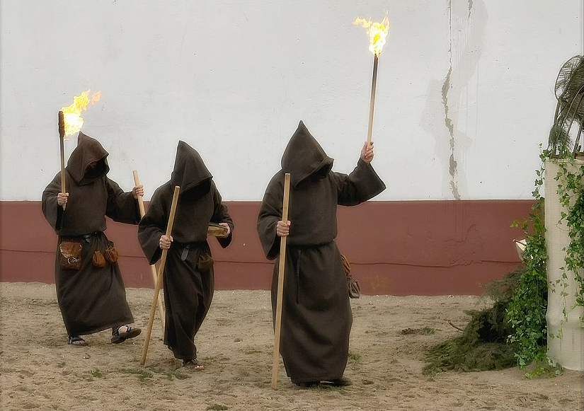

Figure 4: Ritual at the Midwinterfair, fantasy and gothic festival, in historical theme park Archeon. (2004, J.J. van der Wees)
This work is not the first to point to the relationship between RPGs and ritual. By anti-RPG communities, such as Bothered About D&D, role-playing is represented as a ritual satanic activity: “We are concerned with violent forms of entertainment such as: violent –occult-related rock music, role-playing games that utilize occult mythology and the worship of occult gods in role playing situations like Dungeons & Dragons […]” [22] In these discourses (fantasy) RPGs function as a scapegoat, as there seems to be no real connection between RPGs and Satanism. Although in fantasy role-playing magic and ritual are very influential on the level of content. From a game theoretical perspective, authors such as Daniel Mackay, Torill Mortensen, Martin Ericsson, and Christopher Lehrich link role-play and ritual performance together.

Mackay defines RPGs as imaginary-entertainment environments wherein players move through various porous spheres (drama, script, theatre and performance), which are domains of the ritual sphere of role-playing. [5] Lehrich argues in his article “Ritual Discourse in RPGs” (2004), published in The Forge: “[…] classical and recent tools of ritual analysis apply fully to RPGs, for analytical purposes, for making sense of RPGs as something other than an entirely isolated hobby, indeed for seeing RPGs as a human cultural product not particularly distinctive to modern society.” [23] He presents different theories of ritual which might be helpful in analyzing RPGs. Anthropologists Victor Turner and Ronald Grimes define ritual as performance, referring to the total involvement or immersion in a ritual activity. This will produce an effect within the social and mental worlds of the participants thus also having an effect in non-ritual activities. Two other approaches of ritual are those of Claude Lévi-Strauss and Pierre Bourdieu. Lévi-Strauss argues for an interpretation of myth and ritual which he calles bricolage. Every participant of a mythic culture acts as a bricoleur, acquiring signs and objects from across cultures to create ritual and cultural identities. Bourdieu’s practice theory supplements the idea of bricolage, arguing for continuity between behaviors, against the separation of ritual from daily life. Mackay, Mortensen, and Ericsson draw heavily from the work of Richard Schechner, founder of the Performance Studies Department at New York University. Schechner has written extensively on performance and ritual and states that anything can be studied as performance. [24] Thereby extending his ideas of performance far beyond the theatre. Considering these theoretical links between role-play and ritual performance, how can we critically understand Huizinga’s bold statement, “ritual is play and play is ritual”? Can ideas from ritual theory and performance studies help to understand play and specifically the relationship between fantasy subculture, RPGs, and the daily life of their participants?

The Ritual of Role-Playing
Ericsson presents an interesting example of how to use ritual theory and performance studies to understand LARP in his article “Play to Love” (Kuntepunkt book, 2003). “For many years my mental picture of what role-playing is all about has been heavily influenced by models linking ritual behavior, human creativity and social transformation.” [25] Just like the work of Mackay on table-top RPGs, Ericssons analysis of what he calls “the ritual of role-playing” is mainly based on Turner’s concept of liminal space and Arnold van Gennep’s model of rites of passage. Van Gennep identifies three crucial stages in each rite of passage: first the separation, which involves the removal of the individual from his or her former status; second, the rite of marginality or liminality, which is a period of transition involving specific rituals, and often suspension from normal social contact; and third, the rite of aggregation, which is the readmission into society in the newly acquired status.
Ericsson argues for an analogy or fundamental similarity between LARP and the liminal rite. He describes the separation phase psychologically (character creation) and materially (preparation of the game area, props and costumes). “Many players find great enjoyment in this first step of the journey between worlds.” [25] The LARP event itself is characterized by a ritual in between-ness Turner refers to as liminality. The part of return or aggregation is difficult: “Role-players are notoriously bad at letting their liminoid experiences change them, or at least admitting to have changed them.” [25] Importantly, Ericsson notes that the function and meaning of ritual liminality is very different than LARP liminality. Mortensen notes the same for MUD’s: “The role-playing as play maintains the knowledge of playfulness, and a frequent reminder in online role-playing games is “Chill this is just a game” as opposed to considering it more real and truthful, somehow superior to ordinary experience [role-playing as a sacred rite, a part of a drama, or even a comedy].” [26] Therefore, Ericsson also refers to Turner’s concept of liminoid forms, meaning; all arts and entertainments that have risen from ritual liminal practices, to describe LARP. [26] He realizes that Van Gennep’s rites of passage model cannot be completely used as a pattern to understand LARP.
Ericsson’s argumentation points us to some problems in looking for the relationships between play and ritual and, specifically, role-play and ritual performance. First of all, passage rites are a specific type of ritual. They are transition rituals, characterized by an often linear moving in and out of the liminal space. It is a process in which the participants are undergoing ritual or even spiritual change. Secondly, liminality is, just as the magic circle, often represented as a space with utopian qualities. It is said to be a structure inverse to that of everyday life (Turner calls this an anti-structure). According to Ericsson, it is a field of play where boundaries of normal behavior and thinking are extended or even dissolved. Within it, communitas can be created, meaning “[…] the experience of moving beyond and outside our prison-selves, of choosing to believe in a dream together, and in doing so suddenly seeing each other not as targets of transactions to benefit our ambitions, but as part of an Essential We, as part of communitas. [25] Applying the rites of passage model to role-playing suffers from the same problem as every model we apply to something else than it was originally designed for. Inherent to this type of analysis is the risk of losing the specific characteristics of a cultural phenomenon and/or of adding qualities which might not be there. Nevertheless, ritual theory and performance studies can be useful when studying RPGs and role-play.
Referring back to Huizinga, one cannot simply say that role-play is ritual, for there are many different types of sacred and profane ritual. Instead of describing fantasy role-play as a certain type of ritual, I would argue that role-playing is not one ritual or performance. Role-playing consists of collections performances or ritual acts. Some of these acts have similar formal characteristics as other ritual structures, such as rites of passage. But they do not necessarily have the same meaning or formal structure as, for instance, a complete transition ritual. In discussing the game/play space, I propose to deviate from Huizinga’s focus on the characteristics of the space itself in order to focus more on the process of constructing the space by using the concept of ritual acts.

CONNECTING WORLDS
In my PhD dissertation, I have used the concept of collections of performances or ritual acts to conduct ethnographic research and to analyze my material on analog (table-top and live action), digital RPGs (MMORPGs) and the Dutch Elf Fantasy Fair. Perceiving role-play as ritual acts underlines the argumentation that games have to be played (acted out or performed) in order to be able to analyze them fully. Therefore I have used various non-playing as well as playing methods to collect research material. [28] I have gathered data on the Elf Fantasy Fair by (participant) observations, questionnaires and interviews. I have also been playing table-top RPGs, LARP and MMORPGs extensively (self-play), and I have been involved in various Dutch fantasy and role-play communities.
Examples of my case studies are the “neo-Celtic pagan folk” band Omnia, which performed almost every year at the Elf Fantasy Fair. Fantasy role-playing, like D&D, is an important part of the forming of Omnia and the (pagan) lifestyle of their band members. I have also studied Dutch fantasy LARP organizations such as Vortex Adventures, Cauldron, and Lands in Exile, as well asthe games they designed. The focus of my research on online RPGs has been on role-playing in the games Neverwinter Nights and World of Warcraft.
The concept of ritual acts enables me to define the various collections of performances (forms of behavior) of role-players and the relationship between role-playing games, fantasy subculture and the daily life of their participants. Originally I started off by thinking of this process as taking place “between worlds”. While writing this article I have renamed it “connecting worlds”. Role-players not only role-play in role-playing games but also during events such as the Elf Fantasy Fair and in daily life. By doing this players construct, as Huizinga called it, temporary worlds. One of the most important ritual acts of role-players is bricolage. In role-playing games, but also during their daily life, players are constantly constructing intertextual relationships between imaginary fantasy worlds, history, religion, experiences from daily life, etc. Within this often very transparent act, they are not only constructing and connecting worlds or spaces, but also identities and meaning. In my work I analyze various the ritual acts of role-players; the meanings of which can range from mere playfulness to serious incorporation of the role-play experience. As Huizinga already noted: “In play we may move below the level of the serious, as the child does; but we can also move above it – in the realm of the beautiful and the sacred.” [4] Both types of acts are part of their role-play experience as well as of their daily lives. As Schechner argues: “More and more people experience their life as connected series of performances […]”. [24]
To conclude, I would like to underline the importance of analyzing games in relation to their players, the activity of playing, and cultural contexts. Both play an important role in the construction of the game/play space. This also means that in analyzing games we have to draw from approaches of a variety of disciplines. As I have shown, the concept of ritual acts or collections of performances can be useful in understanding the game/play space of role-playing. In understanding the game/play space of all sorts of games, I propose to leave the boundaries of the magic circle behind us and shift the focus to the construction of the game/play space and therefore to the players and their activities of play and performance.

REFERENCES
- Bie, T. de, “Playing in the Rain: A Dutch Fantasy Fair” (2001). Available at: http://www.rpgconsortium.com/articles/article.cfm?id=272
- Tolkien’s The Lord of the Rings became immensely popular with American students in the 1960s after an illegal copy of the book was printed.
- http://www.elffantasy.nl/
- Huizinga, J., Homo Ludens. The Beacon Press, Boston, 1955.
- Mackay, D., The Fantasy Role-Playing Game. A New Performing Art. Mc Farland and Company, North Carolina, 2001.
- Cook, M., J. Tweet, S. Williams, Dungeons and Dragons Players Handbook. Wizards of the Coast, Renton, 2000.
- Adams, R. “The Colossal Cave Adventure page”. Available at: http://www.rickadams.org/adventure/a_history.html
- Bartle, R., “Early MUD History” (1990). Available at: http://www.mud.co.uk/richard/mudhist.htm
- This research was conducted together with Dr. Martin Ramstedt, Meertens Institute Amsterdam.
- According to Elf Fantasy BV. At the moment the fantasy subculture in the Netherlands is experiencing a period of growth and professionalization. In 2001 the Elf Fantasy Fair was the only fantasy event. While in 2005 there are at least seven other fantasy/ gothic events organized throughout the year. More fantasy shops, like Elf Fantasy, are popping up everywhere on the Internet and in the streets, selling everything from RPGs, fantasy novels to neo-pagan paraphernalia. Specialized LARP shops are opened up, making a profit by selling clothing, armor, honey wine etcetera. And LARP groups like Cauldron are trying to run their business as a commercial organization.
- Figures from the 2005 questionnaire are not available yet.
- Boersma, J., “Levend rollenspel: beleef het avontuur!”, Elf Fantasy Magazine (2005). We can compare this number to the rough estimation of the number of LARPers in the Nordic countries: Sweden (10.000), Denmark (5.000), Finland (3.000), Norway (2.000). Fatland, E., “Knutepunkt and Nordic Live Role-Playing: A crash Course,” in Bockman, P., R. Hutchison ed., Dissecting larp, Oslo, 2005.
- Clute, J., J. Grant, The Encyclopedia of Fantasy, St. Martin’s Press, New York, 1998.
- RPGnet is available at: http://www.rpg.net/ and The Forge is available at: http://www.indie-rpgs.com/. Most articles are also collected by John H. Kim at: http://www.darkshire.net/~jhkim/rpg/theory/
- Gade, M., Thorop, L., Sander, M., As Larp Grows Up – Theory and Methods in Larp, Bookpartner, Denmark 2003.; Montana, M., Stenros, J., Beyond Role and Play. Tools, toys and theory for harnessing the imagination, Finland, 2004.; Bockman, P., R. Hutchison ed., Dissecting larp, Oslo, 2005.
- Juul, J., Half Real. Video games between real rules and fictional worlds, PhD dissertation IT University of Copenhagen, 2003
- Frasca, G., “Ludology meets Narratology. Similitude and differences between (video)games and narrative.” (1999). Available at: http://www.ludology.org/articles/ludology.htm
- Salen, S, E. Zimmerman, Rules of Play. Game Design Fundamentals, MIT Press, Massachusetts, 2004.
- Sniderman, S., “Unwritten Rules”, in The life of games (1999). Available at: http://www.gamepuzzles.com/tlog/tlog2.htm
- ‘Has the circle gone rusty”, Discussion Gamesnetworklist (September 2004).
- Salen, K., E. Zimmerman, “This is not a game: play in cultural environments,” in Copier, M, J. Raessens, Level Up. Digital games research conference, Utrecht, 2003.
- This citation from Bothered About D&D is available at : http://www.holysmoke.org/wb/wb0017.htm other links between violence, Satanism and RPGs: http://www.theescapist.com/faq_encyclopedia.htm
- Lehrich, R., “Ritual Discourse in RPGs,” in The Forge (2004). Available at: http://www.indie-rpgs.com/_articles/ritual_discourse_in_RPGs.html
- Schechner, R., Peformance Studies. An introduction, Routledge, London, 2002.
- Ericsson, M., “Play to Love,” in Gade, M., Thorop, L., Sander, M., As Larp Grows Up – Theory and Methods in Larp, Bookpartner, Denmark 2003.
- Mortensen, T., Pleasures of the Player; Flow and control in online games, Doctoral Dissertation Volda College and University of Bergen (2003).
- Schechner, R., The Future of Ritual. Writings on culture and performance, Routledge, London, 1993.
- Aarseth, E., “Playing Research: Methodological approaches to game analysis.” (Melbourne DAC 2003). Available at: http://hypertext.rmit.edu.au/dac/papers/Aarseth.pdf

