The Play’s the Thing: Practicing Play as Community Foundation and Design Technique

Tracy Fullerton
Visiting Assistant Professor
Co-Director Electronic Arts Game Innovation Lab
University of Southern California
School of Cinema-Television
Interactive Media Division
Los Angeles, CA 90089
tfullerton@cinema.usc.edu

ABSTRACT
Earth balls, parachutes, word plays, provocative magic ... This session is a discussion of the USC Game Design Community, an attempt to encourage inter-disciplinary game design and research through community play experiments. The USC Game Design Community is a cross-departmental student group responsible for initiating a series of social play experiments designed to bring students and researchers from various schools of the University together. The play experiments of the previous year culminated in a game innovation research grant offered to an inter-disciplinary student team and a test of our overall assumption that playing together can provide disparate groups with common vocabulary, social relationships and collaboratively generated design concepts.

Keywords
Game play, design, community, social games, new games, innovation.

Introduction
Game development is an intensely collaborative art; requiring and benefiting from the talents of individuals from disperse disciplines and backgrounds. In a professional setting, these individuals may or may not find ways to communicate effectively, depending on the size of the team and the strength of its leadership. In the end, they are generally employed under the assumption that they can and will find their way amongst those of differing educations and biases to some sort of collaborative effort, harmonious or not. If they can not do this in the end, they can always be replaced. Thus the basic nature of cross-disciplinary trial and error in a business setting is quite brutal: those who can play well with others, stay; those who cannot, move on.

This rather haphazard approach to collaborative practice may have worked to date, but as game development becomes more complex, specialized and requiring of larger teams, and as the creative questions we wish to ask in regards to games veer away from their technical aspects and more towards the player experience, the issue of how to train a new generation of developers, not only in their own specializations, but in cross-disciplinary teamwork seems more important than ever.

At the University of Southern California, as at a number of other universities, there are several initiatives underway in regards to this question. The Schools of Cinema-Television and Engineering are working closely together to develop games-related curriculum that brings our students together in co-created classes so that they can benefit and learn from each other’s skills.

Integrated curriculum, however, is only one way in which students and researchers from the various disciplines involved in game studies may come together. An equally important initiative is one that focuses on how to create an extracurricular community that can cross-pollinate all of the various divisions and schools and lay the foundation for successful communication amongst
multi-talented teams that all speak and play the same language of game design. This initiative is called the USC Game Design Community.

USC Game Design Community
The goal of the Game Design Community is to use game play itself as a community building tool and design practice, to build a population of game designers and developers at the University who communicate in the shared language of activity and play. Inspired by independent and alternative games culture, the USC Game Design Community is a collaboration between the Institute for Multimedia Literacy at the Annenberg Center for Communication and the Interactive Media Division at the USC School of Cinema-Television. Monthly game play events alternate between the Institute for Multimedia Literacy and the Game Innovation Lab at the School of Cinema-Television. These events include experimental play projects, game critique salons, and social teambuilding exercises.

Through these interactions, the IML and the Interactive Media Division hope to raise cross-disciplinary dialogue, build a community based in playful practice, and empower students and researchers from all areas of game expertise to expand the palette of game design for the future. The results of these community building efforts will be measured by the success of a series of interdisciplinary game projects funded by the Interactive Media Division and supported by the Game Design Community.

The past year has included the following game play events which have each been informally evaluated by the community as to their success in building relationships and creating shared practices between various disciplines:

Cooperative Game Play Experiment
Inspired by the New Games Movement of the 1970’s, the Cooperative Game Play Experiment began as a training event and single day of play and has since spawned a 3-day workshop and a sequel play day because of its popularity within the community. By far the most successful of our play experiments, this example has several interesting aspects that we believe were critical for its popularity:

- Bernie DeKoven: The training day and a subsequent workshop were lead by Bernie DeKoven, author of The Well-Played Game and Junkyard Sports. Bernie not only brought his unique experience and perspective to the group, but assisted students in defining their own social and political aspirations for the play community as a whole [3]. The workshop spurred discussions among artists, engineers and social researchers as to the potential of play to effect political change and a micro and macro level.
- No technology: The experiment required no technology and was played out of doors, focusing instead on games that have social interaction at their core. Because of this, the goals of creating social bonds between people of various skill sets were accomplished quite easily.
- Motto: By adopting the motto of the original New Games Movement for the experiment, “Play hard, play fair, nobody hurt” the experiment brought ideological issues to the forefront of the discussion – not only on the day of the event, but every day that the participants wore their T-shirts after the event [1]. Several months later, participants will still spontaneously begin discussing the cooperative games and the concepts behind them if they run into another person wearing the T-shirt. (Who knew something as simple as a T-shirt would be such a community-builder?)

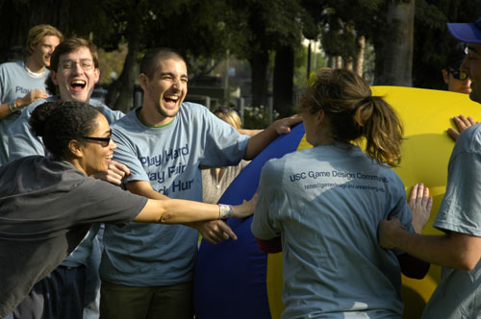

Figure 1: A spirited Earth Ball game at the USC New Games Day. (Photo by Kurt MacDonald)

By holding more cooperative play events the community hopes to keep this important discussion open and improve the meta-discourse regarding the social mechanisms of digital games and how they can be improved for more quality social interaction – for both players and development teams.

Surrealist Game Play Experiment
Another event inspired by a previous moment, the Surrealist Game Play Experiment is an ongoing investigation into unlocking creativity and introducing playful practice into the game design process. Word games, visual plays and re-inventions are the heart of Surrealist games and activities, a sort of “provocative magic” that results in unexpected and surprising results [2]. By playing these games, the community hopes to spur creative thinking and discussion about the nature and practice of art and design and its relation to the more technical aspects of game design.

Following the New Games Day, this was next in popularity among our experiments. The reasons behind its success include:

- Simplicity: The Surrealist games have a very small learning curve. Not only are the original games easy and quick to learn for participants of any skill set. There were some humorous moments in the first event when a computer science student was not comfortable with the lack of a “win scenario” in one of the games, but this only spurred a lively conversation on the nature of game objectives, rather than causing disunity.
- Dialogue: The fact that many of the Surrealist games encourage conversation about the results of play is one of the primary reasons for this event’s success. The social nature of the play and the visual, verbal and cultural collisions that occur in these games are reflective of the interactions we are trying to create between the communities involved.
- Applicability: Several participants were able to draw immediate correlations between the creative process of playing and making Surrealist games and their own work. Several spur-of-the-moment games have gone on to further iteration since the event.

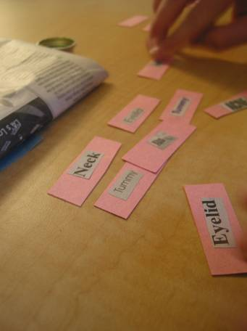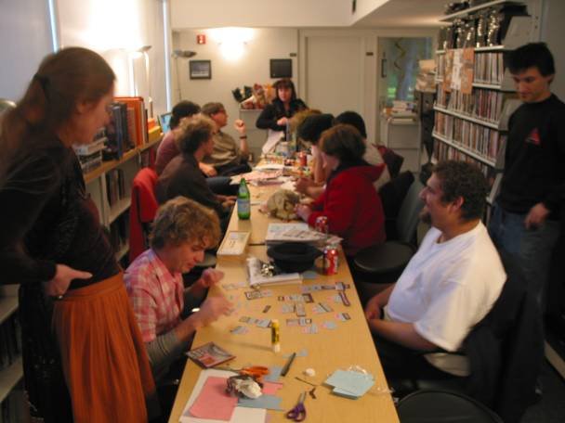

Figures 2 and 2a: Making and playing games using Surrealist techniques. (Photos by Tracy Fullerton)

Game Salons
In an effort to promote literacy and critical thinking, the Game Salons are regular screenings and “deconstruction” of influential new video games. Game features are presented by student teams who have developed extensive save files and are prepared to discuss the game critically. Games have included Grand Theft Auto: San Andreas, Half-Life 2 and World of Warcraft.

This experiment is the only event that is not open to the entire Game Design Community (due to space constraints). The event is structured as a presentation by a team of hand-selected students to a group of invited guests from the games industry. The students are responsible for creating a comprehensive and compelling analysis of the game that will lead to a lively discussion. While these events have been quite well received, and are very well-attended by the invitees, they have produced some mixed results in terms of community building:

- Relationships: These events have been extremely success from an industry relationship point of view. The presenting team has the opportunity to meet and talk with key industry people in a very focused and intimate setting. The presenting teams are usually cross-disciplinary, so there are relationships reinforced at that level. However, since the events are not open to the entire community, they do not tend to strengthen internal relationships as much as they do external relationships.
- Applicability: Because the events are focused on existing commercial games, rather than on the creation of new ideas, or building teams, the results are not as directly applicable as the previous experiments.

The overall sense of the Game Salons is that they are a great success for bringing industry people to campus to interact with a limited number of students in a very focused dialogue, but that in terms of community building, some tweaks to their structure might be necessary.

Game Competitions
The Game Design Community has put on several game competitions as community-building events. The first two events were internal to USC – students played multi-player games, but in a face-to-face setting. The most recent event was an online competition between Carnegie Mellon and USC.

The event consisted of five games, chosen to appeal to a variety of players: Literati, Burnout 3, Carcassonne, Set and Halo 2. Our most technically challenging event, the competition required a number of online computers, Xbox’s with Live accounts, headsets, a plan for matchmaking and reporting scores and real-time coordination between USC and CMU to make sure the competition was fair and fun.

The event, which CMU won 4-1, was very popular on both sides. It inspired some intense moments of game play and rivalry. In order to make sure that more than just a couple players participated on each side, the rules stated that observers could recommend moves, but that no online dictionaries (for Literati) or other computational aids were allowed. Also, trash talking was not allowed. First offense incurred a warning; second offense penalty was the loss of the current game. (As a note, this rule was never invoked.)

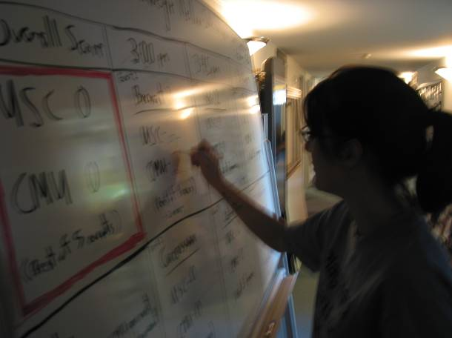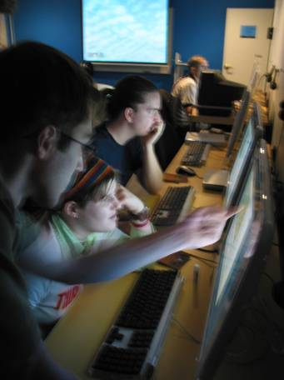

Figure 3 and 3a: USC vs. CMU Intercollegiate Game Challenge: best of 5 online games.

Much of the learning for this particular experiment involved the event coordination, but several very important lessons regarding the community also arose:

- Meeting and greeting: The community effect on each side was quite positive, however, the USC and CMU students didn’t have a good sense of each other. Post-event ideas generated for mitigating rivalry, while at the same time making the competition more meaningful, were to set up a video conference call so that each school could see the players at the other location.
- Rivalry: Since all of the games involved USC vs. CMU, as opposed to mixed teams, rivalry was inevitable. Post-event ideas for this involved having students form balanced teams with the other university prior to the event.
- Follow-up: Unlike a physically located event, the members of each side could not spend the post-event time together creating ties, talking about the play, etc. While this happened locally, it could not happen with our competitors, which would have been chance to extend the play community beyond the USC borders. Some sort of follow up event for players (perhaps at the Game Developer’s Conference) was suggested, but did not occur because not all the participants could attend the GDC.
All in all, the game competitions, internal and with CMU have proved to be very well attended and very successful at bringing new participants to the community. While there are some issues in how to extend them to online events, they have proven to us that competitive as well as cooperative and creative events are an important part of building our play community.

Game Innovation Lab Research Grant
The culmination of these experiments is an interdisciplinary grant offered by the Interactive Media Division to provide funding for innovative games. The grant was announced at a community event, held specifically for the purpose of networking and team-building across University departments. Additionally, the community provided an online talent list for teams seeking talent or vice versa.

The grant has been awarded twice since its inception. Submissions were judged equally on the quality their game concepts and the strength of the proposed team. Teams receive up to $20,000, a team office and equipment in the EA Game Innovation Lab, access to the lab’s usability testing facility and a faculty advisor/executive producer. All USC students are eligible to participate.

The goals of the grant are to:
- Innovation & Research: Provide funding and support for innovative student game projects that address interesting design problems or areas of research,
- Collaboration: Extend the community of play into a working cross disciplinary collaboration.
- Learning: Find out the gating issues in knowledge and skills that exist for the creation of excellent student games so that these may be addressed in our joint curriculum with other departments of the Univeristy.

Projects funded under the Game Innovation Grant are:

Dyadin – Cooperative Game Play
This project explores the potential of cooperative play mechanics in a 2-player adventure game. The story of Dyadin involves two overlapping worlds, and two characters occupying these worlds, but only able to affect objects in their own space. The core mechanic involves moving closer or farther away from the other character to change color and affect objects in the space. Players must cooperate or they cannot escape the puzzle and combat based levels.

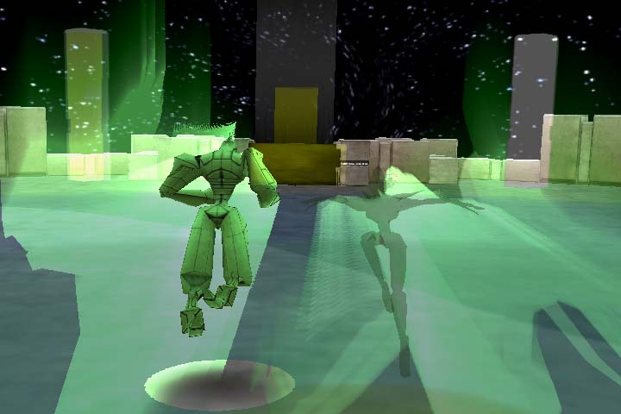

Figure 4: Dyadin, a cooperative action puzzle produced collaboratively by Interactive Media and Computer Science students.

Dyadin was the first game funded by the Game Innovation Grant, and has a crew made up of students from the School of Cinema-TV Interactive Media Division and the Viterbi School of Engineering. This game was showcased at the 2005 Game Developers Conference as a student winner in the Independent Game Festival.

Cloud – Experimental Core Mechanic
Cloud is the second game funded by the grant, and its team is also made up of students from the School of Cinema-Television and the Viterbi School of Engineering. This game concept pushes the envelope play. In Cloud, the player can fly up in the clouds and change their shapes, gathering clouds and building cloud formations. This simple, fantasy mechanic evokes our daydreams as children, wishing we could fly up into the clouds and play. For the development team, Cloud is a rich area of exploration into emergent environments and innovative design.

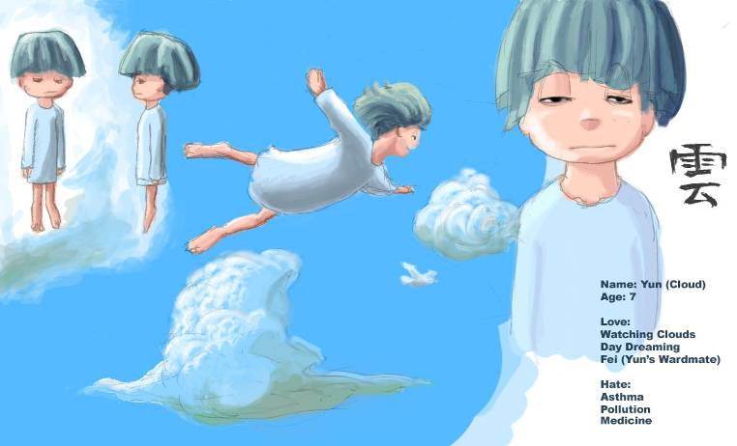

Figure 5: Cloud, an experimental mechanic involving complex emergent cloud formations and fantasy play.

Conclusion
The Game Design Community is a fairly new group, with just over a year of events and organization from which to draw conclusions. Overall, we are pleased with the relationships that have formed through our events, and the level of interaction between departments that we have seen. However, we are actively searching for new ideas and new types of events to improve our community, while we continue to offer versions of the events that have best articulated our goals.

The success of the Game Innovation Grant teams and future cross-disciplinary game and research teams at USC will be a measure of our core philosophy that play can build a solid foundation for working together. Our hope is that this playful practice will be something that our students carry with them as they go on to work professionally, building their own communities of play and collaboration, and broadening the perspectives of the next generation games industry.

REFERENCES
1. Brand, S. New Games Book. Headlands Press, San Francisco CA, 1976.
2. Brotchie, A., and Gooding, M. (eds.). A Book of Surrealist Games. Redstone Press, London, 1991.
3. DeKoven, B.. The Well-Played Game. Writers Club Press, Lincoln NE, 2002.

