A Landscape-Level Assessment of Restoration Resource Allocation for the Eastern Monarch Butterfly
Rodrigo Solis-Sosa^{1*}, Arne Mooers², Maxim Larrivee³, Sean Cox¹, Christina Semeniuk⁴
¹School of Resource and Environmental Management, Simon Fraser University, British Columbia, Canada
²Biological Sciences, Simon Fraser University, British Columbia, Canada
³Insectarium de Montréal, Montréal, Québec, Canada
⁴Great Lakes Institute for Environmental Research, University of Windsor, Ontario, Canada
* Correspondence:
Corresponding Author
rsolis@sfu.ca

Appendix 2 – Sensitivity analysis of temperature-dependent variables

Since the MOBU-SDM is a tightly dependent model on ambient temperature, we made a sensitivity analysis of how changes in mean temperature across the Breeding grounds would change two critical parameters in the model, intergeneration time and the number of reproducing adults. The results in this appendix give essential insights into the importance of considering these dynamic relations under the light of climate change.
For the analysis, we independently increased and decreased the mean temperature across each of the Breeding regions from 0 to 10 °C in 0.5°C intervals. We used a stable version of the model with a 10-year duration and all dynamic variables fixed to their 2019 values, e.g. temperature, precipitation, sex ratio, PDI.
We extracted the resulting daily values of the intergeneration time and number of reproducing adults for each region between April and September for each year, representing the breeding season. Then, we calculated the mean value of those values per month and plotted them (Figure 1 and Figure 2). Also, we calculated the relative productivity, estimated by the number of reproductive adults, for each breeding month and region (Figure 3)
As expected, our results showed that thanks to the Monarch’s growth °D dependence (Zalucki, 1982), intergenerational time will increase with lower temperatures and decrease with higher ones. However, the known heat impairment threshold (Rawlins & Lederhouse, 1981; Zalucki, 1982) and developmental zero (Zalucki, 1982) set boundaries to this relation, making it plummet down to zero when exceeding a specific limit.
The multiple interactions and feedback loops feeding into the number of reproductive adults show a more complicated behaviour for this variable. The Breeding season is lasting longer in the South than in the Central or North region. However, with increasing temperatures, the breeding season’s length in the Central and North regions increases due to an earlier arrival of south migrants in the Central region and a later departure from both regions. Also, it is noticeable that productivity decreases in the South Region, increases slightly in the Central, and considerably in the North Region.
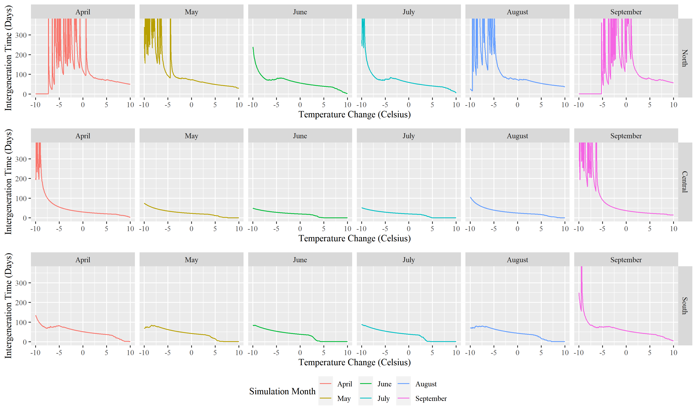
Figure 1Effect of temperature over intergeneration time across the breeding regions. The spikes on the left side of some graphs are artifacts due to the averaging of daily temperatures. This artifact results from some of the months crossing the lower temperature threshold and dropping to zero, drastically lowering the mean value.
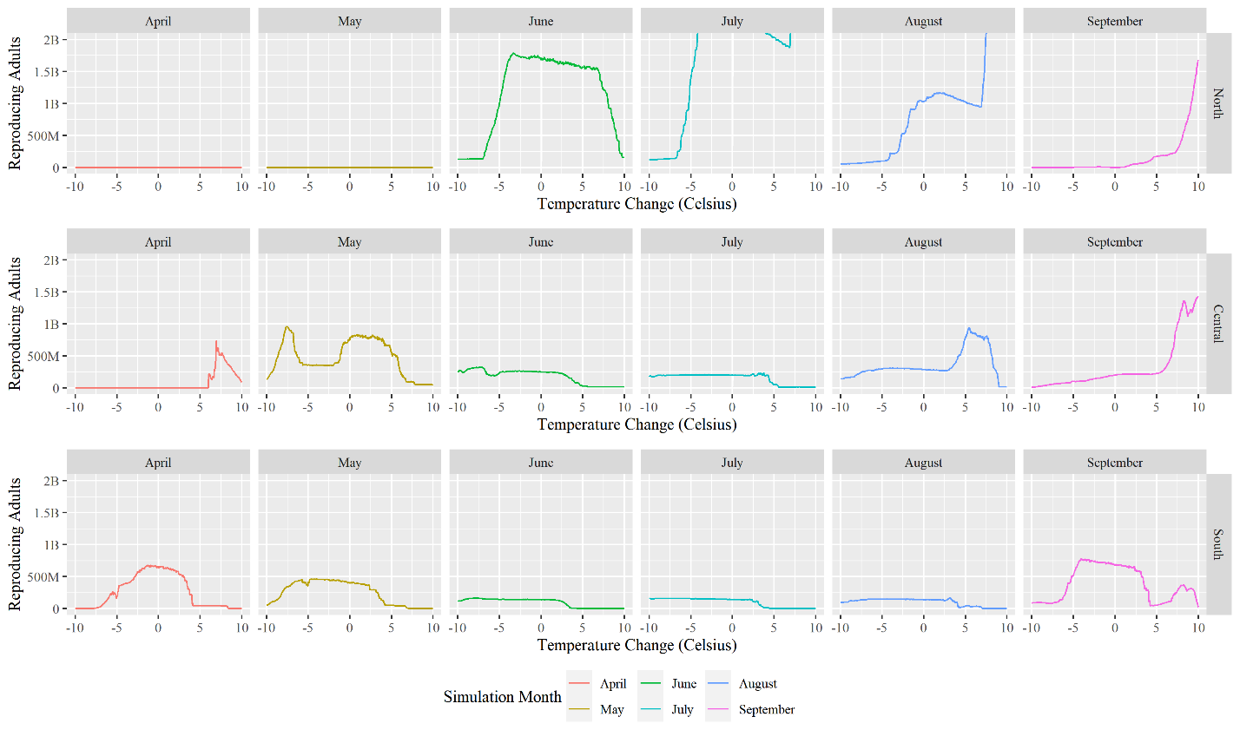
Figure 2 Effect of temperature in the number of reproductive adults across the breeding regions

- 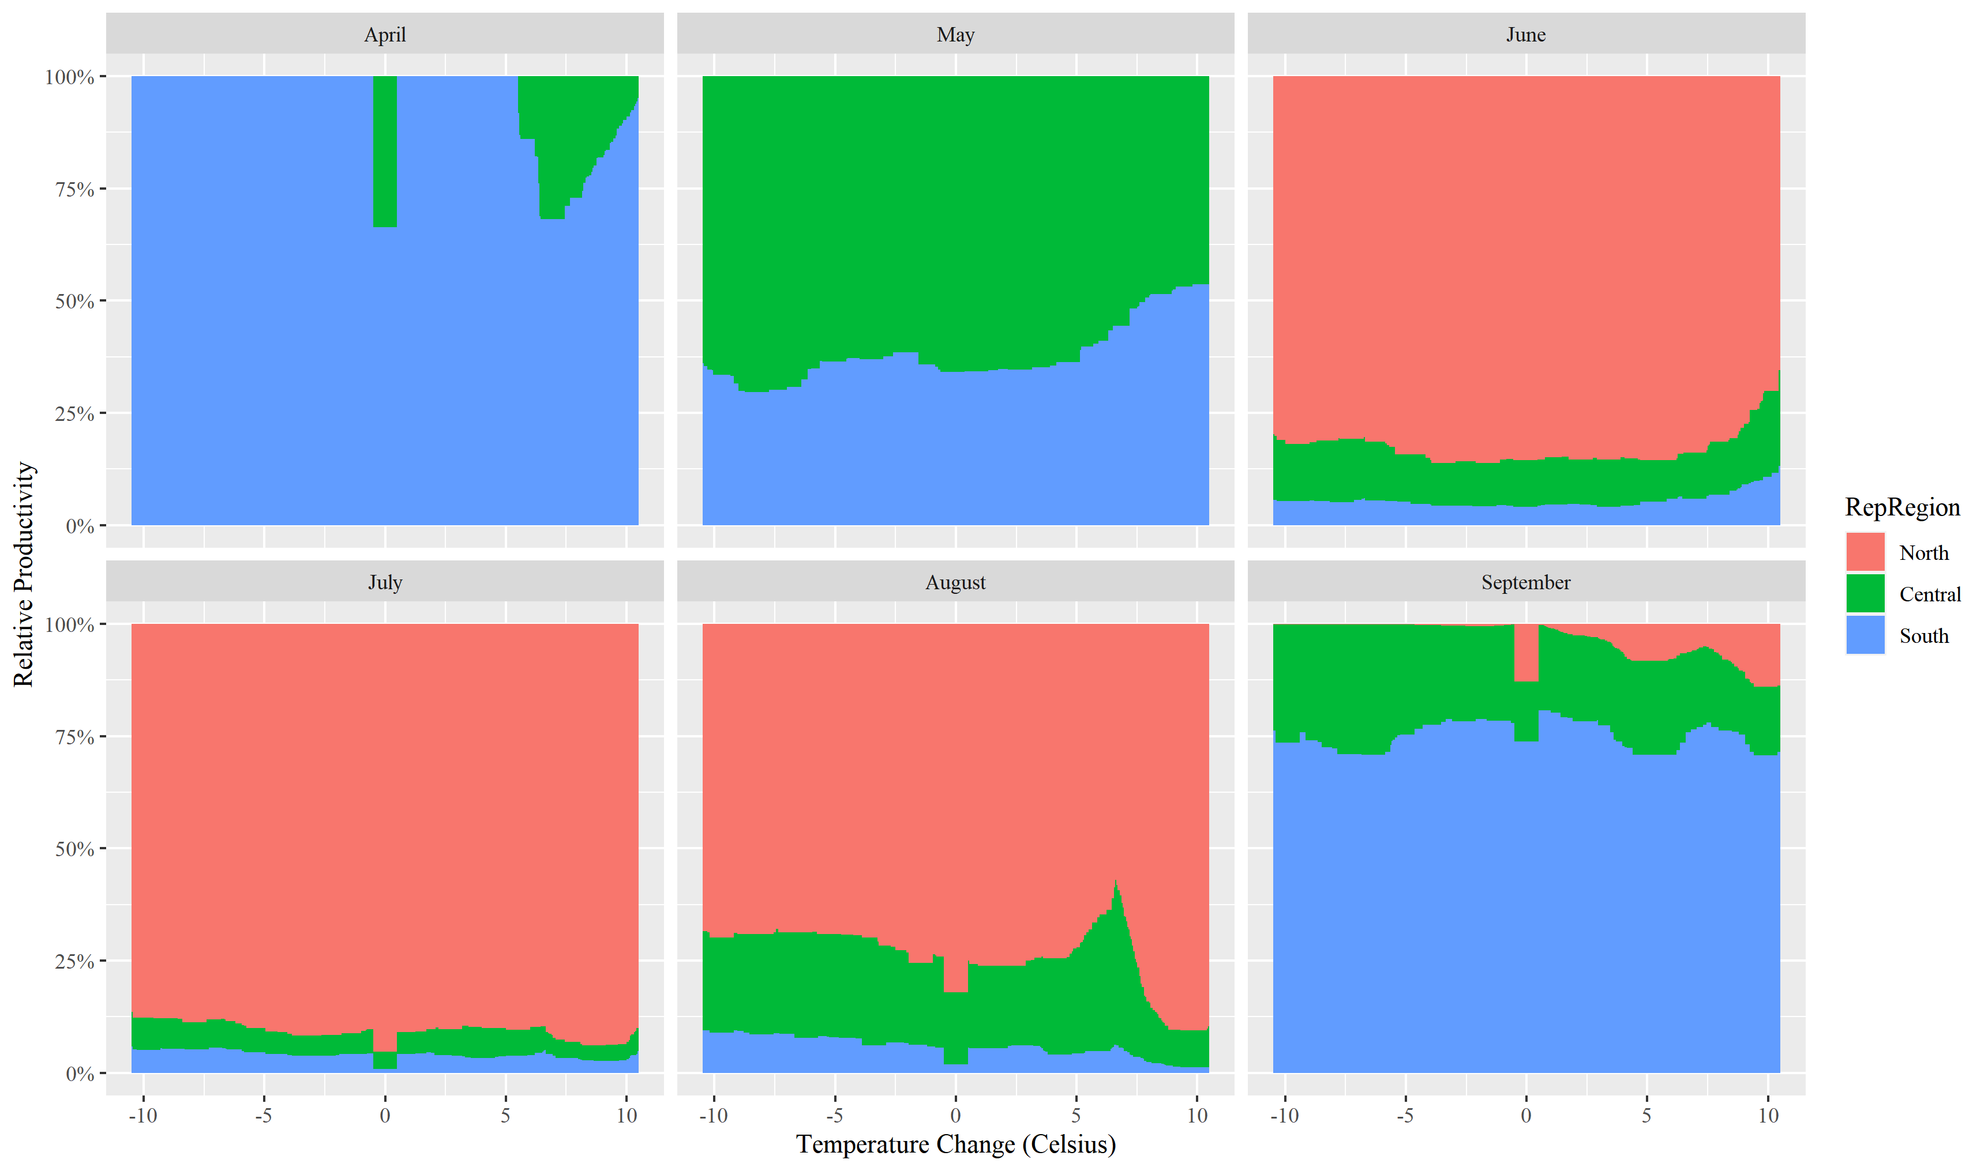
Figure 3 Relative region productivity measured by the number of reproductive adults per month and region.
- REFERENCES
Rawlins, J. E. & Lederhouse, R. C. (1981). Developmental influences of thermal behavior on monarch caterpillars (Danaus plexippus): an adaptation for migration (Lepidoptera: Nymphalidae: Danainae). Journal of the Kansas Entomological Society, 387–408.
Zalucki, M. P. (1982). Temperature and rate of development in Danaus plexippus L. and D. chrysippus L.(Lepidoptera: Nymphalidae). Australian Journal of Entomology, 21(4), 241–246.

