**A Landscape-Level Assessment of Restoration Resource Allocation for the Eastern Monarch Butterfly**

**Rodrigo Solis-Sosa1*, Arne Mooers2, Maxim Larrivee3, Sean Cox1, Christina Semeniuk4**

1School of Resource and Environmental Management, Simon Fraser University, British Columbia, Canada

2Biological Sciences, Simon Fraser University, British Columbia, Canada

3Insectarium de Montréal, Montréal, Québec, Canada

4Great Lakes Institute for Environmental Research, University of Windsor, Ontario, Canada

**\* Correspondence:**Corresponding Author  
[rsolis@sfu.ca](mailto:rsolis@sfu.ca)

**Appendix 1 - TRACE DOCUMENTATION**

# Problem Formulation

## Section summary

The Monarch butterfly's sudden and dramatic decline over the last two decades demands updating the Monarch's management strategies with a deeper understanding of the multiple factors and interactions that may affect the Monarch's migratory cycle's level of success.

Two interrelated questions motivated the design of the MOBU-SDyM: 1) is the allocation of milkweed restoration efforts across the breeding areas adequate? 2) What is the effect of considering available versus total milkweed stems in the setting of habitat restoration strategies?. Also, this model can serve as a decision-making aid tool to set goals and priorities for the conservation of the Monarch butterfly

1.1. Section summary 1

1.2. Problem Formulation 3

1.3. Requirements and Outputs 3

## Problem Formulation

The Monarch butterfly, an iconic species with populations that migrate annually across North America, has steeply declined in numbers over the past decade (Rendón-Salinas et al., 2019). Currently, the most studied and supported cause of the Monarch’s plight is the milkweed-limiting hypothesis (Pleasants & Oberhauser, 2012), although recent evidence suggests that this might not be the only contributing factor (Sarkar, 2017). This hypothesis states that milkweed loss across the Monarch’s breeding range due to GMO-specific herbicides has been the most crucial driver of decline. In tandem with the milkweed-limiting hypothesis, most of the research and conservation efforts for the Monarch have focused on the “US corn belt”: considerable evidence points to this region as the one the most affected by the advent of GMO crops and the use of glyphosate, drastically reducing the Monarch’s habitat in that region (Pleasants & Oberhauser, 2012).

However, even though the Monarch is one of the best-studied insects, knowledge gaps exist that may hinder conservation efforts. Some such unknowns are even a matter of active debate amongst experts in the field, such as the role of fall migration mortality, comprised of hurricanes, roadkills, insecticide use, and tropical milkweed. Moreover, researchers have taken risky assumptions to fill some of those knowledge gaps that may play a critical role within the system. More specifically, it is common practice to assume that milkweed availability is only affected by anthropogenic causes. Still, it is common knowledge that plant growth depends on temperature and soil moisture, which would make milkweed availability variable throughout the season, and across different years.

Even though there is a considerable amount of research regarding the Monarch’s biology and its life history, there are still crucial biological parameters that could improve the realism of modelling efforts such as depensatory effects, changes in sex ratio, oviposition potential affected by habitat patch configuration, and temperature-dependent development time. In the latter, temperature directly affects Monarch development time and, in theory, at high or low temperatures, a Monarch could take as many as 30 days or as few as ten days to reach maturity, respectively (M. P. Zalucki, 1982). Constant warm temperatures could lead to a whole extra generation of butterflies within the yearly cycle, which, for a species with such reproductive potential as the Monarch, would entail population changes of multiple orders of magnitude (Altermatt, 2010).

Yet, most models assume the Monarch's development time is constant and unaltered by regional temperature oscillations. This element becomes particularly relevant in the light of climate change. The flexibility inherent to the Systems Dynamics modelling framework (Forrester, 1989), along with a particle filtering Bayesian inference approach (Tulsyan, Gopaluni, & Khare, 2016), allowed us the inclusion of all the elements listed in the previous paragraphs resulting in a more realistic and flexible model.

## Requirements and Outputs

This systems dynamics model's general objective is to serve as a tool to aid decision-makers set objectives and priorities for the Monarch butterfly's conservation. It is also envisioned to help highlight the several parameters still unknown or highly uncertain within the Monarch's migratory cycle to establish their likely importance and aid in research prioritization. Knowing that those two objectives are broad and ambitious, we provide all the needed details of the model so others may modify it to meet their specific objectives.

In the present study, we aim to investigate the importance of habitat availability to Monarch demographic trajectories within each of the three broad breeding regions, and the consequence of considering total versus available milkweed stems set as policy objectives. A tentative answer to this question would allow us to predict where habitat provision and protection might better contribute to the Monarch population's increase as measured on the overwintering grounds.

Systems dynamics (SD) is a computer-based modelling technique based on the systems theory paradigm of thinking, in which small semi-isolated subunits generate output based on the interaction with the output of other subunits via an interaction network (Wolfram, 1985). SD explicitly establishes the interdependencies within the system, the mutual interactions, information feedback, and circular causality via a digraph (Bossomaier & Green, 2000), also known as a structural hypothesis (Mojtahedzadeh, 2019). By using a structural hypothesis (i.e., a series of assumptions of how each of the system’s elements is interconnected) to describe the possible feedbacks of the system (Jain, 2004), it is easier for experts, and perhaps non-expert modellers, to query its validity (Weller et al., 2016). This approach allows the inclusion of most known and unknown or uncertain parameters, such as the number of Monarchs per hectare at the overwintering sites that govern the system. That flexibility also permits, if the structural hypothesis is correct, to explore the sensitivity of the system to highly uncertain or unknown parameters that might be critical drivers; in the case of the Monarch here, these might be fundamental elements for the conservation of the Monarch butterfly in Eastern North America.

The present model was developed in an iterative process over five years using feedback from several Monarch migration experts. The basic unit of this model is the individual Monarch, and the main output of the model is the area (hectares) of the overwintering colonies on January 20th of every simulation year since 1994. This unit of measure for the output, instead of the number of individuals, is used to allow comparisons with the measures published by WWF-Mexico and CONANP every year (Rendón-Salinas et al., 2019). Paradoxically, as it is in the real world, this unit of measure contributes considerably to the system's uncertainty: the relationship between the imprecise total area that the Monarch roosts occupy across different overwintering colonies and their population size in a given year may be weak. The uncertainty derived from reporting the population estimates as a unit of area is due to two factors. First, the overwintering colonies change their size across the season, and not all colonies are measured simultaneously (Oberhauser et al., 2008). The area estimate does not capture the varying Monarch density across and within colonies, years, and even throughout the season (Keiman & Franco, 2004). Several density estimates exist, ranging over an order of magnitude from 6.9-60.9 million butterflies ha-1 (L. P. Brower et al., 2004; L. Brower, 1977; W. Calvert, 2004). Recently, Thogmartin et al. (2017) did a meta-analysis of previously reported densities and proposed an estimated ~21.1 million butterflies ha-1 with a considerably wide CI range [2.4-80.7 million butterflies ha-1]. Currently, efforts are underway to make more accurate on-the-field estimates using terrestrial LiDAR and thermography and high-resolution imagery (Holt, 2017). However, considering that the colonies’ densities are highly variable over time, several years of accurate on-the-field measurements will be needed before making retrospective estimates of the number of Monarchs that have occupied the overwintering sites in the last two decades. The MOBU-SDyM captures such uncertainty via Bayesian posterior sampling of butterflies ha-1 to provide a model’s output in hectares.

# Model Description

## Section summary

This TRACE documentation element describes the model’s structure, the rationale behind that structure, and the equations that describe the structural components.

TRACE DOCUMENTATION 1

1. Problem Formulation 1

1.1. Section summary 1

1.2. Problem Formulation 3

1.3. Requirements and Outputs 3

2. Model Description 6

2.1. Section summary 6

2.2. Model Structure 7

2.3. Demographics and Model Equations 8

2.3.1. Initial Setup 8

2.3.2. Population dynamics 9

2.3.2.1. Immature individuals 11

2.3.2.2. Adult individuals 12

2.3.2.3. Migration and Overwintering 13

2.4. Pressures 15

2.4.1.1. Development time 16

2.4.1.2. Habitat availability 16

2.4.1.3. Interpatch distance 18

2.4.1.4. Fall Migration Mortality 19

2.4.1.5. Weather-Related Overwintering Mortality 21

2.4.1.6. Depensatory Effects 22

2.4.1.6.1. Egg density dependence 22

2.4.1.6.2. Adult Density Dependence 23

## Model Structure

The model was built with the Systems Dynamics specialized software VENSIM DSS V 7.3.5 (Ventana Systems) on a Microsoft Windows 10 platform. The full model is available for reproduction using VENSIM Model Reader (Ventana Systems) as a supplement to this document, and a schematic overview is in Figure 1

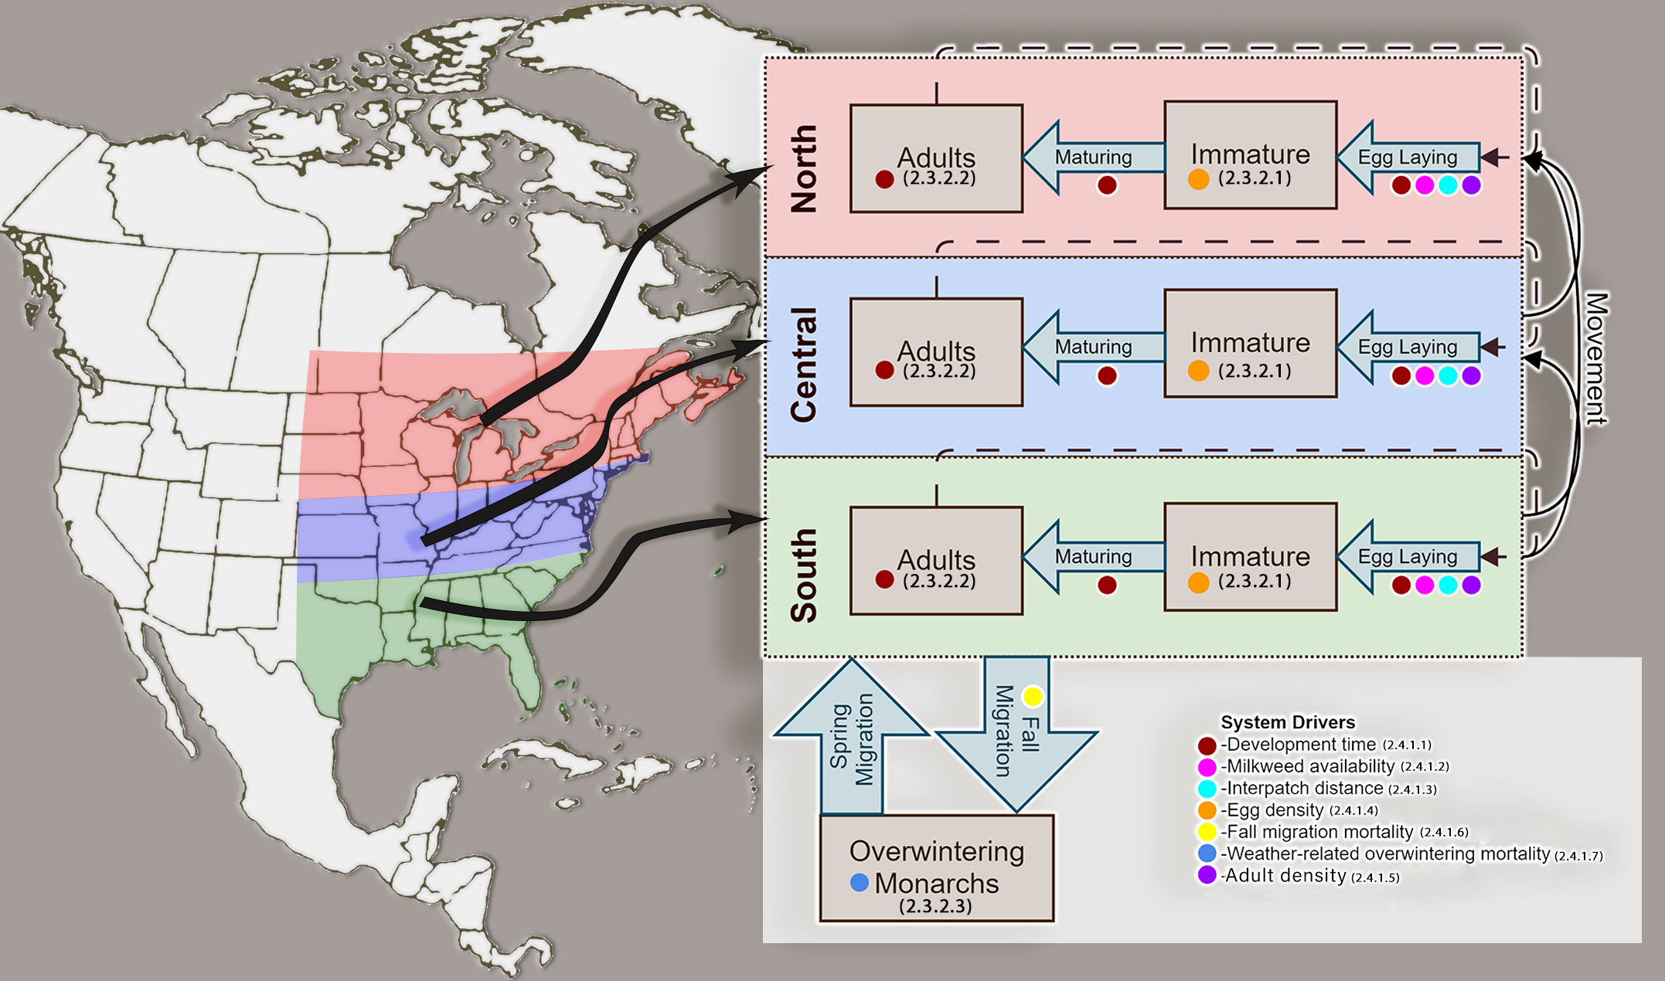

Figure 1 Spatial (vertical dimension) and stage-class (horizontal dimension) structure of the Monarch Butterfly System Dynamics Model (MOBU-SDyM). Simulated Monarchs reproduce and disperse across the three breeding regions during the breeding months and mobilize to a non-breeding overwintering region during the overwintering season. The coloured dots give the key to the system drivers that affect MOBU-SDyM dynamics. Numbers in parentheses give sections in this document where a description of that driver can be found.

The model has three age classes of individuals, Immature (including eggs, larvae and pupae), breeding Adults, and overwintering Adults, and also four regional geographic pools— three Breeding pools (South, Central, and North), plus the Overwintering pool in Mexico. The Breeding pools delimit Eastern North America from 75°-105° and latitudinally from 30°-35°, 35.1°-40°, and 40.1°-50° for the South, Central and North regions, respectively. Just as for any other insect, Monarch development time is highly dependent on temperature, measured in Degree-Days (°D). Here, the model captures such dependency through a temperature variable based on historical records, which is converted into °D and provides an expected total development time for each region at each time step. The model transitions individuals from the Immature to the Adult class using the Monarch’s requirement of °D, the heat impairment threshold, and the developmental zero temperature, using values obtained by Zalucki (1982). When the temperature is between the heat impairment threshold and the developmental zero, the individual will develop according to the °D. If the temperature falls outside that temperature range, the individual’s development will come to a full stop. The adult’s °DD requirement also determines their lifespan (M. P. Zalucki, 1981) (see section 2.4.1.1 for details)

Individuals transition across the four geographic regions (Figure 1) based on the monthly proportions found in the transition matrix created by Flockhart, Pichancourt, Norris, & Martin (2014b) and the stable isotope work by Flockhart et al. (2013a). Those same studies also provide the Monarch’s estimated survival while transitioning across the Breeding regions and are included in the model. The factors triggering the fall migration are still unknown, and the model incorporates this uncertainty by including a non-fixed migratory trigger dependent on temperature and sun angle rather than the date of the year (see section 4.4.3 below for details).

When the migration trigger is activated, individuals from the North region transition to the Central region. Soon after, those individuals concentrated in the Central region transition to the South. Finally, when the migration trigger is activated in the South, individuals take an average of 15 simulation days to transition to the Overwintering region. By mid-December, all of the individuals within the simulation concentrate in the Overwintering region and remain there until mid-March when, based on the same transition matrix used before (Flockhart et al., 2014b), they transition back to the Breeding regions. During the time that individuals are in the Overwintering region, they do not reproduce, and they reduce in numbers due to both background and weather-related death rates (see section 2.4.1.5 below for details)

## Demographics and Model Equations

## Initial Setup

The base model starts in January 1994, with all individuals concentrated in the Overwintering region. The specific number of individuals depends on the overwintering colonies’ area recorded in 1994, multiplied by a sample of the overwintering Monarch density posterior distribution. The rest of the classes and regions begin containing no individuals.

## Population dynamics

The following section presents the abbreviations, descriptions, and equations that define the model's population dynamics.

## Immature individuals

The number of Immature individuals (including eggs, larvae, and pupae) found in region *x* at the end of time step *t* (${Immature}_{x, t}^{ }$; eq.1) depends on four variables: the number of Immature individuals in the previous time step ${(Immature}_{x, t-1}^{ })$, the number of eggs laid in that time step ( $E_{x,t}^{ })$ and Immature numbers transitioning out of the class because of death ${(M}_{x,t}^{ })$ or reached maturity in that time step $\left({Id}_{x,t}^{ }\right)$.

${Immature}_{x, t}^{ }={Immature}_{x, t-1}^{ }+\left(E_{x,t}^{ }- M_{x,t}^{ }- {Id}_{x,t}^{ }\right)$

From eq.1, the number of eggs laid per Adult female multiplied by the total number of females in time *t* determines the number of new individuals joining the Immature class ($E_{x,t}^{ }$; eq.2). The total number of Adults (${Adults}_{x,t}^{ }$) and the sex ratio (${Sr}_{t}^{ }$) dictates the number of females in the Adult class. In turn, the number of eggs laid per female in a time step is dictated by (i) the average oviposition potential per female $\left({Ef}_{x,t}^{ }\right)$, which is dictated by the estimated mean female age; and (ii) environmental conditions such as the interpatch distance (${Dis}_{x,t}$), depensatory effects (${Al}_{x,t}$), and whether the time step is before or after the fall migratory trigger is set off (determined by the Boolean ${Ft}_{x,t}$).

$E_{x, t}^{ }= \left( 1 - {Ft }_{x,t}\right)* \left(\begin{aligned}{Adults}_{x,t} * {Sr}_{x,t} * {Ef}_{x,t} * {Dis}_{x,t} * {Al}_{x,t} \end{aligned}\right)$

Previous Monarch models have assumed a constant development rate for the Monarchs (Flockhart, Pichancourt, Norris, & Martin, 2014a; Oberhauser et al., 2017). However, this does not capture the development time’s variation related to the number of Degree-Days (°D) to which individuals are exposed. The MOBU-SDyM captures that variation by calculating the number of individuals transitioning from the Immature to the Adult class at a time step ($M_{x,t}^{ }$; eq.3) as the number of Immature individuals (${Immature}_{x, t}^{ }$) divided by the immature development time in region *x*, at time *t* (see2.4.1.1). Note that the *zidz* function in eq.3 is in VENSIM, a regular division of the first by the second term, except that it returns zero when the second term is zero. Also, the m*ax* and *min* functions are used throughout the model structure to deal with rounding errors that can lead to small negative numbers; we opted not to show these functions in the main document for easiness of reading.



$M_{x,t}^{ }=max\left(0, zidz\left( {Immature}_{x, t}^{ }, \left({Immature Development time}_{x,t} \right)\right)\right)$

The number of new individuals that die daily within the Immature class (${Id}_{x, t}^{ }$; eq.4) is a conditional equation that combines the mortality effect of freezing temperatures (-10°C) with background mortality. When the mean modelled temperature within a region is below -10 °C, all the new Immature individuals in that region during that time step die. If the temperature is above that threshold, the sum of Immature individuals joining the class in that time step ($E_{x, t}^{ }$) multiplied by a basal death rate (${IDd}_{x, t}^{ }$) and a density-dependent death rate (${Densd}_{x, t}^{ }$) dictate the background mortality of Immature individuals. Since available literature only states overall survivorship of the immature individuals (rather than daily death rates), the model calculates the number of Immature individuals dying per time step $\left({Id}_{x, t}^{ }\right)$ as the number of eggs laid in that time step (i.e. the new individuals entering the class) multiplied by the proportion of all Immatures expected to die.

${Id}_{x, t}^{ }=\begin{aligned}if \left({Te}_{x, t}^{ } >-10\right) then \left(max⁡(0, \left(\left({ E}_{x, t}^{ } *{Densd}_{x, t}^{ }\right) + \left(E_{x, t}^{ }*{IDd}_{x, t}^{ }\right)\right))\right) else{(Immature}_{x,t}^{ })\end{aligned}$

## Adult individuals

We estimated the number of individuals within the Adults classes (${Adults}_{x,t}^{ }$; eq.5,6,7) for each region every time step using similar stock equations. The number of individuals within the Adults class increases with individuals transitioning from the same region’s Immature class ($M_{x,t}^{ }$), and individuals transitioning from Adult classes of other regions ( $D_{y,t}^{x}$ where x is the current region). Conversely, the number of individuals decreases with outgoing individuals towards Adult classes from other regions ($D_{x,t}^{y}$ where x is the current region), the incoming individuals from other regions who die ${(Sd}_{x,t}^{ }$), the number of dying Adults within the region due to their age $\left({Ad}_{x,t}^{ }\right)$ And the number of Adults dying at the start of their fall migration ${(Fd}_{y,t}^{ }$ Where *y* is any of the three breeding regions). The South region has an additional term that describes the movement of Adults individuals to the Overwintering region (${Fs}_{t}^{ }$).

${Adults}_{North,t}^{ } ={Adults}_{North,t-1}^{ }+ \left(M_{North,t}^{ } + D_{Overwintering,t}^{North}+D_{Central,t}^{North}+D_{South, t}^{North}-{Ad}_{North,t}^{ }-{Sd}_{North,t}^{ }-D_{North,t}^{South }-D_{North, t}^{Central }-{Fd}_{North,t}^{ }\right)$

${Adults}_{Central,t}^{ } ={Adults}_{Central,t-1}^{ }+\left(M_{Central,t}^{ } + D_{Overwintering,t}^{Central}+D_{South, t}^{Central }+D_{North,t }^{Central }-{Ad}_{Central,t}^{ }-{Sd}_{Central,t}^{ }-D_{Central,t}^{North }-D_{Central,t}^{South }-{Fd}_{Central,t}^{ }\right)$

${Adults}_{South,t}^{ }={Adults}_{South,t-1}^{ }+\left(M_{South,t}^{ }+D_{Overwintering,t}^{South}+D_{Central,t}^{South }+D_{North,t}^{South }-{Ad}_{South,t}^{ }-{Sd}_{South,t}^{ }-D_{South,t}^{North }-D_{South,t}^{Central }-{Fd}_{South,t }^{ }-{Fs}_{t}^{ }\right)$

The movement of any one individual across Breeding regions is assumed to be instantaneous (eq.8), and the model uses lookup tables to describe the monthly proportion of individuals moving across the four regions ($D_{x,t}^{y }$). The Overwintering transition to the Breeding regions expands across 30 days before May, transitioning out any remaining individuals on May 1st (eq.9). The MOBU-SDyM assumes that adults moving across regions ( $D_{x,t}^{y }$) have a higher probability of dying than the ones remaining within the same region (${Dd}_{x, t}^{y }$), which is reflected in the model by a specific death rate during movement (${Sd}_{x,t}^{y };$ eq.10).

$D_{\left(South Central, North\right),t}^{y}={{Adults}_{\left(South Central, North\right),t}^{ }* Trans}_{\left(South Central, North\right),t}^{y }$

$D_{Overwintering,t}^{y }=\frac{{Trans}_{overwintering,t}^{y }*{Adults}_{Overwintering,t}}{\begin{aligned}if \left({Month of the year}_{t} < 5\right) then \left(30\right) else \left(1\right) \\ \\ \end{aligned}}$

${Sd}_{xt}^{y }= D_{x,t}^{y }*{Dd}_{x, t}^{y }$

## Migration and Overwintering

It is common knowledge for the Monarch experts that a sun angle of 52° at solar noon cues the Monarch’s migratory behaviour, although little peer-reviewed research exists in that regard (Perez & Taylor, 2004; Taylor Jr et al., 2019). However, the migratory behaviour does not appear precisely the same day every year as it would happen if the sun angle were the only cue. Evidence suggests that temperature and host plant senescence influence the reproductive diapause before migration (Goehring & Oberhauser, 2002), although the relation between sun angle, plant senescence, and weather variables is still unknown. The model explores that uncertainty by assuming a non-fixed migratory trigger (${Ft}_{x,t}$), i.e. independent on any specific date. Instead, the combination of sun angle at solar noon below 52° and a 5-consecutive-day mean weather temperature below a posterior sample of a temperature migration threshold sets off the migration trigger in each model's Breeding region. As in the natural system, the migration trigger sets off earlier in the North region, following the Central and being last in the South. The priors used to estimate the temperature migration threshold's posterior distribution were the temperatures measured during the months that migration begins within each region.

Once the adequate cues set off the migration trigger within each region (${Ft}_{x,t}=1$), a southward transition of Adults starts, being affected by stochastic environmental factors that increase their death rate while migrating (${FMigDR}_{x,t}^{ }$) and consequently, the number of dead individuals (${Fd}_{x,t}^{ };eq. 11$) at every time step.

${Fd}_{x,t}^{ }=max\left(0, if\left({Ft}_{x,t}=1\right) then\left(min\left({Adults}_{x,t}^{ }, {FMigDR}_{x,t}^{ }*D_{x,t}^{y }\right)\right) else\left(0\right)\right)$

The Central region migrating Adults, already merged with individuals from the North, converge in the South until the migration trigger is activated there. Then, the South region transitions all the Adults towards the Overwintering region. Since the distance from the south to the overwintering region is considerably more than the distance among breeding regions, the MOBU-SDyM assumes that it will take 15 days for an individual to begin its migration from the South region(${Fs}_{t}$; eq.12) to its arrival at the Overwintering region (${Fe}_{t}$; eq. 13). Mid-Texas' distance to the overwintering grounds and the average flight speed of south-migrating Monarchs (65-80 km/day; (Downhower, 1988; Howard & Davis, 2015)) give the value to this time delay.

${Fs}_{t}^{ }=max\left({0, {Adults}_{South,t}*{Ft}_{South,t})}_{ }\right)$

${Fe}_{t}^{ }=delay\left({Fs}_{t}^{ }, 15\right)-\frac{{Fs}_{t}^{ }*{Hd}_{t}^{ }}{15}$

To accommodate for those 15 days between departure from the south and arrival to the overwintering grounds, along with the mortality associated with it, we added a stock variable (${Migrating}_{t }^{ }$; eq.14) holding migrating individuals until their arrival to the Overwintering region

${Migrating}_{t }^{ }={Migrating}_{t-1}^{ }+\left({Fs}_{t}-{Fe}_{t}-{Fwd}_{t}\right)$

During that migration time, many factors not sufficiently studied but broadly assumed to be present ${(Hd}_{t})$, affect the Monarch’s survival. The MOBU-SDyM considers these factors by including an extra term to the mortality definition (${Fwd}_{t}^{ }$; eq.15).

${Fwd}_{t}^{ }=max\left(0, {Migrating}_{t}*{Hd}_{t}\right)$

The Overwintering region holds all the individuals within the system for about five months (${Adults}_{Overwintering,t}$; eq.16); the exact duration depends on when the South region's migration trigger is activated. The Overwintering region increases its number of Monarchs with the arrival of individuals from the Breeding regions (${Fe}_{t}^{ }$), decreases in number along the Overwintering season (${Od}_{t}^{ }$; eq.17) due to predation and background mortality (${Pd}_{t}$), and weather-related factors (${Cd}_{t}$). When the overwintering season ends, the surviving Adults transition back north to the Breeding regions ( $D_{Overwintering,t}^{y }$ where y is any of the three breeding regions).

${Adults}_{Overwintering,t}={Adults}_{Overwintering,t-1}+\left({Fe}_{t}^{ }-{Od}_{t}^{ }-D_{Overwintering,t}^{y }\right)$

${Od}_{t}^{ }=max\left(0,\left( {Adults}_{Overwintering,t}*{Pd}_{t}\right)+\left({Adults}_{Overwintering,t}*{Cd}_{t}\right)\right)$

## Pressures

The Monarch’s biological system is a large and complex ecological mosaic that expands across most of North America. It is not surprising that the Monarchs’ population dynamics, with such extensive range, are affected by many drivers, many of whom are not fully understood or likely known. The two most relevant drivers of the Monarch’s downward trend that have dominated the scientific and political discourse are the availability of milkweed across the breeding regions and the inclement weather in the overwintering region. The current model includes those pressures and a set of others (e.g., interpatch distance, temperature-dependent development time, depensatory effects, and larval density) that have a theoretical justification and proved to improve the model’s behaviour. Figure 2 depicts the way the model includes each of those pressures and their type of relation.

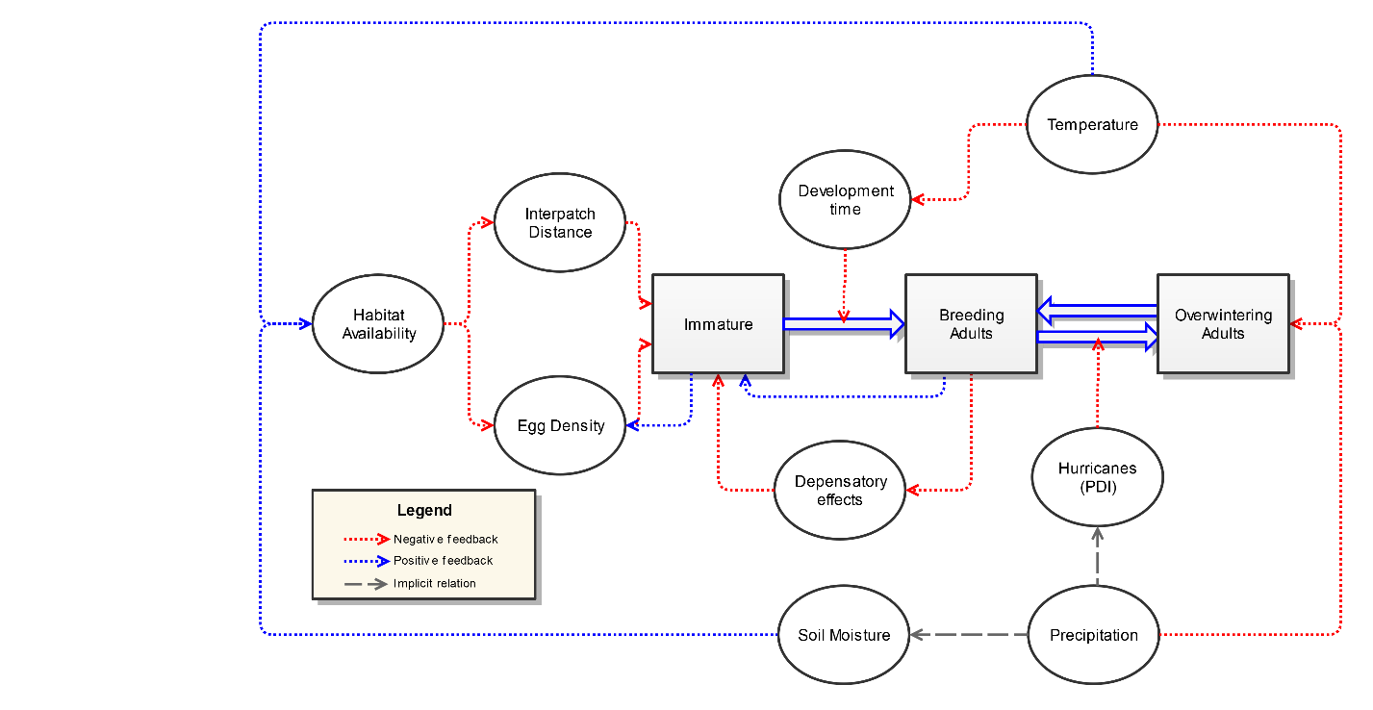

Figure 2 Driving pressures included in the model, including the presumed type of relationship with overwintering Monarch numbers (positive or negative) and wherein the lifecycle each is expected to exert its effect. The relationship (positive or negative feedback) is depicted here as a simplification because most variables are modelled to exert a non-linear effect on demographic parameters. "Implicit relation" means that the model does not explicitly establish that relationship, but, in reality, those variables are correlated. See the text for further detail.

## Development time

Temperature directly affects the time a Monarch takes to develop (M. P. Zalucki, 1982); in theory, at low or high temperatures, a Monarch could take as many as 30 days or as few as ten days to reach maturity respectively. Moreover, research with Monarchs (M. P. Zalucki, 1981) and other butterfly species (Gossard & Jones, 1977) suggests that the adult lifespan is also negatively related to temperature. The MOBU-SDyM captures that variability in development time (${Adult lifespan}_{x,t}$; eq.18 and *Immature Development timex,t*; eq.19), number of deaths (${Ad}_{x,t}^{ }$; eq. 20), and number of Immature individuals maturing per time step ($M_{x,t}^{ }$; eq. 21) by calculating the daily Degree-Days in a region (${°D}_{ x,t}^{ }$; eq. 22)(Baskerville & Emin, 1969) using the current simulated temperature (${Temp}_{x,t}$), the Monarch’s developmental zero[1] () and heat impairment threshold[2] (). To calculate the proportion of individuals transitioning through classes, the Adults °D requirement to reach their estimated longevity (${Ta}_{ x,t}^{ }$) or the sum of °D required for immature Monarchs to overcome their specific developmental stage ( ${Th}_{ x,t}^{ }, {Te}_{ x,t}^{ }, and {Tp}_{ x,t}^{ }$ for an egg, a larvae, and pupae, respectively) are divided by the current °D to give a current expected Adult lifespan (eq. 18) or current expected Immature development time (eq. 19), respectively.

${Adult lifespan}_{x,t}=\frac{{Ta}_{ x,t}^{ }}{{ °D}_{ x,t}^{ }}$

${Immature Development time}_{x,t}=\frac{{Th}_{ x,t}^{ }+{Te}_{ x,t}^{ }+{Tp}_{ x,t}^{ }}{{ °D}_{ x,t}^{ }}$

${Ad}_{x,t}^{ }=max \left(0, zidz\left({Adults}_{x, t}^{ }, {Adult lifespan}_{x,t}^{ }\right)\right)$

$M_{x,t}^{ }=max \left(0, \left(zidz\left({Immature}_{x,t}^{ }, {Immature Development time}_{x,t}\right)\right)\right)$

${ °D}_{ x,t}^{ }=if \left({Temp}_{x,t}>Tth :OR: {Temp}_{x,t}<Tl\right), 0, else \left({Temp}_{x,t}-Tl\right)$

## Milkweed availability

In addition to its effect on Monarch development time, milkweed growth and consequent habitat availability are also affected by temperature. Most experts agree that habitat availability across the breeding regions is the crucial driver of the Monarch’s final population size (Pleasants & Oberhauser, 2012; Pleasants, 2017; Stenoien et al., 2018; Thogmartin, López-Hoffman, et al., 2017). Previous studies used the estimated total number of milkweed stems that a region can support as a proxy for habitat availability (Flockhart, Pichancourt, Norris, & Martin, 2015; Thogmartin, López-Hoffman, et al., 2017). However, it is essential to consider that the actual number of stems on the ground and available to the Monarch is highly dependent on weather conditions, e.g., a drought can reduce the number of stems across the landscape. Considering that butterflies are an R-selected species (Pianka, 1970) with highly fluctuating populations, models should capture the factors behind these fluctuations, such as habitat’s dynamic availability across the landscape. However, no peer-reviewed studies exist linking weather and milkweed growth to the necessary level of detail.

The MOBU-SDyM explores the link between weather and milkweed growth by including a hypothesized relationship between temperature, soil moisture, and milkweed availability (${Milkweed Availability}_{x,t}$; eq. 23). Since those parameters' value is yet unknown, we used a Markov Chain posterior sampling of the data, using prior work on soil moisture and temperature for other plant species (Veihmeyer & Hendrickson, 1927). The interaction between the hypothesized ideal temperature $\hat{(T})$, soil moisture ( $\hat{H})$ and a scaling moisture estimate $(Me$) for milkweed growth defines such curve. When the ideal temperature and soil moisture are met within a region, the milkweed availability is at its highest; if any of those parameters are below or above that optimal point, the availability decreases. This relationship is instantaneous, meaning no latency time exists between meeting the optimal conditions and the consequent milkweed availability. Further iterations of this model might try to implement such an element.

${Milkweed Availability}_{x,t}=\frac{Me}{{(e}^{-10\left(H_{x,t}-0.5\hat{H}\right)}+1)(e^{\hat{H}-H_{x,t}}+1)(e^{-0.2\left(T_{x,t}-0.5\hat{T}\right)}+1)(e^{-0.005\left(T_{x,t}-\hat{T}\right)}+1)}$

We hypothesize the shape of the Soil Moisture-Temperature relation to be of elliptic paraboloid shape, as shown in Figure 3, where the shape's height is the milkweed availability, and the moisture and temperature shape the width and depth of it. This shape assumes that milkweed availability decreases with deviations, either up or down, from any of those two parameters. Also, to simulate the incomplete use of the resource, which is one of our approach's central innovations, we added a scaling factor that modifies its overall steepness and total height. We also obtained a posterior distribution for this parameter.

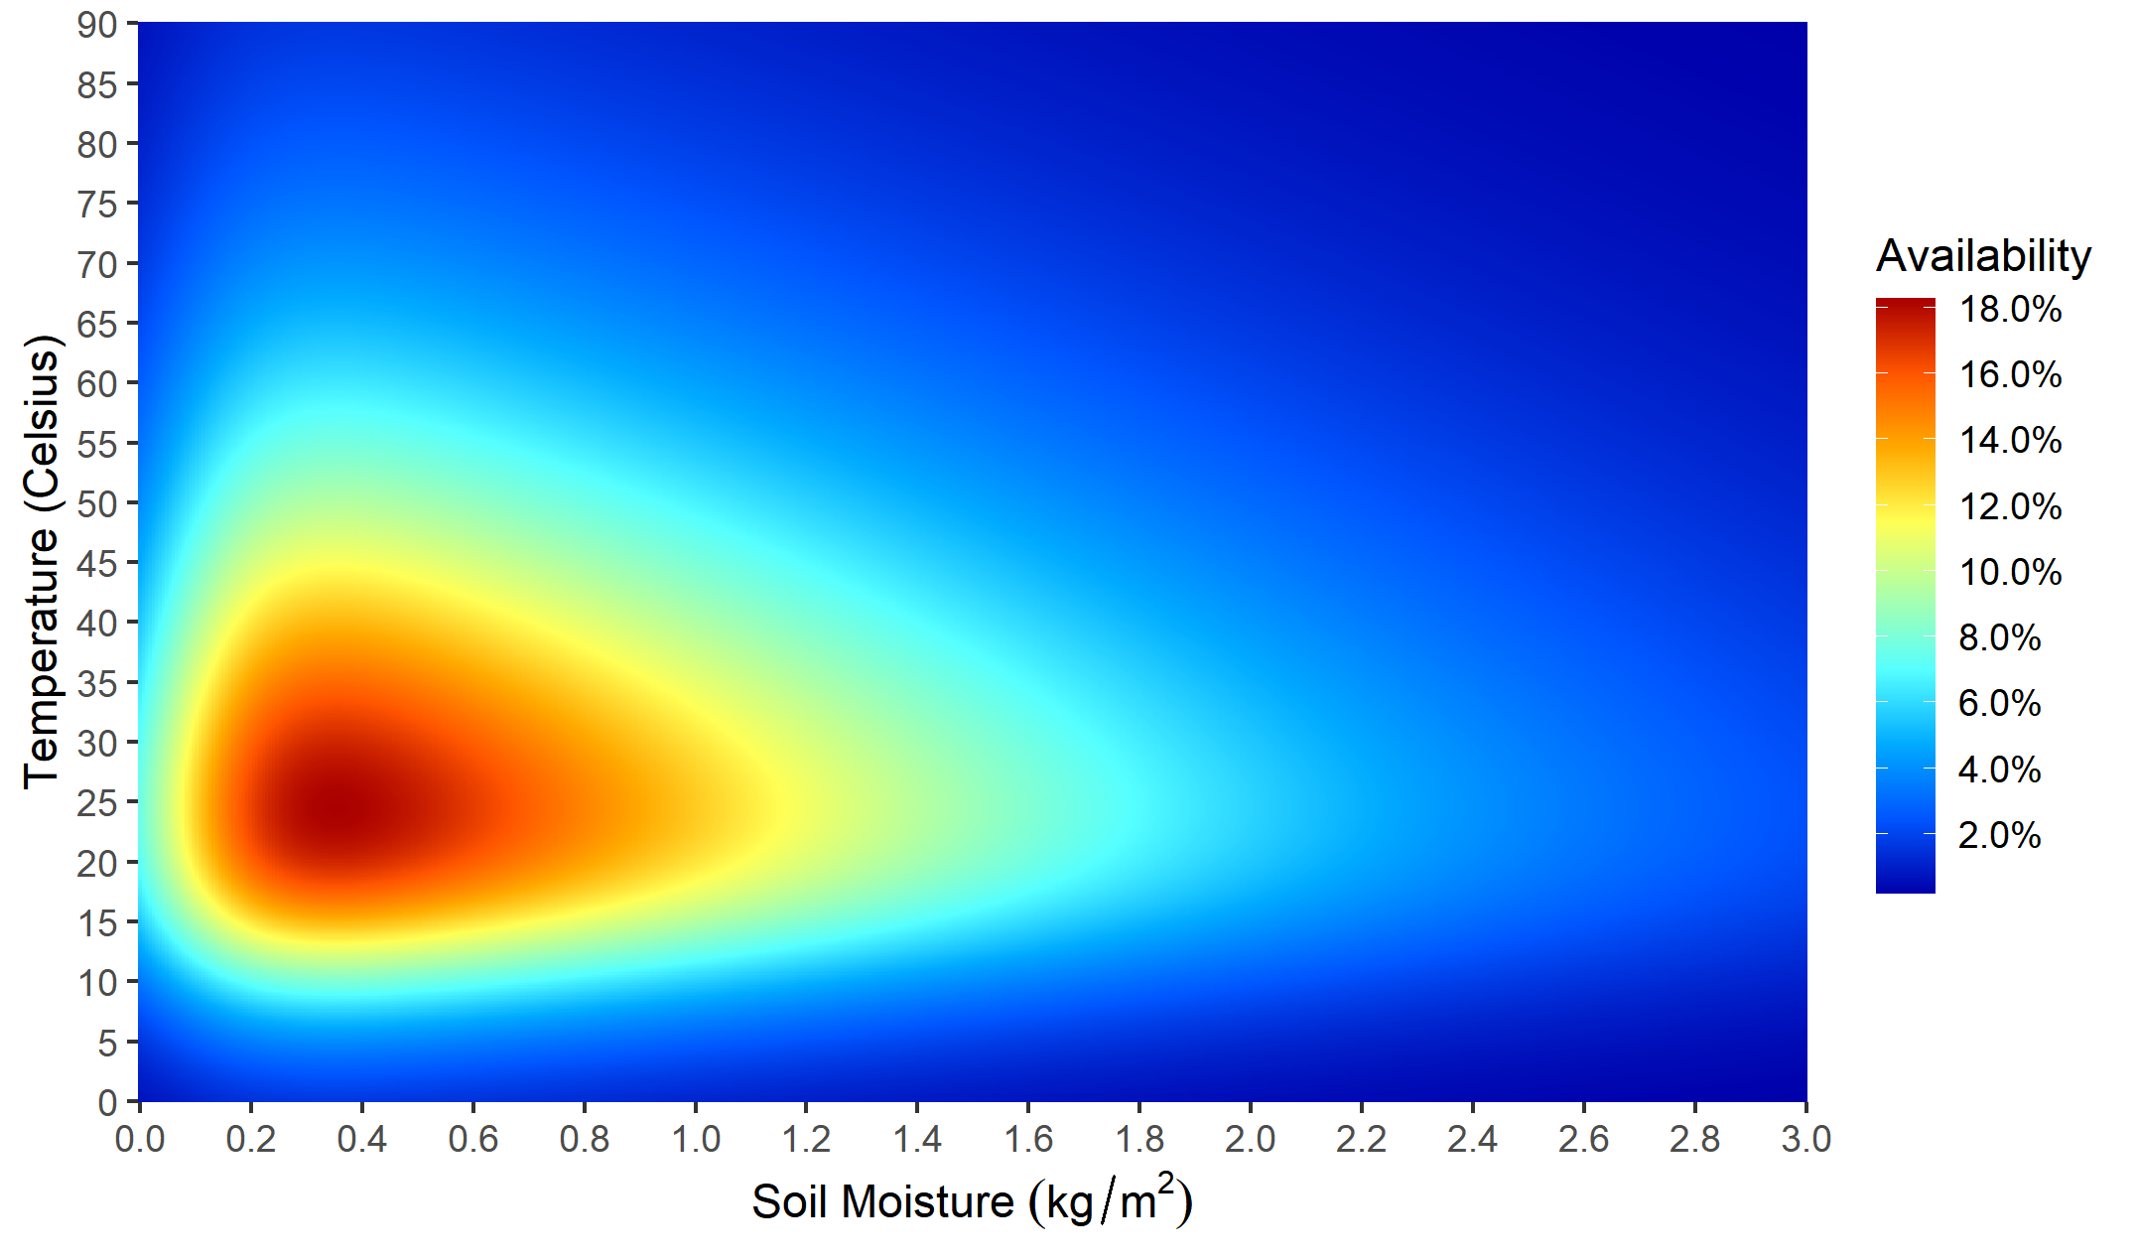

Figure 3 Hypothetical relation between Soil Moisture, Temperature, and Milkweed Availability. Note that the values shaping this graph are hypothetical and, in reality, they are shaped by the joint posterior distribution of the three parameters: Ideal Temperature, Ideal Moisture, and Moisture Estimate.

## Interpatch distance

Recently, the discussion around milkweed being the main driver of the Monarch’s decline has expanded from considering the sheer numbers of stems to include their distribution across the landscape (Cutting & Tallamy, 2015; Kasten, Stenoien, Caldwell, & Oberhauser, 2016; Stenoien et al., 2018; M. Zalucki, Parry, & Zalucki, 2016). Even though spatially explicit models would be more suitable for including this kind of element and that analyzing the effect of interpatch distance is not the model's primary objective, we decided to account for interpatch distance since it is an element with considerable impact over the Monarch's egg-laying success (M. Zalucki, Parry, & Zalucki, 2015). We included this effect by estimating the average interpatch distance across the landscape $\left({Dis}_{x, t}\right)$ with a logistic-shaped relation (eq. 24) formed by a midpoint ($Ia$) and slope ($Ib$) based on M. Zalucki et al. (2015) and experts’ opinion

$Egg Laying Success=\frac{1}{e^{{\left({{Ip}_{x,t}}/{Ia}\right)}^{Ib}}}$

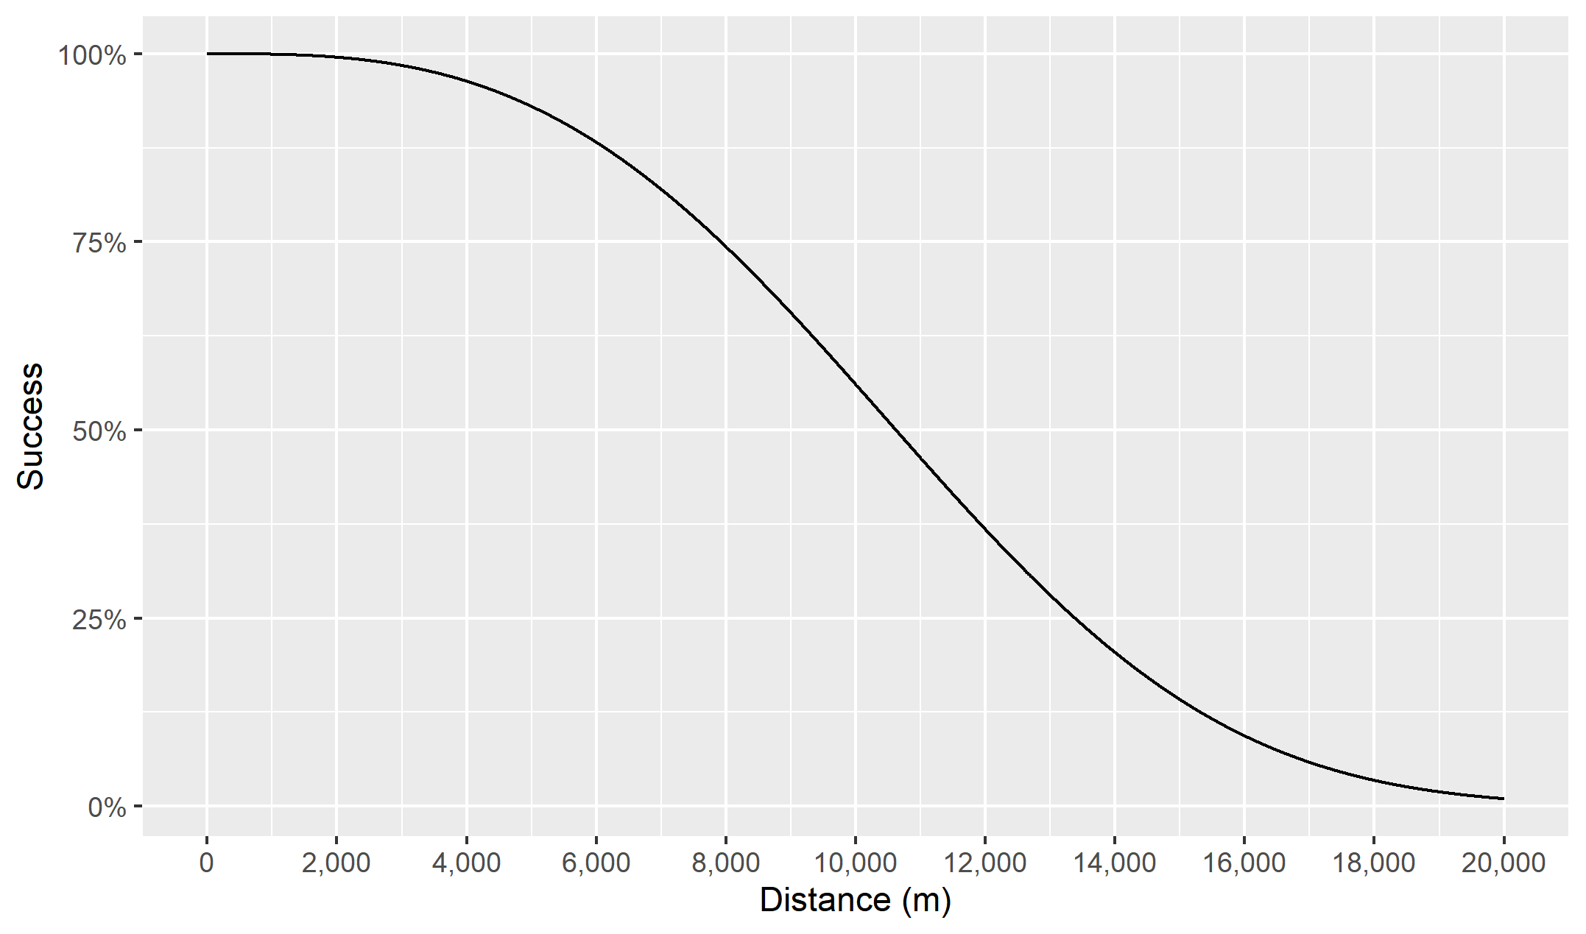

Figure 4 Probability that a Monarch female successfully lays its eggs in relation to the mean distance between milkweed patches

The MOBU-SDyM estimates the interpatch distance (${Dis}_{x,t}$) by linking the dynamics of the Adults within a region and the milkweed availability. The model assumes that each patch is circular and estimates the interpatch distance (${Dis}_{x,t}$; eq.25) of the average nearest neighbour (Gotoh, Jodrey, & Tory, 1978) as the square root of the available milkweed patches on region *x* on timestep *t*, divided by the area within the region that is not a suitable habitat for a Monarch to lay its eggs (${Aw}_{x}$; eq. 26). The habitat not suitable for Monarch oviposition was considered to be the total area of the region minus the overall area of available milkweed patches. The number of available milkweed patches ($P_{x,t}$; eq. 27) depends on the available milkweed area (${Am}_{x,t}$; eq.28) divided by the mean patch area (${Pa}_{x,t}$; (Hartzler & Buhler, 2000)). The available milkweed area (${Am}_{x}$), in turn, is the result of dividing the number of available stems (${MWa}_{x,t}$; eq. 29; (Flockhart et al., 2014a)) by the stem density $(MWdens$; (Ralph, 1977)).

Based on the authors' empirical observations, the MOBU-SDyM assumes that while a female is laying eggs in one stem, no other female will lay eggs on that same stem. So, the available stems (${MWa}_{x,t}$; eq.29) is the result of subtracting the number of Adults within a region from the total number of stems $\left({MW}_{x,t}\right)$ in that same region. Finally, the area not suitable for egg-laying (${Aw}_{x}$; eq. 26) is defined as the total area of region *x* ($A_{x}$) minus the area occupied by milkweed (${Am}_{x}$). A graphical description of how all these calculations happen is depicted in Figure 5



$Interpatch Distance: {Dis}_{x,t}=\sqrt{\frac{P_{x,t}}{{Aw}_{x}}}$

${Area not Suitable for egg laying: Aw}_{x}=A_{x}-{Am}_{x}$

$Available patches: P_{x,t}=\frac{{Am}_{x}}{{Pa}_{x,t} }$

$Available Milkweed Area: {Am}_{x}=\frac{{MWa}_{x,t}}{{MWdens}_{ }}$

$Available Stems: {MWa}_{x,t}={{MW}_{x,t}-Adults}_{x,t}$

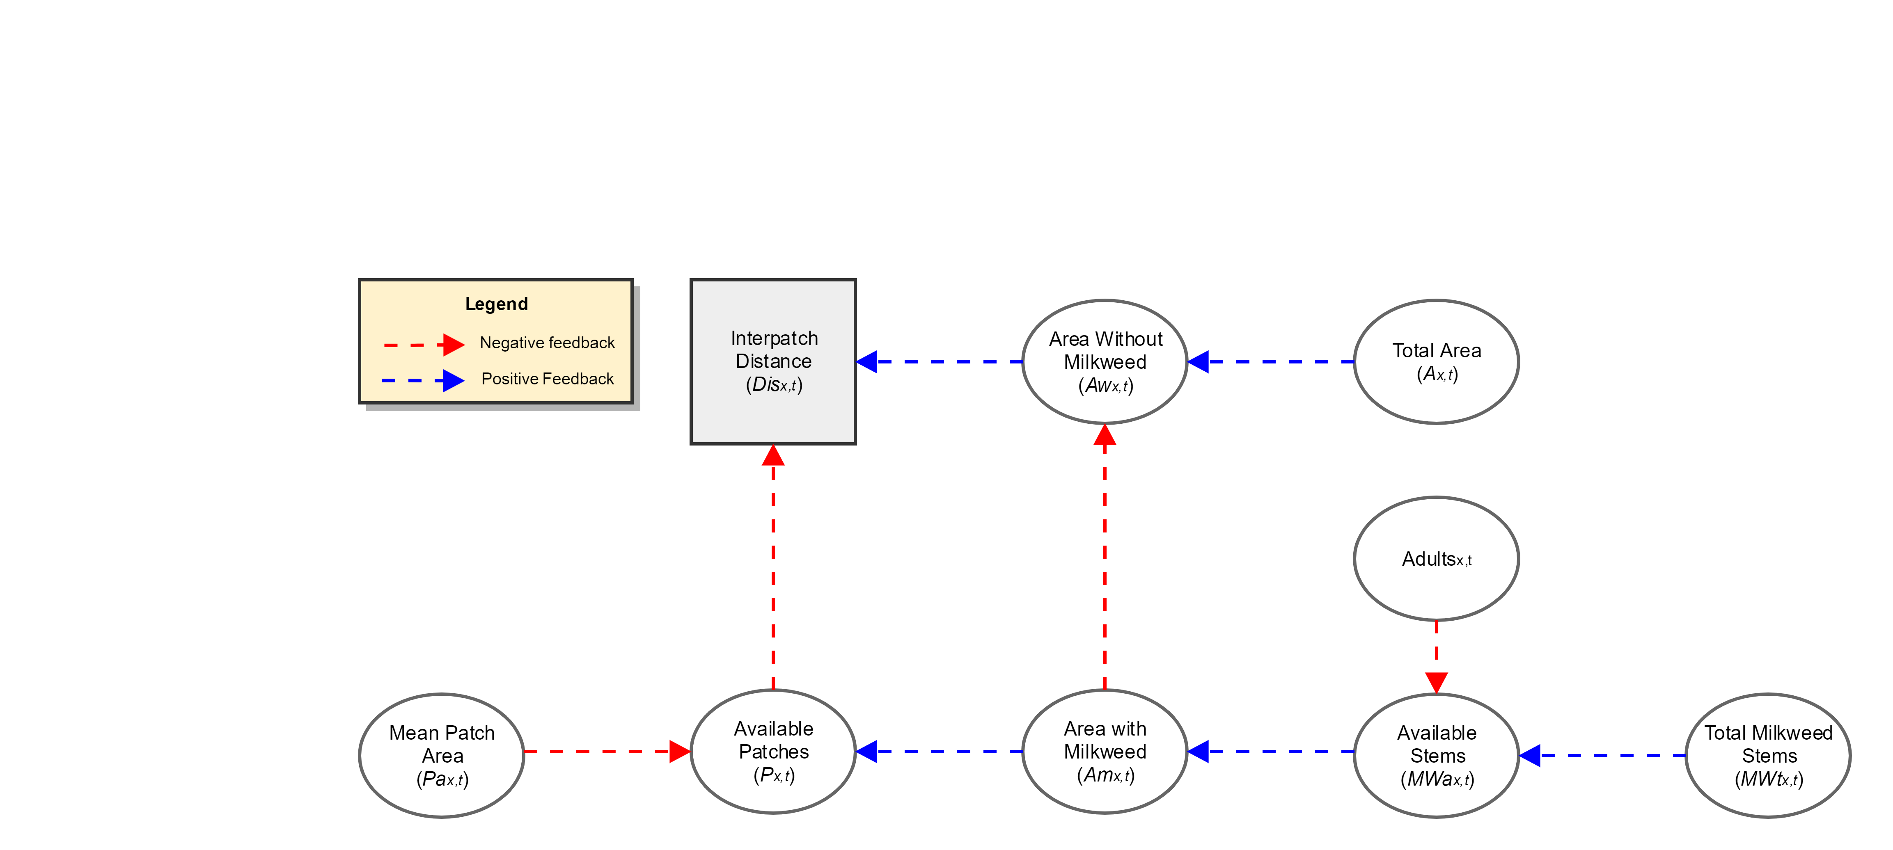

Figure 5 Steps to calculate the interpatch distance within a region

## Egg density

According to Flockhart, Martin, & Norris (2012), there is a marked decrease in egg survival when the egg density on a milkweed stem exceeds a threshold. Considering that the milkweed is, arguably, the most critical limiting factor for Monarch success, the density-dependent death rate (${Densd}_{ x,t}^{ }$; eq.30) of eggs is a likely crucial variable to consider. This parameter is estimated based on a laboratory experiment from Flockhart et al. (2012) and the egg density calculated by dividing the number of eggs (${Eggs}_{x, t}^{ }$; eq.31) by the total available stems in region x during timestep t (*Milkweed Availabilityx,t*). Since the model does not consider a separate class for eggs (the Immature class includes eggs plus all larval states plus pupae), the number of eggs is back-estimated by dividing the current days to hatch (${Th}_{x, t}^{ }$) by the total number of days to complete the Immature stage: egg (${Th}_{x, t}^{ })$, larva (${Tm}_{x, t}^{ })$, and pupae $\left({Tp}_{x, t}^{ } \right),$ and multiplying this by the total number of Immature individuals (${Immature}_{x, t}^{ }$).



${ Densd}_{ x,t}^{ }={\left(e^{1.0175-{(0.1972{*Eggs}_{x, t}^{ }}/{{Milkweed Availability}_{x,t})}}+1\right)}^{-1}$

${ Eggs}_{ x,t}^{ }={Immature}_{x, t}^{ }*ZIDZ\left( {Th}_{x, t}^{ }, \left({Th}_{x, t}^{ } + {Tm}_{x, t}^{ } + {Tp}_{x, t}^{ } \right)\right)$

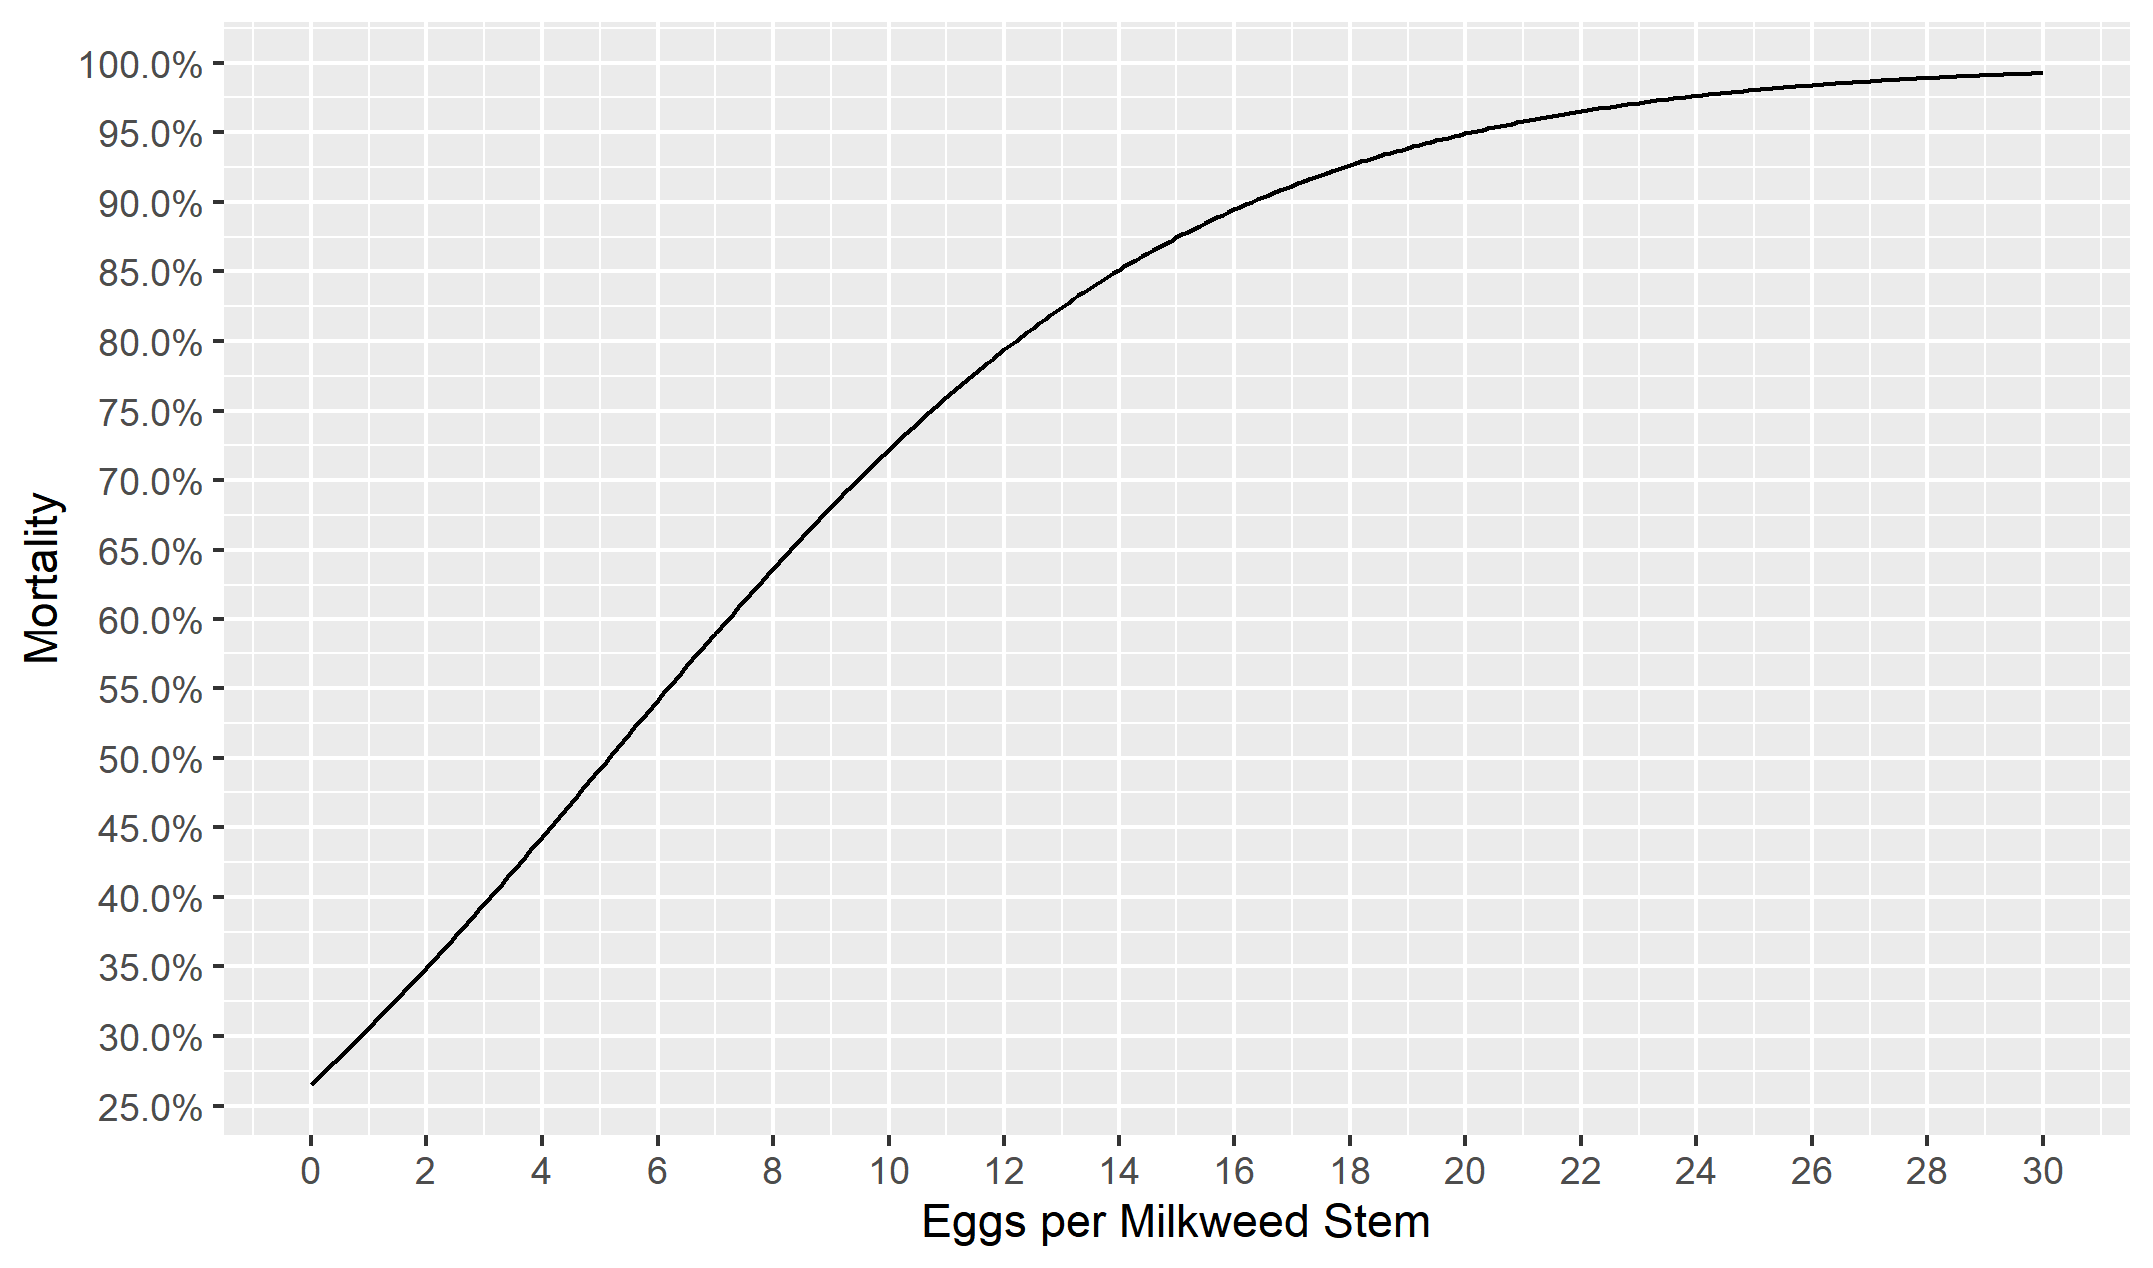

Figure 6 Egg's density-dependence mortality curve from eq.30 from Flockhart et al. (2012)

## Adult density

Problems that arise at small population sizes, e.g. inbreeding depression, difficulty in finding a mate, and protection against predators, are grouped within the broad category of depensatory or negative density-dependent effects (also known as Allee effects), all of which can hinder a population’s potential to recover from a perturbation (Freckleton, Gill, Noble, & Watkinson, 2005). Currently, no studies link the Monarch directly with any of these phenomena. However, these effects are present in other butterfly species (Kuussaari, Saccheri, Camara, & Hanski, 1998; Murphy, Freas, & Weiss, 1990). Here, the MOBU-SDyM assumes an individual's reproductive success logistically decreases once it reaches the lower threshold of approximately 0.5 individuals per hectare (eq.32). We resourced to a Powell hill-climbing optimization algorithm to estimate this parameter (Burns & Janamanchi, 2007; Powell, 1971), using as a start search parameter the estimated Monarch density across the breeding regions during the lowest overwintering season recorded, in 2014 (Rendón-Salinas et al., 2019). We did not opt to use Markov Chain posterior sampling as we did with the other uncertain parameters in the model since it would considerably complicate the parameter search space, and it proved to have almost a negligible effect within the current reported size of the colonies (Figure 10).

${Depensatory Effect}_{ x,t}^{ }=\frac{{Egg Laying}_{ x,t}^{ }}{e^{\left({3.11496*10}^{-8}\right)*\left({Adults}_{ x,t}^{ }-79480400\right)}}$

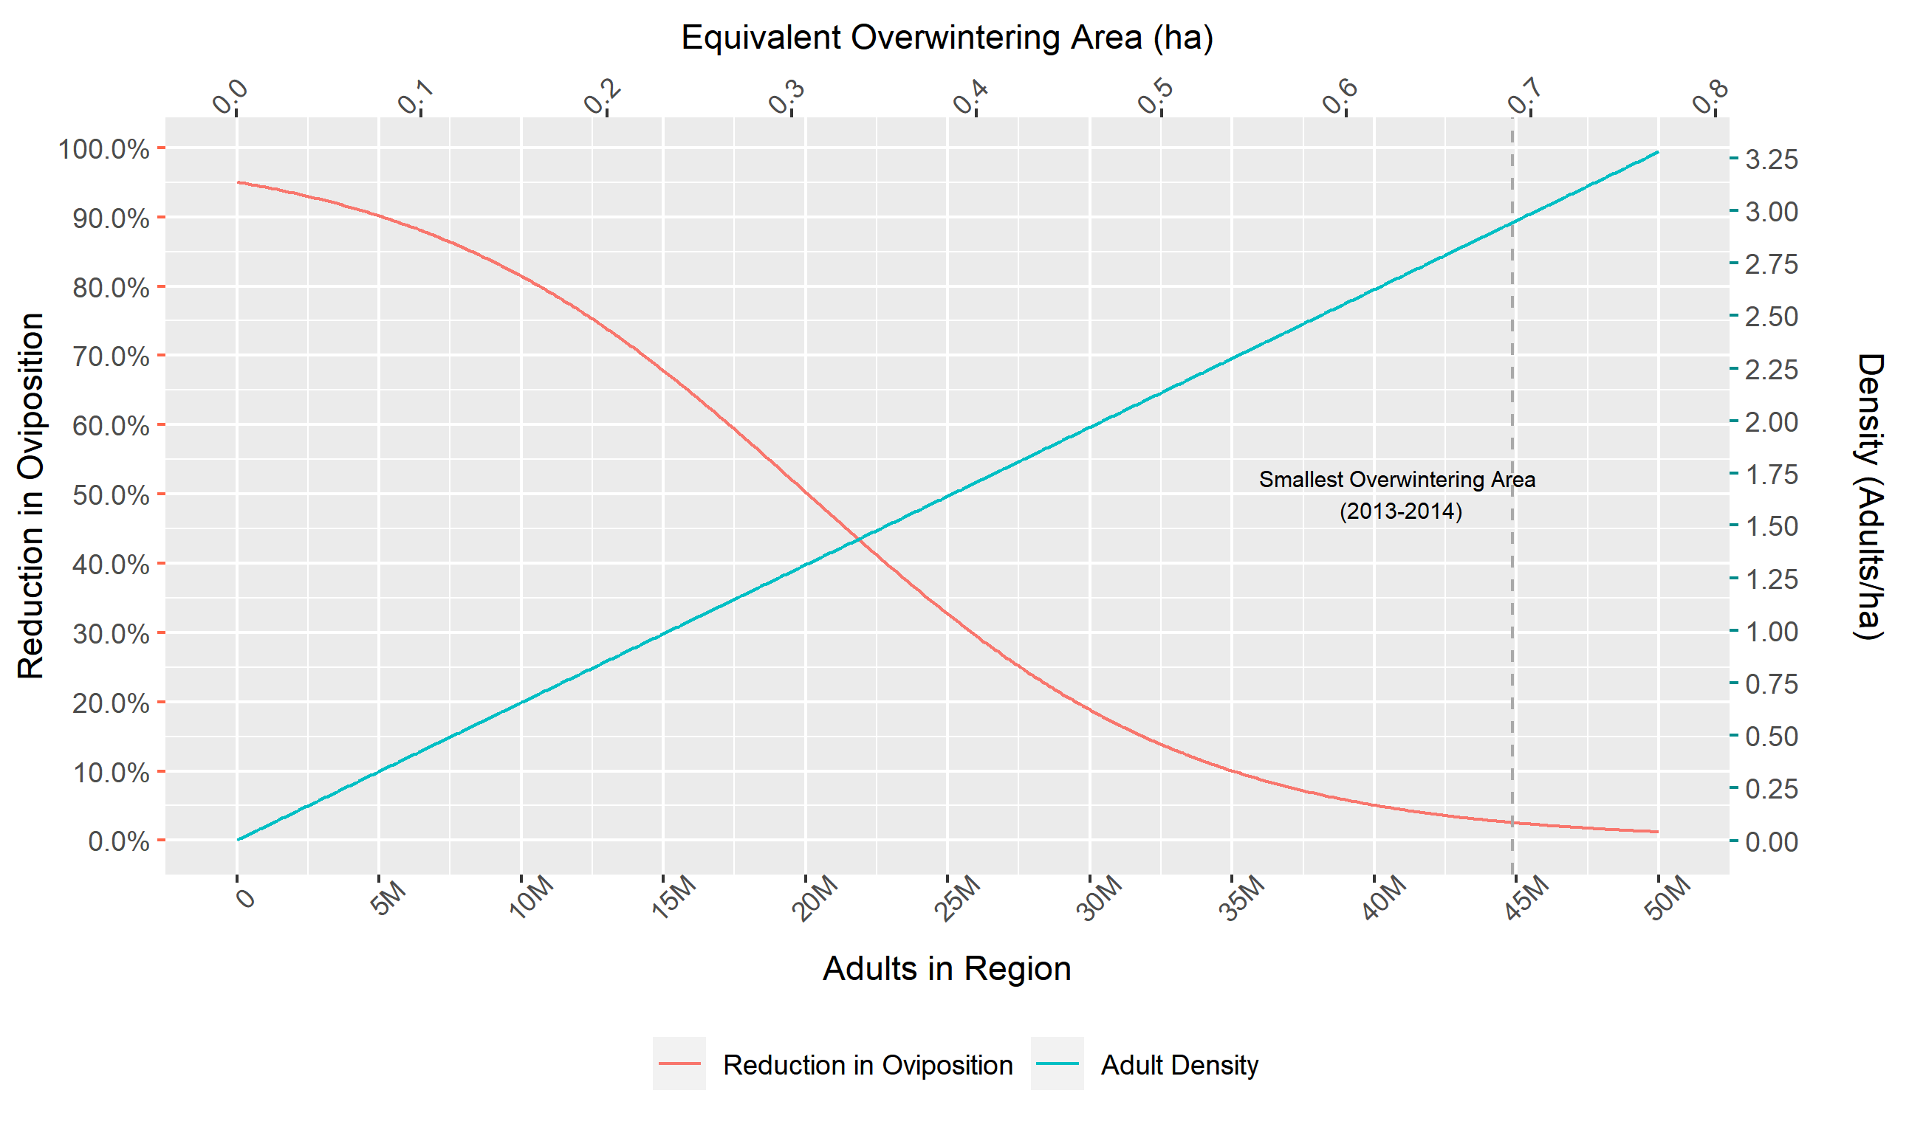

Figure 7 Curve of the depensatory effect across the breeding regions. The female’s oviposition success is reduced (cyan line, left y-axis) as adults' density across the landscape (orange line, right y-axis) reaches a critical threshold. The lower y-axis shows the number of adults across a region, and the upper axis shows the equivalent of those adults as the area of overwintering colonies. For example, during the lowest overwintering season (2013-2014), the total overwintering area was 0.69 ha. Considering the mean fecundity and survival of the migrant females and the mean 1st generation immature survival from Oberhauser et al. (2017), along with a conservative 1:1 sex ratio, the 1st spring generation adults in the South were approximately was 31.3x106. Based on that, the adult’s density per hectare was approximately 0.2 Adults/ha, which reduced the first spring generation's oviposition success by 15%. This plot and the example are based on one sample drawn from the Overwintering Density parameter's posterior distribution. In reality, a distribution of this parameter is what generates the output of the model.

## Fall Migration Mortality

Multiple demographic drivers exist during the fall migration, e.g. road mortality, mosquito-controlling pesticides (Tracy, Kantola, Baum, & Coulson, 2019), ‘sequestration of migrants’ by tropical milkweed (*Asclepias curassavica*) in the southern region (Rebecca V Batalden & Oberhauser, 2015), and climactic adversities such Atlantic hurricanes (Ries, Neupane, Baum, & Zipkin, 2018) and droughts that could strongly alter the availability of nectar sources (L. P. Brower, Fink, & Walford, 2006). Moreover, some authors propose that some of these drivers may not be solely detrimental but could improve migration success (Ries et al., 2018); however, there is an ongoing debate about their strength and impact. The MOBU-SDyM indirectly incorporates these arguments by including a fall migration mortality parameter (named ‘Hurricanes Estimate’ in the model) parameterized through its estimated posterior distribution.

The MOBU-SDyM assumes that all the factors comprising the fall migration mortality are constant over time, except for the hurricane's season intensity, expected to increase in the future (Villarini & Vecchi, 2013). The model uses the historical records of the Power Dissipation Index[3] and its forecasted behaviour (Villarini & Vecchi, 2013) as a proxy of mean hurricane intensity. The posterior distribution of the fall migration death rate gives a general sense of the possible magnitude of mortality during the fall migration but does not discern which of all those elements are the main contributors to that value. Section 2.3.2.3 describes the equations that incorporate the ‘Hurricanes estimate’ (${Hd}_{t}$) in the model.

.

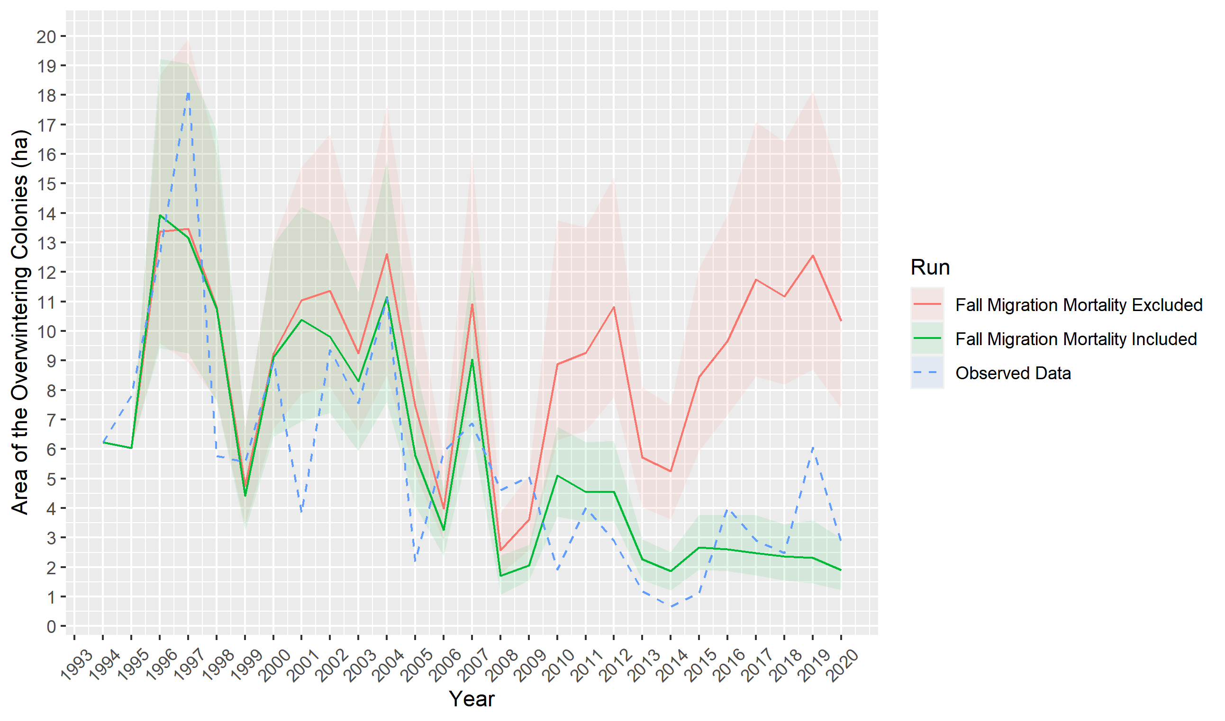

Figure 8 Difference of model's output when including an estimate for fall migration mortality

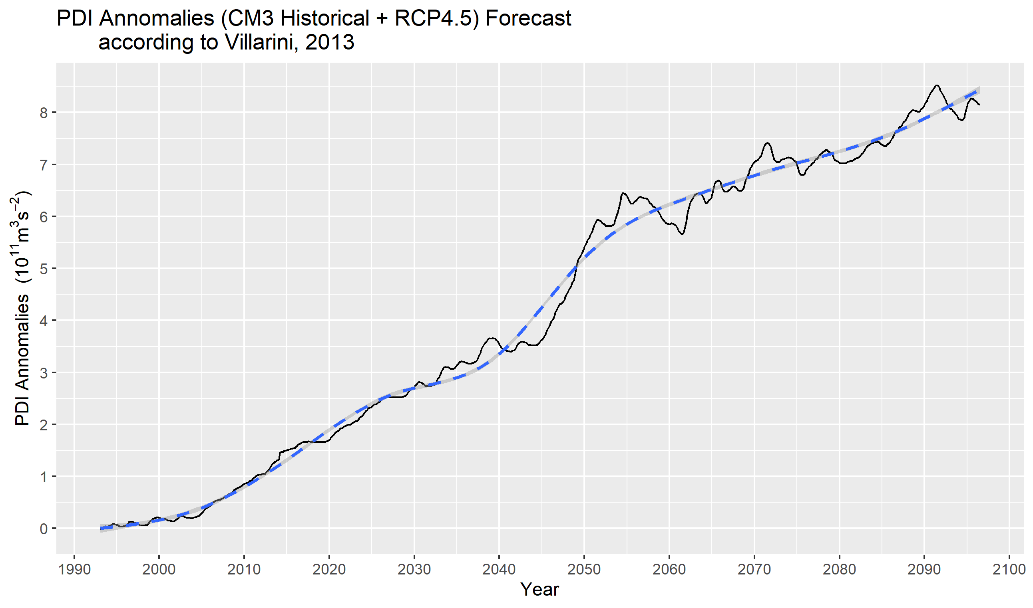

Figure 9 Power Dissipation Index anomalies based on the Geophysical Fluid Dynamics Laboratory CM3 model (GFDL-CM3) with the Representative Concentration Pathway 4.5 projected (Villarini & Vecchi, 2013).

## Weather-Related Overwintering Mortality

Most of the eastern Monarch population gather in just a few forest patches from early-November to mid-March (Urquhart & Urquhart, 1978). This elevated concentration of individuals makes the overwintering sites extremely vulnerable to perturbations, where a localized threat can be devastating (Oberhauser et al., 2008). Although predation by birds and rodents is a constant pressure, the greatest threat to the overwintering Monarchs is extreme weather events such as winter storms (W. H. Calvert, Zuchowski, & Brower, 1983). Some such events have killed up to 30% of the entire population at a time (L. P. Brower et al., 2004). The exposure to open-air due to forest canopy degradation, mostly driven by illegal logging, can exacerbate such casualties (Anderson & Brower, 1996).

In the model, the number of individuals dying within the Overwintering region (${Od}_{t}^{ }$; eq. 33) is a function of the proportion of individuals who die from background drivers, e.g. predation, tourism, exhaustion (${Pd}_{t}^{ }$), and the proportion of individuals who die due to extreme weather events (${Cd}_{t}^{ }$; eq. 34). The MOBU-SDyM calculates the extreme weather-related death rate based on the interaction of precipitation (${Ppt}_{OW,t}$) and temperature (${Temp}_{OW,t}$), the probability of Monarchs mortality to freezing temperatures when they are either wet (${OWd}_{wet}$; eq. 35) or dry (${OWd}_{dry};eq. 36$), and the canopy’s “blanket effect” on the Monarch’s body temperature $({BodyTemp}_{t}$; eq. 37), a function of the parameter Exposure to open sky (Anderson & Brower, 1996). Since the exposure to the open sky is highly variable depending on every overwintering colony's specific location, which varies considerably every year, we generated a posterior sample for this parameter.

${Od}_{t}^{ }={(Overwintering}_{t}^{ }*{Pd}_{t}^{ })+{{(Overwintering}_{t}^{ }*Cd}_{t}^{ })$

${Cd}_{t}^{ }=\left((1-{Ppt}_{OW,t}\right)*{OWd}_{dry})+({Ppt}_{OW,t}\text{*}{OWd}_{wet})$

${OWd}_{wet}=\frac{1}{1+e^{-1.9*\left({BodyTemp}_{t}-7.9\right)}}$

${OWd}_{dry}=\frac{1}{1+e^{-3.9*\left({BodyTemp}_{t}-4.4\right)}}$

${BodyTemp}_{t}=\left(1.078*{Temp}_{OW,t}-\left(0.034*Exposure*100\right)-0.089\right)$

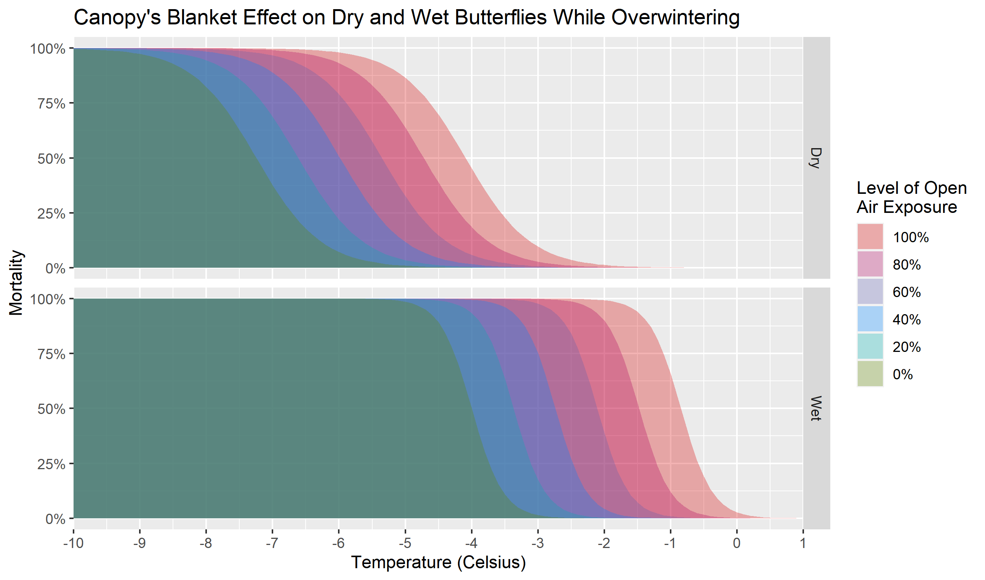

Figure 10 Change in Monarchs’ mortality when exposed to different ambient temperatures under many exposure levels to open sky and humidity. Calculated from eq 35 and eq 36, obtained from Anderson & Brower (1996)

# Data Evaluation

This TRACE element describes the quality of the data and its sources used to parameterize the model both by direct methods and reversely via Bayesian model calibration.

## Section Summary

3. Data Evaluation 25

3.1. Section Summary 25

3.2. Use of Expert Opinion 25

3.3. Parameter Calibration 25

3.4. Parameters Used in The Model 27

3.4.1. Movement Parameters 27

3.4.2. Demographic Parameters 28

3.4.3. Pressure Parameters 30

3.4.4. Habitat Parameters 31

## Use of Expert Opinion

The process of improving the model’s structural hypotheses relied on the continuous input from experts in the field, either through direct interviews or through solicited feedback at several conferences. Experts also provided their expertise in formulating and endorsing some of the model’s assumptions (e.g. Moisture-Temperature milkweed growth curve).

## Parameter Bayesian Inference

One of the tenets of Systems Dynamics modelling is to use parameters in the less possible aggregated form (Graham, 1980). This principle allows the model to have a less ‘dictated’ behaviour and allows emergence to prevent overfitting (Yates, 2012). However, in most ecological systems, there is not enough empirical data to parametrize all the possible variables that can be included in the system. Nevertheless, the use of sound ecological theory supporting the structural hypothesis of the system, along with Automated Calibration (AC) techniques such as Full-Information Maximum-Likelihood via Particle Filtering (FIMLPF; (Peterson, 1980)) and Model Reference Optimization (MRO; (Lyneis, 1996)) can help to overcome this challenge (Oliva, 2003).

Here, we used a Bayesian Inference Particle Filtering approach (Tulsyan et al., 2016) to estimate the posterior distribution of the variables that, based on the theory, were included in our structural hypothesis but were uncertain or unknown. The priors and search ranges for each parameter were established from either previously reported data (Monarch’s overwintering density, Temperature migration threshold, Mean milkweed patch area, and Fall migration weather-related mortality), or similar systems (Ideal temperature and humidity for milkweed growth and Depensatory effect). The priors used for each of the parameters and the posteriors estimated are shown in Figure 11.

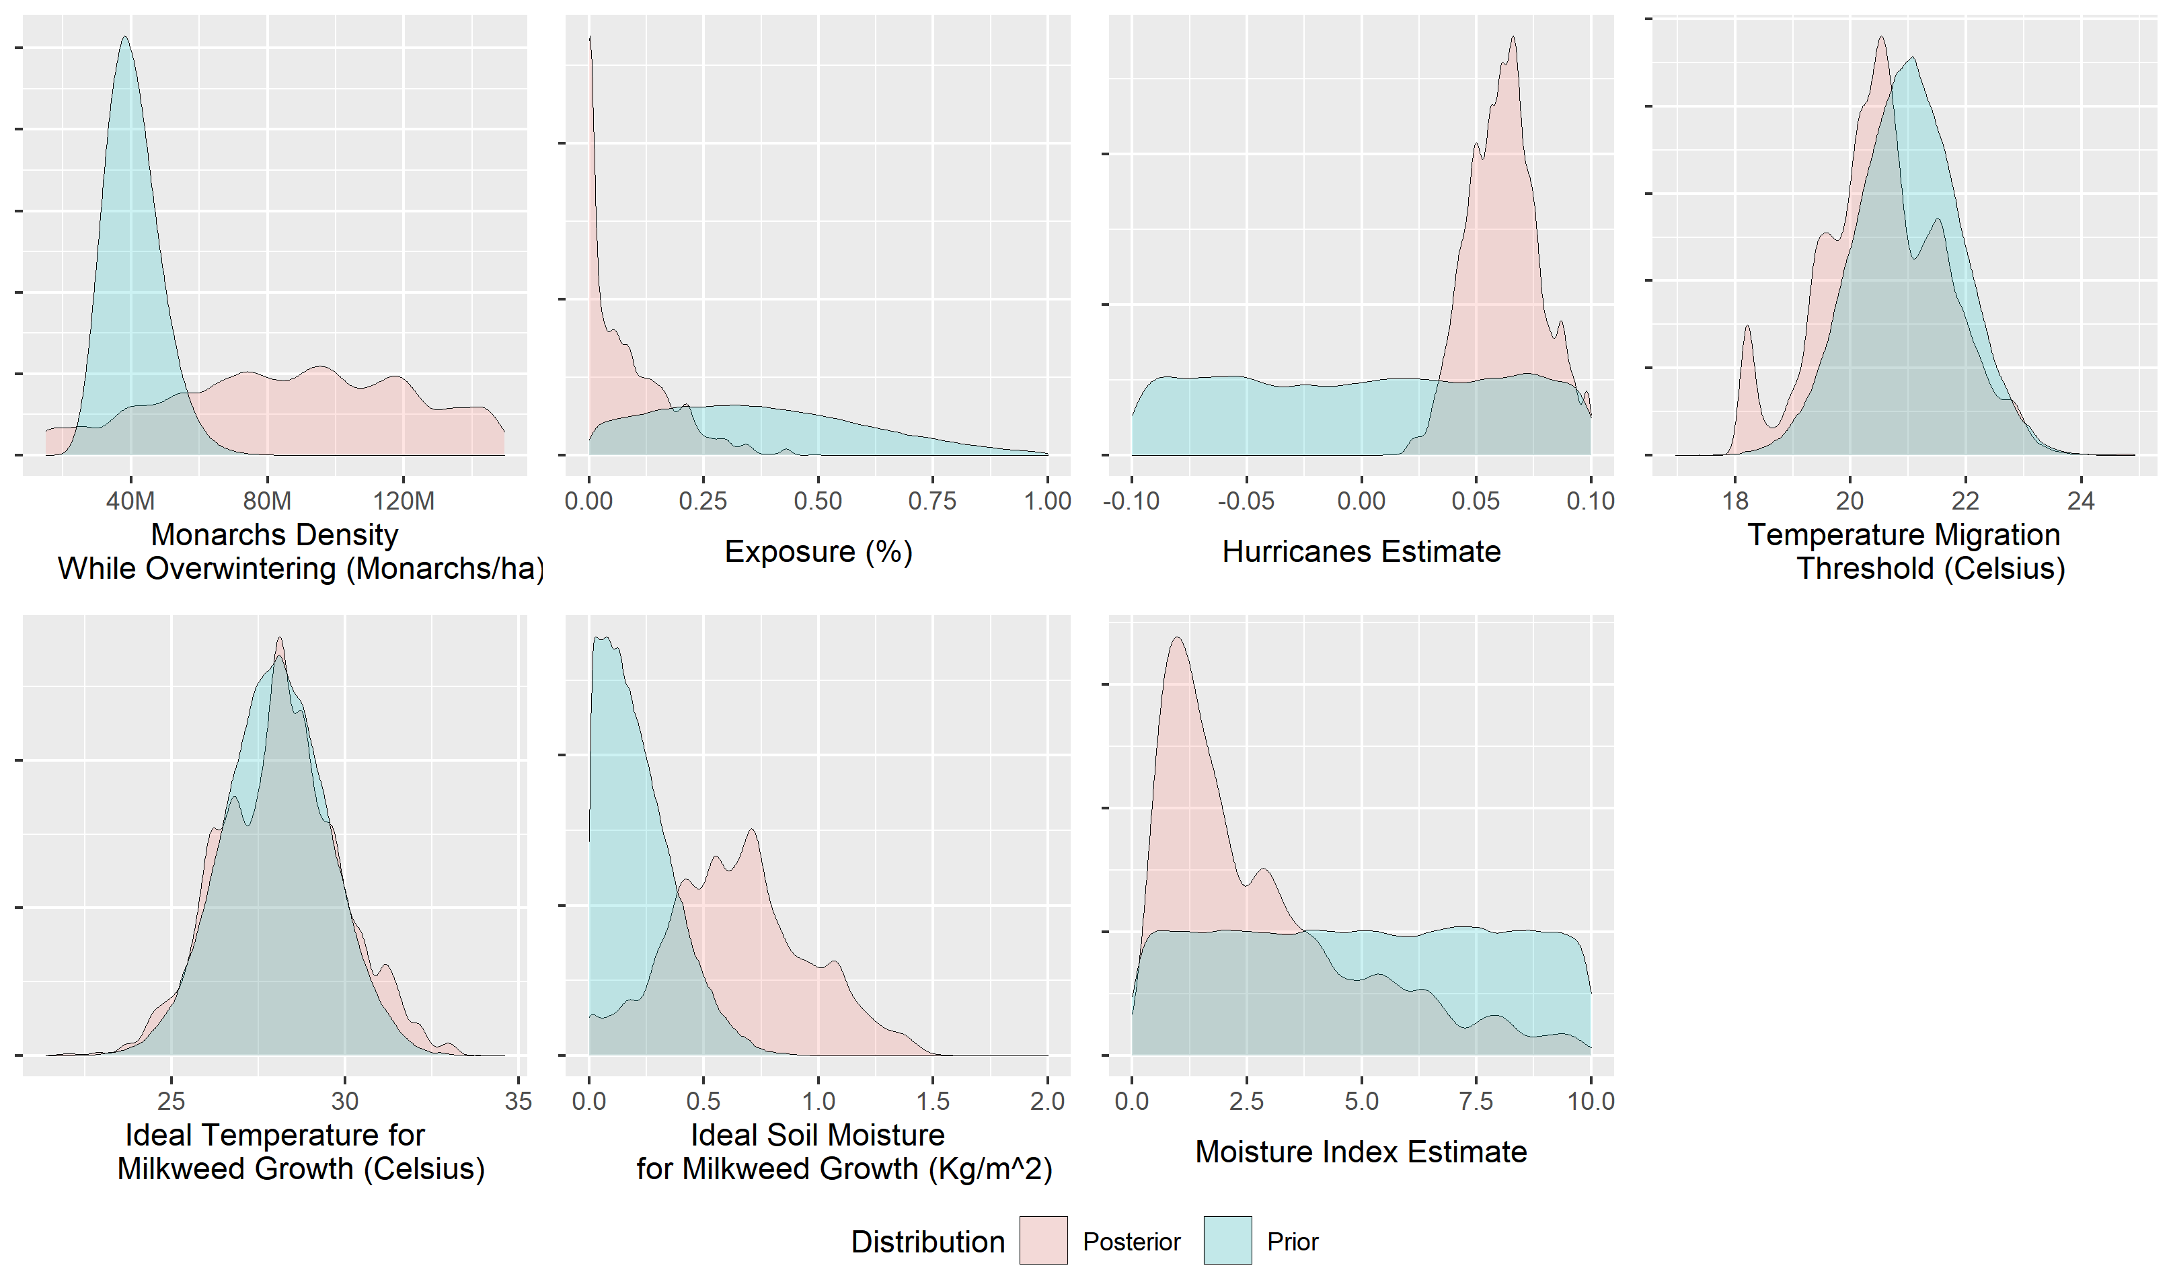

Figure 11 Prior and posterior distributions of the parameters explored. The prior distributions of the Hurricanes and Moisture Index estimates were uniformly distributed through wider ranges than shown in the image (-4 to 4 and -100 to 100, respectively), but it was cropped in the graph to show more detail of the posterior.

Two elements comprise the payoff function (eq. 38) defining the likelihood surface that the algorithm explored: i) the sum of the log-likelihoods of all the priors given the vector of parameters used ($θ$), and ii) an assumed log-gaussian-distributed measurement error of the observed data of 1.96 standard deviations (Vensim, 2010); previous modelling efforts (Flockhart et al., 2014a) have assumed similar measurement error (Figure 12).

$payoff=\log\left(L\left(computed|θ\right)\right)-\frac{{{\left(log⁡(computed)-log⁡(observed))\right)}^{2}}/{{\log\left(1.96\right)}^{2}}}{2}-log(1.96)$

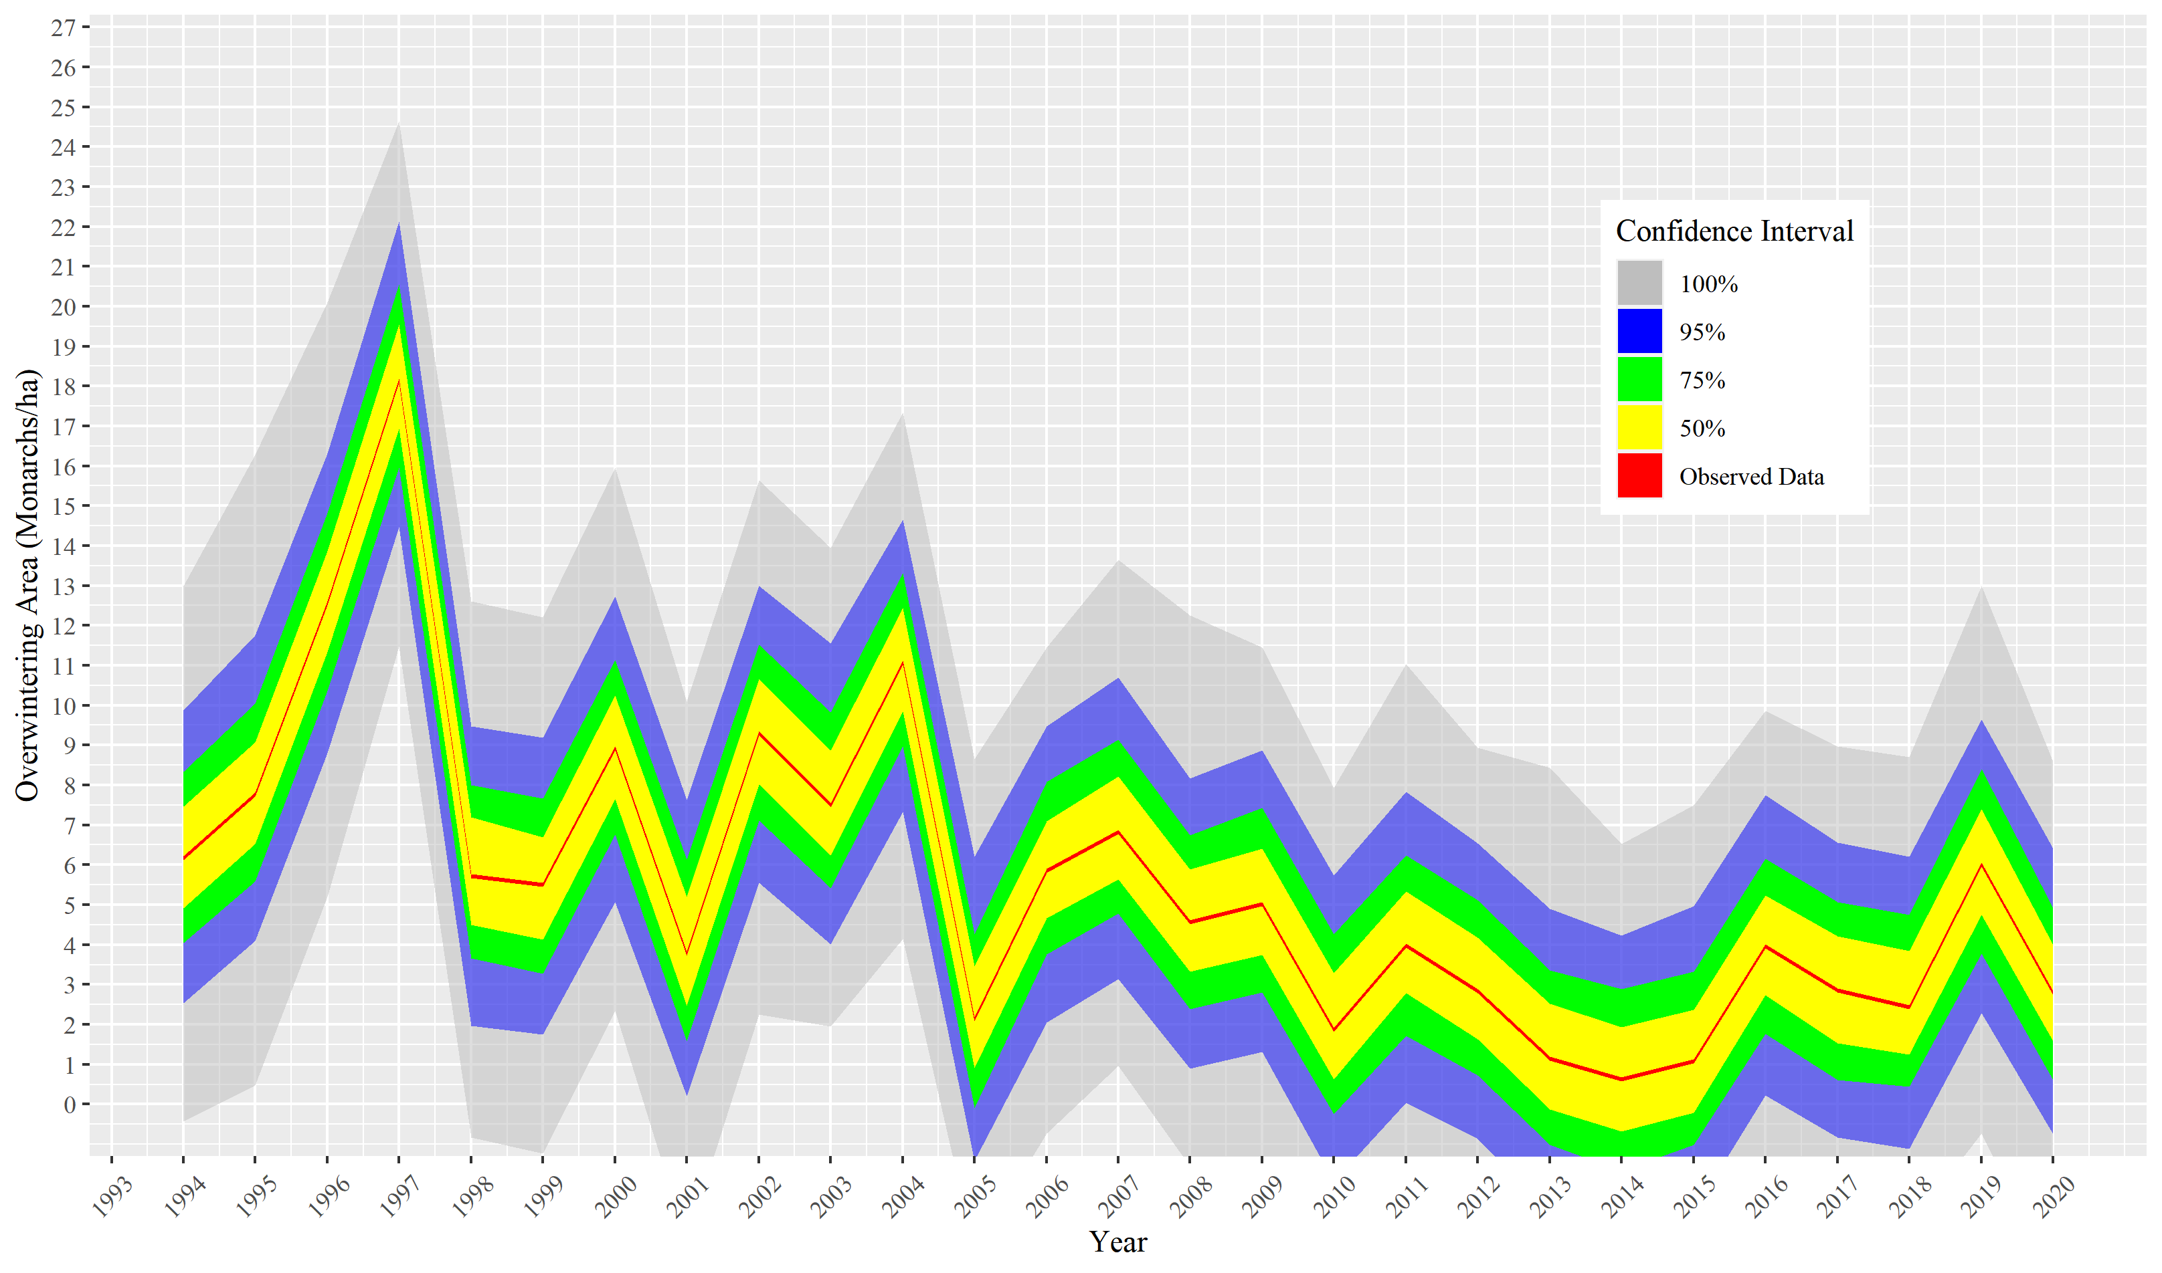

Figure 12 Gaussian-distributed measuring error of the overwintering colonies assumed for the payoff function

## Parameters Used in The Model

This section summarises in tables the numerical values and equations that parameterize the model. A text preceding the tables describes the parameters that require further clarification, such as assumptions, numerical treatment, quality of the source, or discrepancies among different sources.

## Movement Parameters

The model assumes the transition of individuals from one area to another, using values from Flockhart et al. (2014b), which, in turn, are based on Flockhart et al. (2013b). Since the model’s time step is 0.25/day and the movement parameters are monthly, the model assumes a one-month ramp increase instead of a quick step from one day to the next. The model also includes individuals' mortality while transitioning between areas using normal (for the breeding areas) or beta (for the fall migration) distributed stochastic variables. The fall migration mortality within the breeding areas from Flockhart et al. (2014b), adopted in the model, results from an expert elicitation exercise by that author.

Table 2 Monthly proportion of Monarchs transitioning between regions of the model and their associated mortality — table modified from Flockhart et al. (2014b).

|  |  |  |  |  |  |  |  |  |  |  |
| --- | --- | --- | --- | --- | --- | --- | --- | --- | --- | --- |
| **Destination** |  | | **Origin** | | | | | | | |
|  | | **Mexico** | | **South** | | **Central** | | **North** | |
|  | | **Proportion $$D_{Ow,t}^{y}$$** | **Mortality $${Dd}_{OW, t}^{y }$$** | **Proportion $$D_{South,t}^{y}$$** | **Mortality $${Dd}_{South, t}^{y }$$** | **Proportion $$D_{South,t}^{y}$$** | **Mortality $${Dd}_{South, t}^{y }$$** | **Proportion $$D_{North,t}^{y}$$** | **Mortality $${Dd}_{North, t}^{y }$$** |
|  | **South** | 0.875 | (1.212, 1.132) |  |  |  |  |  |  |
| **April** | **Central** |  |  |  |  |  |  |  |  |
|  | **North** |  |  |  |  |  |  |  |  |
|  | **Mexico** |  |  |  |  |  |  |  |  |
| **May** | **South** | 0.697 | (1.212, 1.132) |  |  | 0.039 | N(0.433, 0.128) |  |  |
|  | **Central** | 0.348 | (0.500, 2.052) | 0.130 | N(0.733, 0.137) |  |  |  |  |
|  | **North** |  |  |  |  |  |  |  |  |
| **Jun** | **Central** |  |  | 0.355 | N (0.733, 0.137) |  |  |  |  |
|  | **North** |  |  | 0.333 | N (0.544, 0.183) | 0.667 | N(0.742, 0.140) |  |  |
| **Jul** | **Central** |  |  | 0.183 | N (0.733, 0.137) |  |  | 0.017 | N(0.5, 0.191) |
|  | **North** |  |  | 0.169 | N (0.544, 0.183) | 0.738 | N(0.742, 0.140) |  |  |
| **Aug** | **Central** |  |  | 0.180 | N (0.733, 0.137) |  |  | 0.084 | N(0.5, 0.191) |
|  | **North** |  |  | 0.016 | N (0.544, 0.183) | 0.438 | N(0.742, 0.140) |  |  |
|  | **Mexico** |  |  | 1 | N (0.31, 0.160) |  |  |  |  |
| **Sep** | **South** |  |  |  |  | 0.563 | N(0.31, 0.128) | 0.125 | N(0.310, 0.128) |
|  | **Central** |  |  |  |  |  |  | 0.167 | N(0.433, 0.191) |

## Demographic Parameters

The demographic parameters shape the Monarch's life history within the model and determine mortality, productivity, and development time (Table 3). The number of eggs per female per day, the total number of adults in a region at a specific time step, and the sex ratio of those adults contribute to that region's daily productivity. Grant, Parry, Zalucki, & Bradbury (2018) measured the number of eggs that a female lays per day according to its age as an adult. To generate that age-dependent egg-laying behaviour, the model uses a linear decay function that takes the average age of the individuals in a specific region at each time step, bounded by zero (to avoid negative egg output over the winter months).

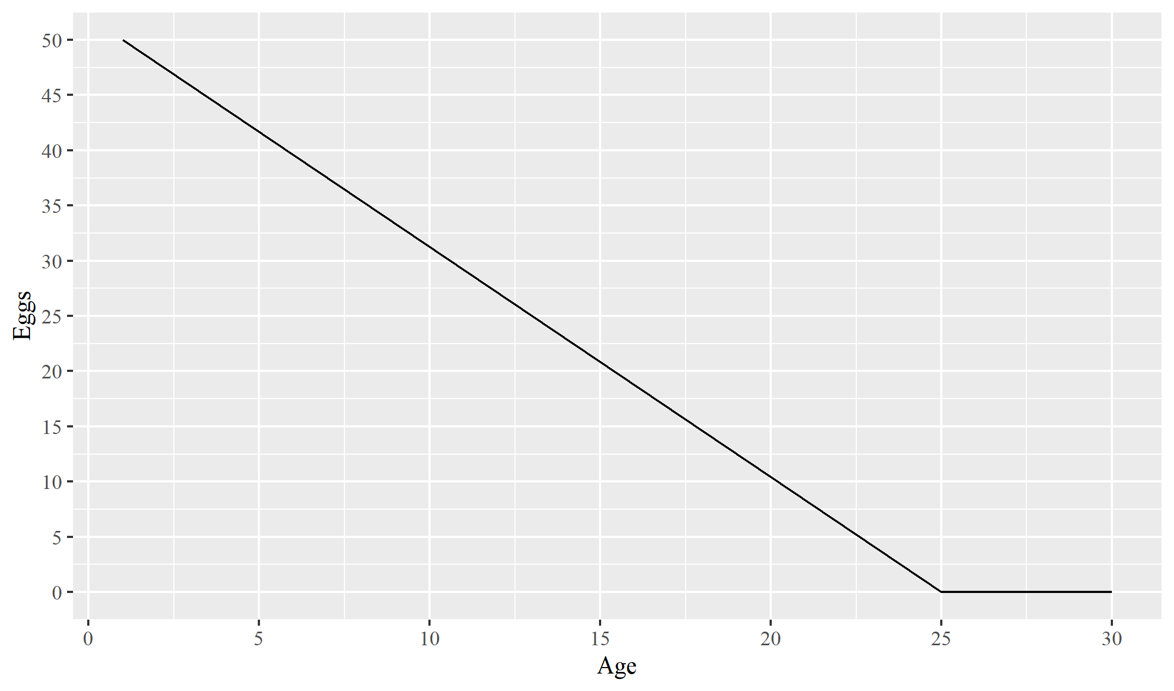

Figure 13 Relation between female age and egg daily egg output.

The demographic unit of the model is the individual. However, the total number of individuals able to produce offspring depends on the sex ratio at a specific time. Davis & Rendón-Salinas (2010) describe a shift in the sex ratio from approximately 56% of females in 1975 to 43% in 2010 resulting from an apparent preference of O*phryocystis elektroscirrha* to infest more females than males. Recent research has shown that this protozoan is more prevalent in Monarchs bred in Tropical Milkweed (*Asclepias curassavica*) and that it could be a factor furthering the decline of the Monarch (Satterfield, Maerz, & Altizer, 2015). Even though there are no data on this trend after Davis & Rendón-Salinas (2010), the model conservatively assumes the downward trend continues, though at only 10% the rate from 1975-2010 (Figure 14).

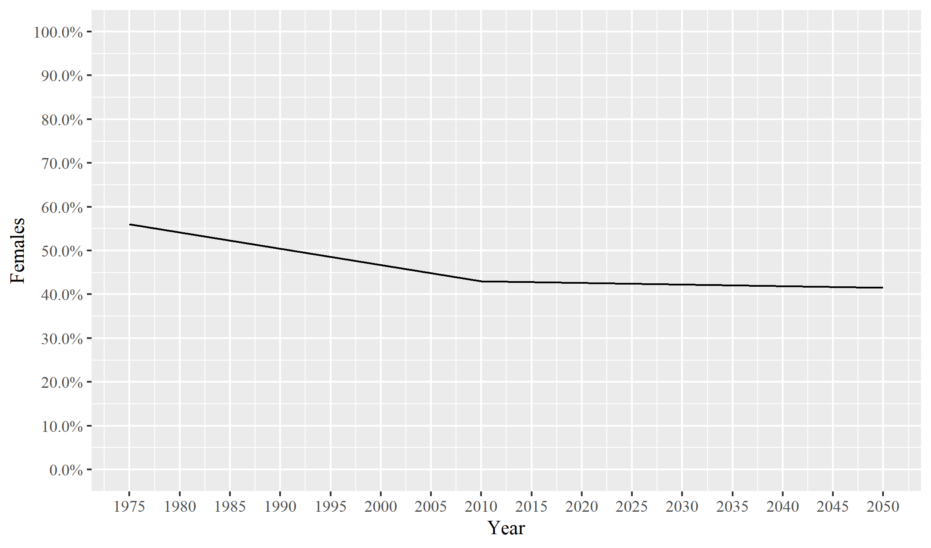

Figure 14 Shift of sex ration assumed in the model

Several papers document the survival of immature Monarch as a function of either specific stressors (Prysby, 2004) or specific stages (M. P. Zalucki, Brower, & Alonso-M, 2001). To keep the model on a manageable size, it concentrates all the immature life stages in one single class (eggs, pupae, and all five larval instars). Since Oberhauser et al. (2017) uses a similar analysis scale, we used that reference as the source for this parameter. However, since the model uses a dynamic development time, unlike the source reference, it divides the reference parameter by the current development time at every time step to obtain the specific survival for every time step. Moreover, Oberhauser et al. (2017) provide different survival rates for the early and late breeding season; here, the model captures such variation with a lookup table that sets a gradual increase between the last day of the early season (31st day of May) and the first day of the late season (1st day of September).

The density of Monarchs while overwintering is one of the most substantial sources of uncertainty within the system. Efforts are underway to estimate it better using LiDar and Thermography (Holt, 2017) technology. However, the density observed is highly variable at a microclimatic level, mainly based on temperature and dewpoint (Thogmartin, Diffendorfer, et al., 2017), so, unless these variables have been recorded accurately for previous years, only current and future densities can be estimated. Previous research has proposed densities ranging over an order of magnitude, from 6.9-60.9 million butterflies ha-1 (W. Calvert, 2004). Recently, Thogmartin, Diffendorfer, et al. (2017) developed a metanalysis and proposed a density log-normally distributed median of 21.2 million butterflies ha-1. Due to this high uncertainty parameter, we estimated its posterior distribution, using it for further analysis.

Table 3 Demographic parameters

|  |  |  |  |
| --- | --- | --- | --- |
| **Parameter** | **Value** | **Symbol** | **Reference** |
| Eggs/female/day | $max\left(0, 52-\left(2*female post eclosion age\right)\right)$ | $${Ef}_{x,t}^{ }$$ | (Grant et al., 2018) |
| Sex Ratio | Sex ratio until 2010 = 623.4277-(0.288571*year)  Sex ratio after 2010 = 119.3378-(0.03788*year) | $${Sr}_{t}^{ }$$ | Based on Davis & Rendón-Salinas (2010) |
| Immature death rate  (early season—late season) | South: 0.9836-0.9964  Central: 0.9733-0.99377  North: 0.9731 | $${IDd}_{ x,t}^{ }$$ | (Oberhauser et al., 2017) |
| Daily death rate while overwintering | N(0.041,0.0173) /5 months | $${Odb}_{t}^{ }$$ | (Flockhart et al., 2014a) |
| Monarchs density while   overwintering | Posterior distribution generated | $$OWdens$$ | Calibrated to model fit based on Thogmartin, Diffendorfer, et al. (2017) L. P. Brower et al. (2004) |
| Adults’ longevity in ⁰DD | 330 ⁰D | $${Ta}_{ x,t}^{ }$$ | (Gossard & Jones, 1977; M. P. Zalucki, 1981) |
| ⁰DD to eclode | 180 ⁰D | $${Te}_{ x,t}^{ }$$ | (M. P. Zalucki, 1982) |
| ⁰DD to hatch | 45 ⁰D | $${Th}_{ x,t}^{ }$$ | (M. P. Zalucki, 1982) |
| ⁰DD to pupate | 112 ⁰D | $${Tp}_{ x,t}^{ }$$ | (M. P. Zalucki, 1982) |
| Developmental zero | 11.5 ⁰C | $$Tl$$ | (M. P. Zalucki, 1982) |
| Heat impairment threshold | 32 ⁰C | $$Tth$$ | (Rawlins & Lederhouse, 1981; M. P. Zalucki, 1982) |

## Pressure Parameters

The pressure parameters are the elements that drive the biological model's behaviour away from the ‘ideal’ life history. Section 2.4 describes most of the parameters and their rationale, except the temperature and soil moisture parameters, described next.

Most of the pressure parameters are weather-driven. As such, it is vital to represent temperature and soil moisture as accurately as possible. However, with a non-geographically explicit model, it is only possible to generalize the weather across each region. As a temperature variable, we used a cubic smoothing spline to the calculated daily mean of the historical and forecasted daily soil moisture (0-10 cm) and air temperature near the surface for each region.

Table 4 Pressure parameters

| **Parameter** | **Value** | **Symbol** | **Reference** |
| --- | --- | --- | --- |
| Soil Moisture | CGMR_SRB1_2_G_mrso: total soil moisture content | $$H_{x,t}$$ | (Flato, 2007) |
| Temperature | CGMR_SRB1_2_G_tas: near surface air temperature | $$T_{x,t}$$ | (Flato, 2007) |
| Soil Moisture Estimate | Posterior distribution generated | $$Me$$ | Calibrated to fit overwintering area values |
| Sun Angle Trigger | 52⁰ | $$°Sun$$ | (Perez & Taylor, 2004) |
| PDI Anomalies | Lookup table from Figure 9 | $${PDI}_{t}^{ }$$ | Digitized from fig 4 of Villarini & Vecchi (2013) |
| Depensatory effects | $$\frac{1}{1+e^{Adults*3.4*{10}^{-8}-2.84}}$$ | $${Al}_{ x,t}^{ }$$ | Calibrated to fit overwintering area values |
| Hurricanes Estimate | Posterior distribution generated | $$P$$ | Calibrated to fit overwintering area values |
| Temperature Migration Threshold | Posterior distribution generated | $$TT$$ | Calibrated to fit overwintering area values |

## Habitat Parameters

The lack of milkweed across the breeding regions is considered one of the main drivers of the Monarch’s decline (Pleasants & Oberhauser, 2012) and, although many alternative hypotheses exist (Davis & Rendón-Salinas, 2010; Inamine, Ellner, Springer, & Agrawal, 2016; Tracy et al., 2019), it is undeniable that milkweed availability plays an important role. However, the modelling efforts until now (Flockhart et al., 2014a; Oberhauser et al., 2017; Yakubu, Sáenz, Stein, & Jones, 2004) consider the number of milkweed stems as a steady element across the landscape, failing to capture its dynamic behaviour in response to climatic conditions. Even though several efforts have studied the relationship between plant growth and climatic conditions in the past (Flanagan & Johnson, 2005; Ramakrishna, Tam, Wani, & Long, 2006; Teskey & Hinckley, 1981; Wang, Wan, Xing, Zhang, & Han, 2006), previous Monarch models have assumed a constant milkweed availability, unresponsive to climatic conditions, presumably, due to species-specific data available in that regard. However, by not including this element, a potentially critical factor is left out (particularly with the advent of climate change). Here, the model captures the milkweed’s dynamic behaviour to soil moisture and temperature by assuming that its availability has an elliptic paraboloid-shaped relationship formed by those two elements (eq 23 and Figure 3).

Table 5 Habitat Parameters

|  |  |  |  |
| --- | --- | --- | --- |
| **Parameter** | **Value** | **Symbol** | **Reference** |
| Milkweed stems in 1993 | South: 1,343,170,000  Central: 2,975,310,000  North: 1,440,370,000 | $${MWt}_{x,1993}$$ | (Flockhart et al., 2014a) |
| The total area of the region | South: 157,137,000  Central: 163,844,000  North: 177,015,000 | $$A_{x}$$ | Google Earth |
| Milkweed stem density | 33,030 stems/ha | $$MWdens$$ | (Ralph, 1977) |
| Milkweed patch area | ln (N (-2.303, 0.693)) | $${Pa}_{x,t}$$ | Calibrated to model fit based on Hartzler & Buhler (2000) |
| Optimal soil moisture for milkweed growth | Posterior distribution generated | $$\hat{H}$$ | Calibrated to model fit |
| Optimal temperature for milkweed growth | Posterior distribution generated | $$\hat{T}$$ | Calibrated to model fit |
| Parameter A of oviposition success ~ interpatch distance logistic curve | 12000 | Ia | Based on M. Zalucki et al. (2016) and experts’ opinion |
| Parameter B of oviposition success ~ interpatch distance logistic curve | 3 | Ib | Based on M. Zalucki et al. (2016) and experts’ opinion |

# Conceptual Model Evaluation

## Section Summary

This TRACE element provides information and analysis on the assumptions of the model

4. Conceptual Model Evaluation 32

4.1. Section Summary 32

4.2. Spatial and Temporal Scale 33

4.2.1. Spatial Scale 33

4.2.1.1. Movement Across Regions 33

4.2.1.2. Overwintering Region 34

4.3. Stochasticity 34

4.4. Basic Model Assumptions 34

4.4.1. Assumptions related to habitat 35

4.4.2. Assumptions related to population dynamics 36

4.4.3. Assumptions related to the overwintering region 37

## Spatial and Temporal Scale

## Spatial Scale

## Movement Across Regions

The model considers the Monarch’s range as four discrete areas (Overwintering, South, Central, and North) extending more than 5,000 km from its southern to its northern range. The model considers Monarchs within a region will take the same amount of time to move to any other region. The most accurate information regarding the Monarch’s dispersal across its range takes this same assumption (Flockhart et al., 2013a).

Because of the scale of available movement data, the model assumes that Monarchs only move latitudinally, northwards at the beginning of the season and then shifting southwards at its end. Research shows that the Monarch's annual cycle has a clockwise movement, i.e. beginning northwest at the beginning of the season, then shifting north, by mid-summer, shifting east, and then finally migrating southeast back towards the overwintering sites (L. Brower, 1996). The difference between individuals' modelled and real movement across regions potentially exposes individuals to different climate stressors, but most of the Monarch's other full-cycle migratory models also ignore longitudinal movements (Flockhart et al., 2014a; Oberhauser et al., 2017).

Finally, the model considers a death rate during the fall migration, eliminating individuals who do not make it back to the overwintering sites. It is possible that some individuals that do not make it to Mexico are not dead but instead overwinter across the northern coast of the Gulf of Mexico (Howard, Aschen, & Davis, 2010); potentially, their offspring could rejoin the main migratory route the following spring, this route is ignored as well.

## Overwintering Region

The Monarch’s overwintering sites are the few forest patches in Mexico, where most of the eastern Monarch’s population gathers every winter (Urquhart & Urquhart, 1976). The overwintering sites in Mexico are a complex and dynamic array of smaller colonies that vary considerably in shape, size, density, and biogeographical features (Rendón-Salinas et al., 2019; Rendón-Salinas, Martinéz-Meza, Martinéz-Pacheco, & Crúz-Piña, 2018; Rendón-Salinas, Valera-Bermejo, Cruz-Piña, & Martinez-Meza, 2009, 2010; Thogmartin, Diffendorfer, et al., 2017). Colonies can move a considerable distance within the same season, and most of them are not consistently present every year (Vidal & Rendón-Salinas, 2014). However, the model simplifies the overwintering sites as a single unit that concentrates all the individuals within the system, mainly due to the lack of information regarding how individual Monarchs decide which colony they will go to and lack of site-specific bioclimatic information.

Also, even though no research has quantified the effect that tourism has on site-specific mortality of overwintering Monarchs, it is broadly agreed that it is considerable. However, this model does not include general nor site-specific tourism-related mortality (W. H. Calvert, Hyatt, & Villaseñor, 1986). Since the functional objective of the model is to assess the relative importance of the three different breeding regions with regards to the size of the overwintering colonies, we decided to have a finer resolution on those areas. In subsequent iterations of the model, the posterior distribution of tourism-induced overwintering mortality could be estimated the same way relevant uncertain variables were included in the current model.

## Basic Model Assumptions

All biological models are simplifications of nature (Hänninen, 2016), and as such, assumptions are unavoidable, either to reduce the computational load or due to lack of available information. Regardless of this inevitability, it is necessary to justify and explain the rationale behind these decisions and their potential effects. Here, the model has three main groups of assumptions concerning (1) habitat, (2) population dynamics, and (3) overwintering region.

## Assumptions related to habitat

The primary larval food source for the Monarch butterfly is the common milkweed (*Asclepias syriaca*). There are records of Monarch’s larvae using at least 33 other plants in the genus Asclepia (Ackery, Vane-Wright, & others, 1984; Mattila & Otis, 2003); however, up to 92% of Monarchs grow on common milkweed at any given time (Malcolm, Zalucki, & others, 1993). Including all Monarch’s possible host plants while also retaining the dynamic behaviour sought in the model would have entailed the inclusion of the specific biological parameters for each of those plants, mostly unknown in the literature. So, the model only accounts for the presence of A. syriaca. All previous modelling efforts have adopted this same design decision in the past (Flockhart et al., 2014a; Oberhauser et al., 2017).

Research across the Midwest (Hartzler, 2010) suggests that the land type of a milkweed patch location determines the patch's plant density (e.g. roadside, farmland, pasture, rangeland). Accounting for each land type in the model would have needed extensive extra information to parameterize an equally large number of patch availability subsystems to simulate their independent behaviour. As such, the model assumes a plant density of 33,030 stems per hectare (Ralph, 1977) with a similar growth rate and dependence on soil moisture and temperature regardless of the land type cover.

The model seeks to reflect the dynamic behaviour of milkweed availability as a function of soil moisture and temperature. However, this curve does not exist in the literature, so we created such hypothetical relation from the joint posterior distribution of the mean temperature and soil moisture found across the breeding regions and a scaling factor (we called the ”Moisture Index Estimate”). Moreover, a deeper level of detail would have included a time lag to account for the growing time of the milkweed to reach the expected number provided by temperature and soil moisture. Currently, the latency value that the model assumes is zero (i.e., milkweed availability reacts instantly to temperature and soil moisture). The reason for assuming this latency value is two-fold. First, there are no available data on the growth rate of milkweed as a function of temperature and soil moisture. Second, by having a rapidly reacting curve, there can be a better representation of climatic conditions variability (and consequently, milkweed availability). The dynamic availability of milkweed included in the model not only influences the number of stems, but, as in real life, it affects the area of milkweed patches and, consequently, the interpatch distance.

Interpatch distance is a relevant factor that can also affect the Monarch’s egg-laying success. A Monarch can fly daily distances up to 15 km, decreasing the probability of successfully laying eggs (M. Zalucki & Kitching, 1984). Accordingly, to include the effect that interpatch distance has on successful oviposition, the model assumes a decaying function describing it. However, the 15 km flying limit comes from a mark-recapture study, in which a Monarch captured, say, at 10 km from the origin has not necessarily flown 10 km; it most likely flew several times that distance but not in a straight line (M. P. Zalucki & Kitching, 1982), implying that the function that we used here is very conservative.

Also related to the interpatch distance is the assumption that every milkweed patch is circular. Since the circle is the geometric shape with the smallest surface area to volume ratio, an assumed homogenous matrix of circular patches generates the largest average interpatch distances of any other patch shape. This assumption is necessary due to the model's non-explicitly geographic nature, and further modelling should consider the sensitivity of our results to this assumption.

The last assumption regarding habitat is that nectar availability is an element that does not change along different seasons and across years. Recent studies show that this is not the case, and nectar availability may be an essential element for the Monarch’s success (L. P. Brower et al., 2006; Ries et al., 2018). We decided not to include a specific parameter for this element since the functional objective of this research is to assess the effect that milkweed availability across the three breeding regions has on the size of the overwintering colonies. However, since this driver's magnitude and dynamics are not fully understood, we included it as part of the aggregate-level fall migration mortality parameter. Further iterations of the model should include this element at a less aggregate level to assess its specific contribution to the overwintering colonies' size.

## Assumptions related to population dynamics

There are still several life-history elements of the Monarch butterfly that are unknown, or at the very least, highly uncertain. Most of the research has focused on particular stressors without establishing any interactive effects, making this information challenging to incorporate in fully integrated migratory models such as the one presented here. More studies considering multiple stressors and standardized protocols are needed to inform more accurate full-cycle migratory models. Most of the data on Monarch’s biology comes from the Midwest, and its biology in other regions could be considerably different. However, given these limitations, the Monarch butterfly is one of the better-studied butterflies globally and enjoys interest by academics and citizen scientists alike (Solis-Sosa et al., 2019), which is almost unrivalled by any other insect (Oberhauser & Solensky, 2004). Moreover, the use of new modelling techniques enabled by the ever-growing computation power can overcome those knowledge gaps.

The model uses much information supplied by Oberhauser et al. (2017) and Flockhart et al. (2012). However, those two sources consider "upon-completion" survivorship, whereas the modelling technique used here requires daily survivorship. Moreover, since the time to maturation is not constant in our model, attempting to estimate daily survivorship by dividing the upon-completion value by the mean days-to-mature would assign an increased probability of survival to an individual maturing faster. While reasonable, this would not conform to the upon-completion survivorship parameters used, and so, the model assumes that survivorship is independent of maturation time, i.e., longer maturing times are associated with higher daily survivorship. In this way, all individuals have the same total baseline upon-completion survival rate, making it comparable to the source parameters used (Oberhauser et al., 2017). The model also assumes that the sources of mortality included in the model are the only ones existing; many others may occur, so the estimates used here roughly include their effects.

Another element still a matter of debate is the cue or set of cues that cause the Monarch to cease breeding and begin migrating south. It is common knowledge for the Monarch experts that a sun angle of 52° at solar noon cues the Monarch’s migratory behaviour, although little peer-reviewed research exists in that regard (Perez & Taylor, 2004; Taylor Jr et al., 2019). However, the migratory behaviour does not appear precisely the same day every year as it would happen if the sun angle were the only cue. Evidence suggests that temperature and host plant senescence influence the reproductive diapause before migration (Goehring & Oberhauser, 2002), although the relation between sun angle, plant senescence, and weather variables is still unknown. The model explores that uncertainty by assuming a non-fixed migratory trigger (${Ft}_{x,t}$), i.e. not dependent on a specific date. Instead, the combination of sun angle at solar noon below 52° and a 5-consecutive-day mean weather temperature below a posterior sample of a temperature migration threshold sets off the migration trigger in each model's Breeding region. As in the real system, the migration trigger sets off earlier in the North region, following the Central and being last in the South. The priors used to estimate the temperature migration threshold's posterior distribution were the temperatures measured during the months that migration begins within each region.

Multiple reports suggest that several individuals migrating south do not conclude their migration down to Mexico but instead remain in the southern part of the United States (Rebecca Victoria Batalden, 2011). Research suggests that the presence of tropical milkweed *(Asclepias curassavica*) across this area, which has considerably increased over the last few years, could be driving the Monarchs out of their migratory route (Satterfield et al., 2018). The Monarchs that do not reach Mexico show increased parasitism (Altizer & Oberhauser, 1999), and it is uncertain what proportion of the offspring of those individuals will rejoin the main migratory route the next year. The model ignores this phenomenon entirely due to a lack of data.

## Assumptions related to the overwintering region

The model assumes that the Monarch density per hectare within the overwintering sites is constant over time and across colonies. However, in reality, the Monarch density varies widely across and within colonies, years, and even seasons (Keiman & Franco, 2004). Also, the model assumes that any individual outside the overwintering sites by the end of the year will die, which, as discussed in the previous section, disregards individuals that, in reality, stay in the southern US during the winter months. However, we believe this has little impact on our estimates due to the relatively small number of individuals who follow that route.

# Implementation Verification

This TRACE section provides information on testing the computer code and the performance metrics based on the reference model.

## Section Summary

5. Implementation Verification 38

5.1. Section Summary 38

5.2. Code Testing and Verification 38

5.3. User Interface 38

5.4. Output and Data Treatment 41

## Code Testing and Verification

The model was built in VENSIM DSS V 7.3.5 (Ventana Systems). The program compiles the model before running it and automatically checks for code consistency, circular references, and calculation errors (e.g. negative numbers, unit inconsistencies, lookups out of bounds). While running, the program also shows non-critical warnings such as ranges exceeded, which were fixed. For consistency and reproducibility, a command script specified all the runs (baseline or experiments).

The model development sought individual parts of the model's expected behaviour by comparing the partial output to a reference model or exploring extreme scenarios. Sensitivity analysis followed every step of the model development and included several sensitivity multipliers on key parameters (See section 7.1.1 below)

## User Interface

Vensim’s stock and flow graphic interface divides the model into eight different views (2 of them for controls and output) and uses subscripts for the three breeding regions.



Figure 15. Main View of the model. The Immature and Adults stocks and their rates are subscripted (South, Central, North). The blue colour represents the Monarch’s life cycle subsystem. The red represents the milkweed availability subsystem (also subscripted). Green variables were optimized during the search for an optimal allocation of milkweed restoration efforts. Variables in yellow are the parameters for which their posterior distribution was estimated. In purple, variables are not central to the model and were used to test the model during its development. Parameters in grey and within brackets are “shadow variables,” which serve to connect the different screens of the model



Figure 16. View of dispersion. This view calculates the movement (Blue) and mortality (Red) of individuals across regions. Parameters in grey and within brackets are “shadow variables,” which connect the model's different screens. Note that all these variables appear in the Main view as shadow variables. In purple, variables are not central to the model and were used to test the model during its development.



Figure 17 View of development time. Parameters in grey and within brackets are “shadow variables,” which connect the model's different screens. Note that most of these variables appear in the Main view as shadow variables.



Figure 18 View of Weather generation. Soil Moisture and Precipitation of the breeding areas (Red) are subscripted (South, Central, North). The weather subsystem for the Overwintering region is coloured in blue and the lookup table generating the PDI Anomalies (as a proxy for Atlantic Hurricanes’ intensity) is in green. Parameters in grey and within brackets are “shadow variables,” which connect the model's different screens. Variables in yellow are the parameters for which their posterior distribution was estimated



Figure 19. View of the migration trigger. Variables in yellow are the parameters for which their posterior distribution was estimated. Parameters in grey and within brackets are “shadow variables,” which serve to connect the different screens of the model



Figure 20 View of the milkweed availability and patch distribution, subscripted in South, Central and North regions. This view also includes the depensatory effect on Adults (Red). Parameters in grey and within brackets are “shadow variables,” which connect the model's different screens. In purple, variables are not central to the model and were used to test the model during its development.

## Output and Data Treatment

The model's main output is a graph of the Monarch overwintering area in hectares (Figure 19). This graph merges the reference values from Rendón-Salinas et al. (2019) and the simulated number of individuals within the overwintering region divided by the density estimate, given the parameters drawn from the posterior distribution. We used R 3.6.0 for Windows (R Core Team, 2019) to generate the output analysis and graphs.



Figure 21 Example of main baseline run output from the model. The red line represents the observed area of the overwintering colonies between 1994 and 2020. The blue line represents the simulated area of the overwintering colonies for the same time range, and the dashed line is the moving average of the simulated data. Note that the blue line's value decreases from the beginning to the end of each overwintering season, representing overwintering mortality and that the MOBU-SDyM uses the value observed on January 20th of each simulation year to compare against the observed data.

# Model Output Verification

This TRACE element is the critical assessment of 1) how well the model output matches observations, and 2) how much calibration and environmental drivers were involved in obtaining a good fit between model output and data.

## Section Summary

6. Model Output Verification 43

6.1. Section Summary 43

6.2. Calibrated system-level parameters 43

6.2.1. Overwintering density 43

6.2.2. Fall migration mortality 44

6.3. Model Verification 45

6.3.1. Mean of the Standard Deviates Verification 46

6.3.2. The Variance of the Standard Deviates Verification 46

6.3.3. Instantaneous growth verification 46

## Calibrated system-level parameters

Grimm et al. (2014) stress the importance of discerning between lower-level and system-level processes in the context of Dynamic Systems Modelling. In essence, the difference between these two types of variables is the level of aggregation that they use. For example, °D as the butterfly's developmental time driver would be a less aggregated variable than a parameter normatively dictating the development time without accounting for the physiological elements behind it. Parameterising a model with only system-level parameters would overparameterize it and not be useful for situations other than the same conditions in which the parameters were derived. Going back to the developmental time example, a model would only be accurate about the development time if the system's temperature modelled is the same as the temperature in which the parameter was measured initially.

Conversely, a model consisting solely of lower-level parameters, such as °D-dependent development, cannot directly drive the model; instead, these lower-level parameters can establish the conditions for behaviour to emerge from their interaction (Yates, 2012). Moreover, since system-level parameters are normative, i.e., drive the model's behaviour, it is essential to describe them and justify the soundness of their inclusion. Most models are a mix of these two types of variables. Through Bayesian inference particle filtering, we included the posterior distribution of two uncertain system-level parameters, Overwintering Density and Fall migration mortality, that we analyze next.

## Overwintering density

Previous sections described the importance of having a density conversion factor to translate individuals into hectares of overwintering colonies. That conversion factor is still elusive to researchers and remains one of the primary sources of uncertainty for Monarch butterfly demographics models. Incorrect conversion factors have effects beyond estimates of actual numbers – for instance, because of density-dependent effects (Flockhart et al., 2012), different density estimates lead to considerably different model dynamics. We accounted for his uncertainty by estimating this parameter's posterior distribution through our Bayesian inference particle filtering approach using priors as the lowest and highest estimates in the literature (W. Calvert, 2004).

## Fall migration mortality

Many factors not sufficiently studied but broadly assumed to be present influence the Monarch’s ability to reach the overwintering sites from the southern US, e.g. road mortality, mosquito-controlling pesticides (Tracy et al., 2019), ‘sequestration of migrants’ by tropical milkweed (Asclepias curassavica) in the southern region (Rebecca V Batalden & Oberhauser, 2015), and climactic adversities such Atlantic hurricanes (Ries et al., 2018) and droughts influencing the availability of nectar sources (L. P. Brower et al., 2006). Flockhart et al. (2014b) did an expert elicitation exercise to obtain an approximation of such mortality. Also, Ries et al. (2018) attempted to incorporate such effects by estimating the impact that Atlantic hurricanes have over nectar-providing flowers, suggesting that increased intensity of Hurricanes over the season while increasing direct mortality of butterflies might benefit Monarchs overall by increasing flower growth and providing an additional source of nectar (L. P. Brower et al., 2006).

Here, we included a mortality variable that would group all of those variables (and other unknown) into a single Bayesian posterior distribution. The MOBU-SDyM assumes that all the factors comprising the fall migration mortality are constant over time, except for the hurricanes season intensity, expected to increase in the future (Villarini & Vecchi, 2013). The model uses the historical records of the Power Dissipation Index and its forecasted behaviour (Villarini & Vecchi, 2013) as a proxy of mean hurricane intensity. The posterior distribution of the fall migration death rate gives a general sense of the possible magnitude of mortality during the fall migration but does not discern which of all those elements are the main contributors to that value.

This parameter, seen through its posterior distribution, showed a relatively minor effect on the overwintering numbers at the beginning of the simulation compared to other system-level parameters and increased overtime during the baseline model's timespan (Figure 25).



Figure 22 Effect that the Fall migration mortality has on the overwintering colonies size

## Model Verification

We assessed the MOBU-SDyM performance through predictive posterior predictive checks (Meng & others, 1994) using the posterior predictive distribution of the overwintering colonies simulated area on January 20th of every simulation year and comparing it with the real data provided by Rendón-Salinas et al. (2019). The model showed adequate performance in estimating the observed overwintering population's size, trend, and oscillations under the metrics we used. The posterior predictive checks of the models’ data, also known as ‘Bayesian p-value’ (Meng & others, 1994), showed 96% accuracy. In other words, the size of the overwintering colonies posterior predictive data distribution generated by the model included 96% of the times the data points from the observed colonies’ size (Figure 23). The visual overlay of the spread (Figure 24) and the observed and simulated data's empirical cumulative distribution function (Figure 25), another step of the posterior predictive checks, also accurately resembled the observed data.

Then, we estimated the mean and variance of the standard deviates (McCarthy & Broome, 2000) of the observed population’s growth rate (using the yearly area from Rendón-Salinas et al. (2019)) and simulated growth rate calculated for posterior predictive data of the whole posterior sample (39,980 samples). We compared the standard deviates mean and variance from both datasets using the One-Sample t-test and chi-squared tests, respectively. Full cycle migratory models of the Monarch have used this same measure of performance in the past (Flockhart et al., 2014a). The One-Sample t-test to the mean of the standard deviates failed to reject the null hypothesis that it was different to 0 (95% CI:[-3.87, 0.54], t= -1.56). The variance of the standard deviates evaluated via a Chi-squared test yielded a variance of 0.1215, rejecting the null hypothesis that it is equal to one, suggesting that the patterns obtained from the MOBU-SDyM tended to vary more than the observed data. The system's variance has been a problematic element to capture, and previous models have not been able to do so, either (Flockhart et al., 2014b).

As a final test of model performance, we used a Receiver Operating Characteristic (ROC) curve (Hanley & McNeil, 1982) to evaluate the model’s capacity to recreate the same oscillation pattern as the pattern of the observed data. The ROC curve evaluated the model's accuracy to predict the direction of the year-to-year growth of the observed data, i.e., if the population grows or shrinks. This metric yielded a level of accuracy of 67.91% (CI 95% [67.82-68.94]; Figure 26 ).

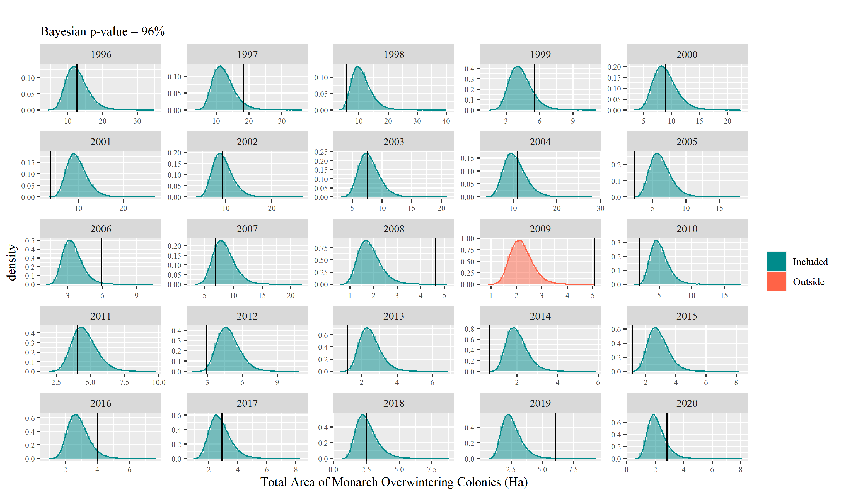

Figure 23 Posterior predictive checks. Histograms for the distribution of the simulated area of the overwintering size for each year, indicating a black vertical line the colonies' observed size that same year. The colour of the histogram indicates if the observed value lies within the distribution of the simulated data.

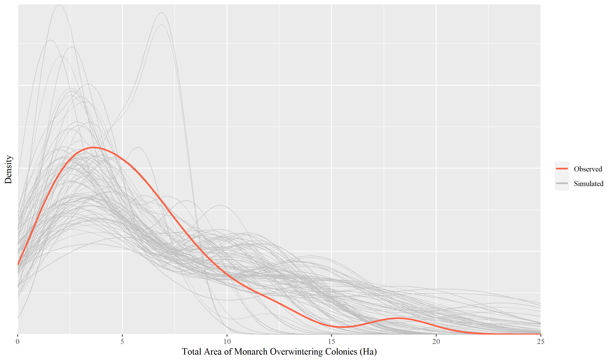

Figure 24 Posterior predictive check. Overlay of the observed (red) and simulated (gray) area distribution of the overwintering colonies

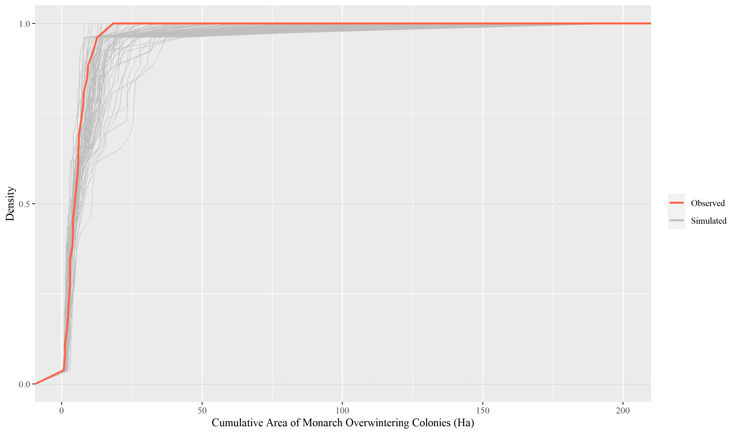

Figure 25 Posterior predictive check. Overlay of observed (red) and simulated (gray) area empirical cumulative density function of the overwintering colonies

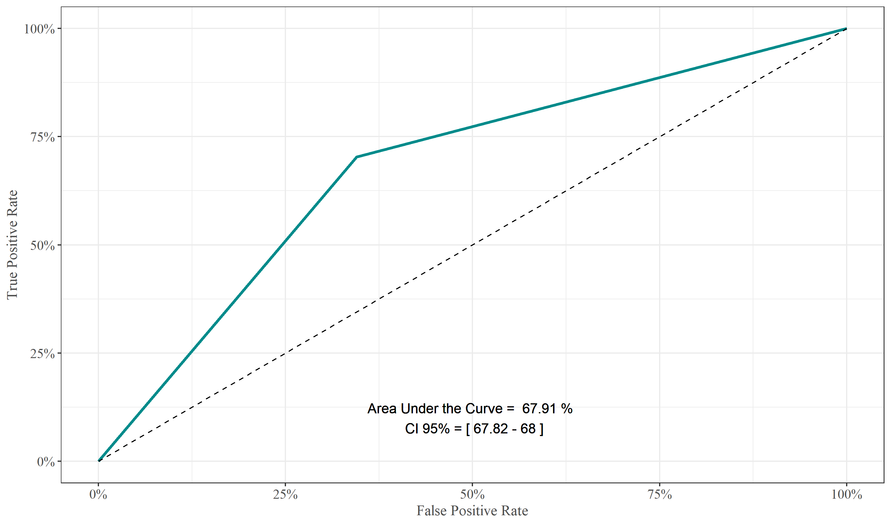

Figure 26 Receiver Operating Characteristic curve(ROC). This curve evaluates how well the model predicts the direction of the year-to-year growth of the observed data. The curve showed an accuracy of 67.91% (CI 95% [67.82-68.94]); considerably higher than a random toss would do, which is represented by the diagonal dashed line

# Model Analysis

This TRACE element supplies supporting information on 1) how sensitive the model output is to changes in model parameters (sensitivity analysis), and 2) how well the reasons behind the emerging behaviour of the model have been understood.

## Section Summary

7. Model Analysis 47

7.1. Section Summary 47

7.1.1. Sensitivity analysis 47

7.1.2. Individual Parameters 48

7.1.3. Groups of Parameters 49

7.1.3.1. Milkweed Availability 49

7.1.3.2. Conditions in the South 50

7.1.3.3. Overwintering Conditions 50

## Sensitivity analysis

Sensitivity analysis is a broad group of techniques that serve as a diagnostic and exploratory tool to probe how the model reacts to modifying one or a set of selected parameters (Senge & Forrester, 1980; Zi, 2011). Here, the model’s sensitivity to each of the model's constants was explored, and groups of the most relevant parameters.

### Individual Parameters

This analysis is the exploration of the model’s sensitivity to the variation of individual parameters. Here, the model changes the value of a single parameter by 5% (increase and decrease), iterating that process for each of the model's constants. The model stores the payoff from each run, which is the mean squared error between the observed and simulated area of the overwintering colonies, to generate a tornado plot for all the runs (Figure 27). The analysis reveals that, for biological parameters, changes in the number of adults in the South region affect the payoff more than the same change elsewhere. Conversely, egg-laying in the Central region had higher leverage in the payoff than other regions. The group of variables that, in general, showed the highest leverage were the ones related to migration. In turn, all those variables are governed by temperature, expected to increase in the coming years, making these variables of significant importance. The Moisture index estimate and Temperature migration threshold, both part of the model's uncertain variables, showed considerable payoff leverage, which underscores the importance of finding consistent empirical evidence of their real value.

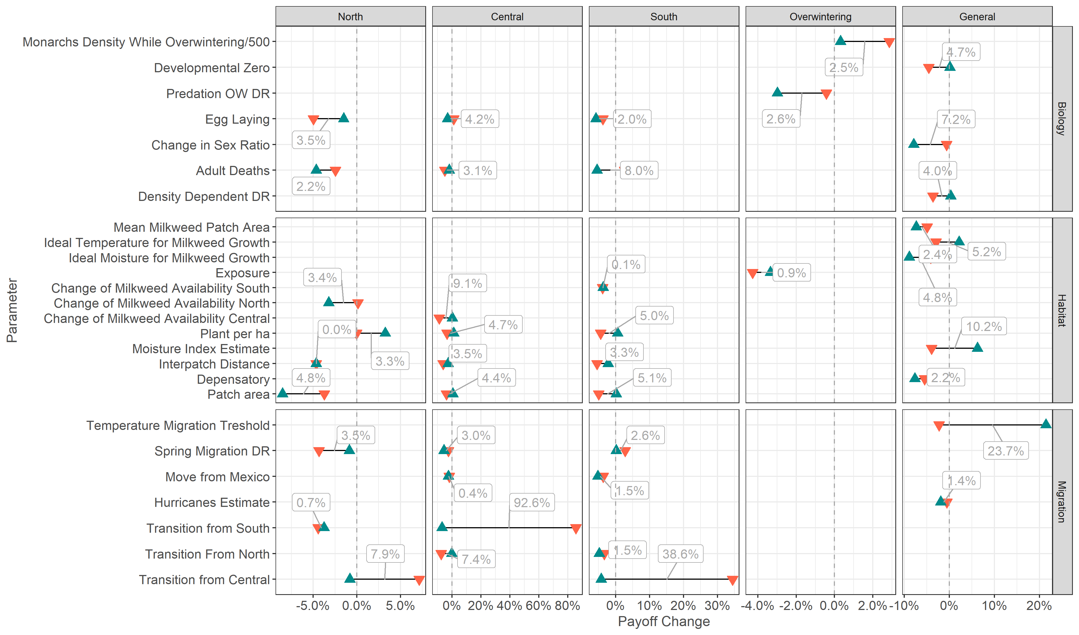

Figure 27 Tornado plot from the sensitivity analysis. Values are obtained from modifying one parameter and assessing its effect on the payoff function, represented by the size of the overwintering colonies. The first parameter listed, Monarch Density While Overwintering, is divided by 500 to match the other parameters’ scale roughly; this large effect for this parameter is due to the direct payoff function dependence on the overwintering colonies' size.

References

Ackery, P. R., Vane-Wright, R. I. & others. (1984). *Milkweed butterflies, their cladistics and biology, being an account of the natural history of the Danainae, a subfamily of the Lepidoptera, Nymphalidae.* British Museum (Natural History).

Altizer, S. M. & Oberhauser, K. (1999). Effects of the Protozoan Parasite Ophryocystis elektroscirrha on the Fitness of Monarch Butterflies (Danaus plexippus). *Journal of Invertebrate Pathology*, *74*, 76–88.

Anderson, J. B. & Brower, L. P. (1996). Freeze-protection of overwintering monarch butterflies in Mexico: critical role of the forest as a blanket and an umbrella. *Ecological Entomology*, *21*(2), 107–116.

Baskerville, G. & Emin, P. (1969). Rapid estimation of heat accumulation from maximum and minimum temperatures. *Ecology*, *50*(3), 514–517.

Batalden, R. V. (2011). *Potential impacts of climate change on monarch butterflies, Danaus plexippus*. Minnesota.

Batalden, R. V. & Oberhauser, K. S. (2015). Monarchs in a changing world: biology and conservation of an iconic butterfly. In Karen S. Oberhauser, Kelly R. Nail, Sonia Altizer (Ed.), (pp. 215–224). Ithaca, New York: Cornell University Press.

Bossomaier, T. R. & Green, D. G. (2000). *Complex systems*. Cambridge university press.

Brower, L. (1977). Monarch migration. *Natural History*, *86*(6), 41–53.

Brower, L. (1996). Monarch butterfly orientation: missing pieces of a magnificent puzzle. *The Journal of Experimental Biology*, *199*(1), 93–103.

Brower, L. P., Fink, L. S. & Walford, P. (2006). Fueling the fall migration of the monarch butterfly. *Integrative and Comparative Biology*, *46*(6), 1123–1142.

Brower, L. P., Kust, D. R., Rendon-Salinas, E., Serrano, E. G., Kust, K. R., Miller, J., … Pape, K. (2004). Catastrophic winter storm mortality of monarch butterflies in Mexico during January 2002. In *Monarch butterfly biology and conservation* (pp. 151–166).

Burns, J. R. & Janamanchi, B. (2007). Optimal control and optimization of system dynamics models: some experiences and recommendations. In *Proceedings of the 2007 Meeting of the Southwest Region Decision Sciences Institute*.

Calvert, W. (2004). Monarch butterfly biology and conservation (pp. 121–128).

Calvert, W. H., Hyatt, M. B. & Villaseñor, N. P. M. (1986). *The effects of understory vegetation on the survival of overwintering monarch butterflies,(Danaus plexippus L.) in Mexico*. Instituto de Ecolog’\ia.

Calvert, W. H., Zuchowski, W. & Brower, L. P. (1983). The effect of rain, snow and freezing temperatures on overwintering monarch butterflies in Mexico. *Biotropica*, 42–47.

Cutting, B. T. & Tallamy, D. W. (2015). An evaluation of butterfly gardens for restoring habitat for the monarch butterfly (Lepidoptera: Danaidae). *Environmental Entomology*, *44*(5), 1328–1335.

Davis, A. K. & Rendón-Salinas, E. (2010). Are female monarch butterflies declining in eastern North America? Evidence of a 30-year change in sex ratios at Mexican overwintering sites. *Biology Letters*, *6*(1), 45–47.

Downhower, J. F. (1988). *The biogeography of the island region of western Lake Erie*. The Ohio State University Press.

Flanagan, L. B. & Johnson, B. G. (2005). Interacting effects of temperature, soil moisture and plant biomass production on ecosystem respiration in a northern temperate grassland. *Agricultural and Forest Meteorology*, *130*(3-4), 237–253.

Flato, G. M. (2007). IPCC DDC AR4 CGCM3.1-T47_(med-res) SRESB1 run2. Retrieved from http://cera-www.dkrz.de/WDCC/ui/Compact.jsp?acronym=CGCM3.1_T47_SRESB1_2

Flockhart, Pichancourt, J.-B., Norris, R. & Martin, T. (2015). Unravelling the annual cycle in a migratory animal: breeding-season habitat loss drives population declines of monarch butterflies. *Journal of Animal Ecology*, *84*(1), 155–165.

Flockhart, T., Martin, T. & Norris, R. (2012). Experimental examination of intraspecific density-dependent competition during the breeding period in monarch butterflies (Danaus plexippus). *PloS One*, *7*(9), e45080.

Flockhart, T., Pichancourt, J.-B., Norris, R. & Martin, T. (2014a). Unraveling the annual cycle in a migratory animal: Breeding-season habitat loss drives population declines of monarch butterflies . *Journal of Animal Ecology*.

Flockhart, T., Pichancourt, J.-B., Norris, R. & Martin, T. (2014b). Unraveling the annual cycle in a migratory animal: Breeding-season habitat loss drives population declines of monarch butterflies (Supplementary). *Journal of Animal Ecology*.

Flockhart, T., Wassenaar, L., Martin, T., Hobson, K., Wunder, M. & Norris, R. (2013a). Tracking multi-generational colonization of the breeding grounds by monarch butterflies in eastern North America. *Proceedings of the Royal Society B: Biological Sciences*, *280*(1768).

Flockhart, T., Wassenaar, L., Martin, T., Hobson, K., Wunder, M. & Norris, R. (2013b). Tracking multi-generational colonization of the breeding grounds by monarch butterflies in eastern North America (supplement). *Proceedings of the Royal Society B: Biological Sciences*, *280*(1768), 20131087.

Forrester, J. W. (1989). The beginning of system dynamics. In Forrester, Jay W (Ed.), *System Dynamics Society*. Jay W. Forrester.

Freckleton, R., Gill, J., Noble, D. & Watkinson, A. (2005). Large-scale population dynamics, abundance-occupancy relationships and the scaling from local to regional population size. *Journal of Animal Ecology*, *74*(2), 353–364.

Gossard, T. & Jones, R. (1977). The effects of age and weather on egg-laying in Pieris rapae L. *Journal of Applied Ecology*, 65–71.

Gotoh, K., Jodrey, W. & Tory, E. (1978). Average nearest-neighbour spacing in a random dispersion of equal spheres. *Powder Technology*, *21*(2), 285–287.

Graham, A. K. (1980). Elements of the System Dynamics Method. In Randers, J (Ed.), (pp. 143–161). Cambridge, MA: Productivity Press.

Grant, T. J., Parry, H. R., Zalucki, M. P. & Bradbury, S. P. (2018). Predicting monarch butterfly (Danaus plexippus) movement and egg-laying with a spatially-explicit agent-based model: The role of monarch perceptual range and spatial memory. *Ecological Modelling*, *374*, 37–50.

Grimm, V., Augusiak, J., Focks, A., Frank, B. M., Gabsi, F., Johnston, A. S., … others. (2014). Towards better modelling and decision support: documenting model development, testing, and analysis using TRACE. *Ecological Modelling*, *280*, 129–139.

Hänninen, H. (2016). *Boreal and temperate trees in a changing climate. Modelling the ecophisiology of seasonality*. *Biometeorology. Springer, Dordrecht* (Vol. 3). Springer.

Hartzler, R. G. (2010). Reduction in common milkweed (Asclepias syriaca) occurrence in Iowa cropland from 1999 to 2009. *Crop Protection*, *29*(12), 1542–1544.

Hartzler, R. G. & Buhler, D. D. (2000). Occurrence of common milkweed (Asclepias syriaca) in cropland and adjacent areas. *Crop Protection*, *19*(5), 363–366.

Holt, H. (2017). *Monitoring Monarch Butter_ies and _eir Habitat across North America: Inventory and Monitoring Protocols and Data Standards for Monarch Conservation. Montreal, Canada: Commission for Environmental Cooperation*. Montral, Canada.

Howard, E., Aschen, H. & Davis, A. K. (2010). Citizen science observations of monarch butterfly overwintering in the southern United States. *Psyche: A Journal of Entomology*, *2010*, 6.

Howard, E. & Davis, A. K. (2015). Tracking the fall migration of eastern monarchs with journey north roost sightings. *Monarchs in a Changing World: Biology and Conservation of an Iconic Butterfly. Cornell Univ Press, Ithaca*, 207–214.

Inamine, H., Ellner, S. P., Springer, J. P. & Agrawal, A. A. (2016). Linking the continental migratory cycle of the monarch butterfly to understand its population decline. *Oikos*, *125*(8), 1081–1091.

Jain, P. (2004). Techno-economic modeling of basic telecommunication services: A system dynamics approach. *FPM Thesis, Indian Institute of Management, Lucknow, India*.

Kasten, K., Stenoien, C., Caldwell, W. & Oberhauser, K. S. (2016). Can roadside habitat lead monarchs on a route to recovery? *Journal of Insect Conservation*, *20*(6), 1047–1057.

Keiman, A. F. & Franco, M. (2004). The monarch butterfly: biology & conservation. In Karen Suzanne Oberhauser AND Michelle J. Solensky (Ed.), (pp. 135–140). Comstock Publishing Associates.

Kuussaari, M., Saccheri, I., Camara, M. & Hanski, I. (1998). Allee effect and population dynamics in the Glanville fritillary butterfly. *Oikos*, 384–392.

Lyneis, J. M. P. A. L. (1996). Proceedings of the 1996 International System Dynamics Conference. In Richardson, G.P., Sterman, J.D. (Ed.), (pp. 317–320). Cambridge, MA: System Dynamics Society.

Malcolm, S. B., Zalucki, M. P. & others. (1993). Biology and conservation of the monarch butterfly. *Biology and Conservation of the Monarch Butterfly.*

Mattila, H. R. & Otis, G. W. (2003). A comparison of the host preference of monarch butterflies (Danaus plexippus) for milkweed (Asclepias syriaca) over dog-strangler vine (Vincetoxicum rossicum). *Entomologia Experimentalis et Applicata*, *107*(3), 193–199.

McCarthy, M. A. & Broome, L. S. (2000). A method for validating stochastic models of population viability: a case study of the mountain pygmy-possum (Burramys parvus). *Journal of Animal Ecology*, *69*(4), 599–607.

Meng, X.-L. & others. (1994). Posterior predictive p-values. *The Annals of Statistics*, *22*(3), 1142–1160.

Mojtahedzadeh, M. (2019). Systems Dynamics Modelling. 135 Western Avenue, Albany, New York. Retrieved May 27, 2019, from http://www.isdps.org/

Murphy, D. D., Freas, K. E. & Weiss, S. B. (1990). An Environment-metapopulation Approach to Population Viability Analysis for a Threatened Invertebrate. *Conservation Biology*, *4*(1), 41–51.

Oberhauser, K., Cotter, D., Davis, D., Decarie, R., Behnumea, A., Galindo-Leal, C., … others. (2008). *North American monarch conservation plan*. *Commission on Environmental Cooperation, Montreal*. Montrel, Canada.

Oberhauser, K. & Solensky, M. (2004). *The Monarch butterfly: biology & conservation*. Cornell university press.

Oberhauser, K., Wiederholt, R., Diffendorfer, J. E., Semmens, D., Ries, L., Thogmartin, W. E., … Semmens, B. (2017). A trans-national monarch butterfly population model and implications for regional conservation priorities. *Ecological Entomology*, *42*(1), 51–60.

Oliva, R. (2003). Model calibration as a testing strategy for system dynamics models. *European Journal of Operational Research*, *151*(3), 552–568.

Perez, S. M. & Taylor, O. R. (2004). The Monarch Butterfly: Biology and Conservation. In Karen S Oberhauser AND Michelle J Solensky (Ed.), (pp. 85–89). Ithaca, NY: Cornell University Press.

Peterson, D. W. (1980). Elements of the System Dynamics Method. In Randers, J (Ed.), (pp. 143–161). Cambridge, MA: Productivity Press.

Pianka, E. R. (1970). On r-and K-selection. *The American Naturalist*, *104*(940), 592–597.

Pleasants, J. (2017). Milkweed restoration in the Midwest for monarch butterfly recovery: estimates of milkweeds lost, milkweeds remaining and milkweeds that must be added to increase the monarch population. *Insect Conservation and Diversity*, *10*(1), 42–53.

Pleasants, J. & Oberhauser, K. (2012). Milkweed loss in agricultural fields because of herbicide use: effect on the monarch butterfly population. *Insect Conservation and Diversity*.

Powell, M. J. (1971). Recent advances in unconstrained optimization. *Mathematical Programming*, *1*(1), 26–57.

Prysby, M. D. (2004). Natural enemies and survival of monarch eggs and larvae. *The Monarch Butterfly: Biology and Conservation Cornell University Press, Ithaca NY*, 27–38.

R Core Team. (2019). *R: A Language and Environment for Statistical Computing* (3.6.0 ed.). Vienna, Austria. Retrieved from https://www.R-project.org

Ralph, C. P. (1977). Effect of Host Plant Density on Populations of a Specialzied, Seed-Sucking Bug, Oncopeltus Fasciatus. *Ecology*, *58*(4), 799–809.

Ramakrishna, A., Tam, H. M., Wani, S. P. & Long, T. D. (2006). Effect of mulch on soil temperature, moisture, weed infestation and yield of groundnut in northern Vietnam. *Field Crops Research*, *95*(2-3), 115–125.

Rawlins, J. E. & Lederhouse, R. C. (1981). Developmental influences of thermal behavior on monarch caterpillars (Danaus plexippus): an adaptation for migration (Lepidoptera: Nymphalidae: Danainae). *Journal of the Kansas Entomological Society*, 387–408.

Rendón-Salinas, E., Martinéz-Meza, F., Martinéz-Pacheco, A. & Crúz-Piña, M. (2018). *Superficie Forestal Ocupada por las Colonias de Hibernación de la Mariposa Monarca en México Durante Diciembre de 2017*. Zitacuaro, Michoacan.

Rendón-Salinas, E., Martínez-Meza, F., Mendoza-Pérez, M., Cruz-Piña, M., Mondragon-Contreras, G. & Martínez-Pacheco, A. (2019). *Superficie Forestal Ocupada por las Colonias de Mariposas Monarca en México Durante La Hibernación de 2018-2019.*

Rendón-Salinas, E., Valera-Bermejo, C., Cruz-Piña, M. & Martinez-Meza, F. (2009). Monitoreo de las colonias de hibernación de mariposa monarca: Superficie forestal de ocupación en diciembre de 2009. *Reporte Inédito*.

Rendón-Salinas, E., Valera-Bermejo, C., Cruz-Piña, M. & Martinez-Meza, F. (2010). *Monitoreo de la superficie ocupada por las colonias de hibernacion de la mariposa monarca en Diciembre de 2010*.

Ries, L., Neupane, N., Baum, K. A. & Zipkin, E. F. (2018). Flying through hurricane central: impacts of hurricanes on migrants with a focus on monarch butterflies. *Animal Migration*, *5*(1), 94–103.

Sarkar, S. (2017). What Is Threatening Monarchs? *BioScience*, *67*(12), 1080–1080.

Satterfield, D. A., Maerz, J. C. & Altizer, S. (2015). Loss of migratory behaviour increases infection risk for a butterfly host. *Proceedings of the Royal Society B: Biological Sciences*, *282*(1801), 20141734.

Satterfield, D. A., Maerz, J. C., Hunter, M. D., Flockhart, D. T., Hobson, K. A., Norris, D. R., … Altizer, S. (2018). Migratory monarchs that encounter resident monarchs show life-history differences and higher rates of parasite infection. *Ecology Letters*.

Senge, P. M. & Forrester, J. W. (1980). Tests for building confidence in system dynamics models. *System Dynamics, TIMS Studies in Management Sciences*, *14*, 209–228.

Solis-Sosa, R., Semeniuk, C., Fernandez-Lozada, S., Dabrowska, K., Cox, S. & Haider, W. (2019). Monarch Butterfly Conservation Through the Social Lens: Eliciting Public Preferences for Management Strategies Across Transboundary Nations. *Frontiers in Ecology and Evolution*, *7*, 316.

Stenoien, C., Nail, K. R., Zalucki, J. M., Parry, H., Oberhauser, K. S. & Zalucki, M. P. (2018). Monarchs in decline: a collateral landscape-level effect of modern agriculture. *Insect Science*, *25*(4), 528–541.

Teskey, R. O. & Hinckley, T. M. (1981). Influence of temperature and water potential on root growth of white oak. *Physiologia Plantarum*, *52*(3), 363–369.

Thogmartin, W. E., Diffendorfer, J. E., López-Hoffman, L., Oberhauser, K., Pleasants, J., Semmens, B. X., … Wiederholt, R. (2017). Density estimates of monarch butterflies overwintering in central Mexico. *PeerJ*, *5*, e3221.

Thogmartin, W. E., López-Hoffman, L., Rohweder, J., Diffendorfer, J., Drum, R., Semmens, D., … others. (2017). Restoring monarch butterfly habitat in the Midwestern US: “all hands on deck.” *Environmental Research Letters*, *12*(7), 074005.

Tracy, J. L., Kantola, T., Baum, K. A. & Coulson, R. N. (2019). Modeling fall migration pathways and spatially identifying potential migratory hazards for the eastern monarch butterfly. *Landscape Ecology*, *34*(2), 443–458.

Tulsyan, A., Gopaluni, R. B. & Khare, S. R. (2016). Particle filtering without tears: A primer for beginners. *Computers \& Chemical Engineering*, *95*, 130–145.

Urquhart, F. & Urquhart, N. (1976). The overwintering site of the eastern population of the monarch butterfly (Danaus p. plexippus; Danaidae) in southern Mexico. *Journal of the Lepidopterists’ Society*, *30*, 153–158.

Urquhart, F. & Urquhart, N. (1978). Autumnal migration routes of the eastern population of the monarch butterfly (Danaus p. plexippus L.; Danaidae; Lepidoptera) in North America to the overwintering site in the Neovolcanic Plateau of Mexico. *Canadian Journal of Zoology*, *56*(8), 1759–1764.

Veihmeyer, F. J. & Hendrickson, A. H. (1927). Soil-moisture conditions in relation to plant growth. *Plant Physiology*, *2*(1), 71.

Vensim. (2010). Vensim reference manual. VENTANA Systems, Inc. Boston.

Vidal, O. & Rendón-Salinas, E. (2014). Dynamics and trends of overwintering colonies of the monarch butterfly in Mexico. *Biological Conservation*, *180*, 165–175.

Villarini, G. & Vecchi, G. A. (2013). Projected increases in North Atlantic tropical cyclone intensity from CMIP5 models. *Journal of Climate*, *26*(10), 3231–3240.

Wang, C., Wan, S., Xing, X., Zhang, L. & Han, X. (2006). Temperature and soil moisture interactively affected soil net N mineralization in temperate grassland in Northern China. *Soil Biology and Biochemistry*, *38*(5), 1101–1110.

Weller, F., Sherley, R. B., Waller, L. J., Ludynia, K., Geldenhuys, D., Shannon, L. J. & Jarre, A. (2016). System dynamics modelling of the Endangered African penguin populations on Dyer and Robben islands, South Africa (Appendix). *Ecological Modelling*, *327*, 44–56.

Wolfram, S. (1985). Complex systems theory. In *Emerging Syntheses in Science: Proceedings of the Founding Workshops of the Santa Fe Institute (Addison-Wesley, 1988)*.

Yakubu, A.-A., Sáenz, R., Stein, J. & Jones, L. E. (2004). Monarch butterfly spatially discrete advection model. *Mathematical Biosciences*, *190*(2), 183–202.

Yates, F. E. (2012). Self-organizing systems: The emergence of order. In F Eugene Yates, Alan Garfinkel, Donald O Walter, Gregory B Yates (Ed.), (pp. 1–14). New York, US: Springer Science & Business Media.

Zalucki, M. & Kitching, R. (1984). The dynamics of adult Danaus plexippus L.(Danaidae) within patches of its food plant, Asclepias spp. *Journal of the Lepidopterists’ Society (USA)*.

Zalucki, M. P. (1981). The effects of age and weather on egg laying in Danaus plexippus L.(Lepidoptera: Danaidae). *Population Ecology*, *23*(2), 318–327.

Zalucki, M. P. (1982). Temperature and rate of development in Danaus plexippus L. and D. chrysippus L.(Lepidoptera: Nymphalidae). *Australian Journal of Entomology*, *21*(4), 241–246.

Zalucki, M. P., Brower, L. P. & Alonso-M, A. (2001). Detrimental effects of latex and cardiac glycosides on survival and growth of first-instar monarch butterfly larvae Danaus plexippus feeding on the sandhill milkweed Asclepias humistrata. *Ecological Entomology*, *26*(2), 212–224.

Zalucki, M. P. & Kitching, R. L. (1982). The analysis and description of movement in adult Danaus plexippus L.(Lepidoptera: Danainae). *Behaviour*, 174–198.

Zalucki, M., Parry, H. & Zalucki, J. (2015). Movement and egg laying in Monarchs: To move or not to move, that is the equation. *Austral Ecology*.

Zalucki, M., Parry, H. & Zalucki, J. (2016). Movement and egg laying in monarchs: to move or not to move, that is the equation. *Austral Ecology*, *41*(2), 154–167.

Zi, Z. (2011). Sensitivity analysis approaches applied to systems biology models. *IET Systems Biology*, *5*(6), 336–6. doi:10.1049/iet-syb.2011.0015

1. Developmental Zero is the temperature below no measurable development occurs (M. P. Zalucki, 1982)
2. Heat Impairment Threshold is the temperature above measurable development does not occur (M. P. Zalucki, 1982)
3. The Power Dissipation Index, PDI, is defined as the sum of the maximum one-minute sustained wind speed cubed, at six-hourly intervals, for all periods when the cyclone is at least tropical storm strength. This measure can be used as a proxy for the intensity of the hurricane’s season (Villarini & Vecchi, 2013).